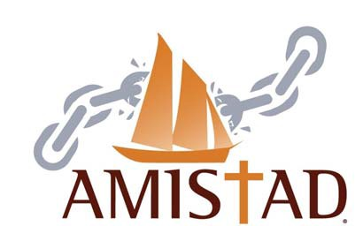

**Amistad Institute November 4-6**

Training Application

**Basic Information**

**Full Name:**

*Last First M.I.*

**Address:**

*Street Address Apartment/Unit #*

*City State ZIP Code*

C

**Home Phone:** Ethnicity:

**Languages spoken**:

**Gender** ☐ Female ☐ Male

**Short Answer Question**

***This information will be used to assess how you can help your community through this training.***

**The Amistad Movement seeks to empower recently arrived immigrants with the informational resources they need to prevent human trafficking in their communities, and what to do when they identify victims. In what ways are you capable/able to reach and train recently arrived immigrants on anti-trafficking prevention and victim identification?**

**The purpose of the Amistad Institute is to train a committed group of volunteers who will take it upon themselves to recruit and train other trainers from within their community to increase victim-identification and prevention. Are you willing to take-on that responsibility for at least a year (more if you would like)? Briefly describe your plan to do so.**

**Do you have any special dietary requirements? YES NO**

**If yes, what is it? ___________________________________________**

**How did you hear about the Amistad Institute?**

☐ E‐mail ☐ USCCB Employee ☐ Parish

☐ Website ☐ Other __________________