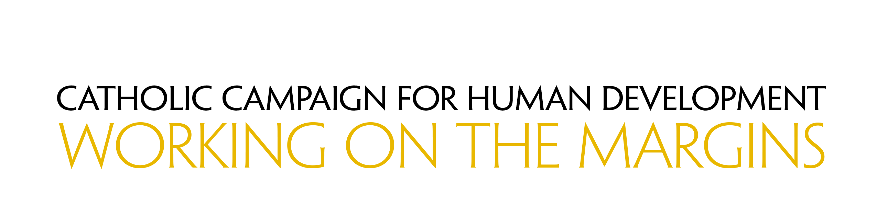
Bulletin Announcements

Week Before the Collection
Next week, our second collection will be for the Catholic Campaign for Human Development. Over 46 million people in the United States live in poverty. This collection supports programs to empower people to identify and address the obstacles they face as they work to lift themselves out of poverty. By supporting this collection you give people a hand up, not a hand out. Learn more about the Catholic Campaign for Human Development at www.usccb.org/cchd/collection.

Week of the Collection
Please be generous in this week’s second collection for the Catholic Campaign for Human Development. In the United States, one in six people lives in poverty. With this collection you support programs that address the causes of poverty and provide a sustainable future for those who are struggling across the country. In addition, 25 percent of funds collected remains in our diocese to fund local anti-poverty projects. Please prayerfully consider how you can support this collection and work on the margins. More information about the Catholic Campaign for Human Development can be found at www.usccb.org/cchd/collection.

Week After the Collection
Thank you for your generous support last week to the collection for the Catholic Campaign for Human Development! As a parish we raised $[amount] to support those on the margins living in poverty. If you missed the collection, it’s not too late to give! Visit www.usccb.org/nationalcollections and click “How to Give” on the left.

