Social Media Toolkit

Facebook
- Did you know that over 43 million Americans live below the poverty line? Learn more about @PovertyUSA and support the Collection for the Catholic Campaign for Human Development at Mass! #PowerOfCCHD #1church1mission www.povertyusa.org
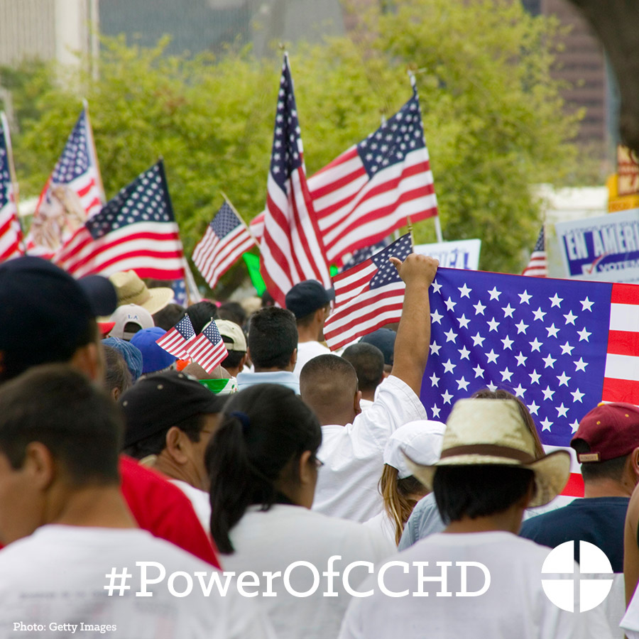

- Have three minutes? Why not use them to learn about how the USCCB addresses issues of poverty in this interview with CCHD Director Ralph McCloud? #PowerOfCCHD #1church1mission https://goo.gl/UMoEIz

- The Collection for the Catholic Campaign for Human Development supports the work of groups by giving a hand up, not a hand out. Support the collection at Mass! #PowerOfCCHD #1church1mission http://goo.gl/I6FqfW

- Check out life at the poverty line. Support the Catholic Campaign for Human Development Collection at Mass #PowerOfCCHD #1church1mission https://goo.gl/MFO7fn

- Want to stay up-to-date on how the Catholic Campaign for Human Development is working to break the cycle of poverty? Sign up for the quarterly newsletter “Helping People Help Themselves.” #PowerOfCCHD #1church1mission http://goo.gl/iktA5H

- Who receives funding from the collection for the Catholic Campaign for Human Development? Watch our “Meet Mary” video and see how your donations break the cycle of poverty. #PowerOfCCHD #1church1mission https://goo.gl/OouOcF

- Support the Catholic Campaign for Human Development collection at Mass! #PowerOfCCHD #1church1mission www.povertyusa.org
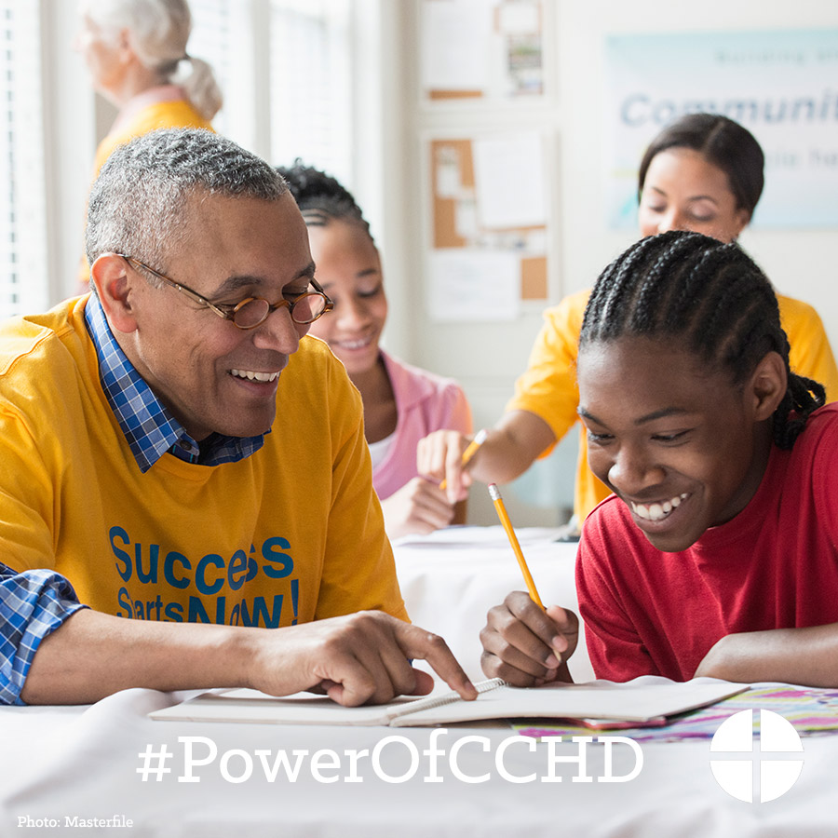

- This weekend our second collection is for the Catholic Campaign for Human Development. 25 percent of funds collected will stay here in the diocese for anti-poverty projects. Please be generous! #PowerofCCHD http://goo.gl/I6FqfW
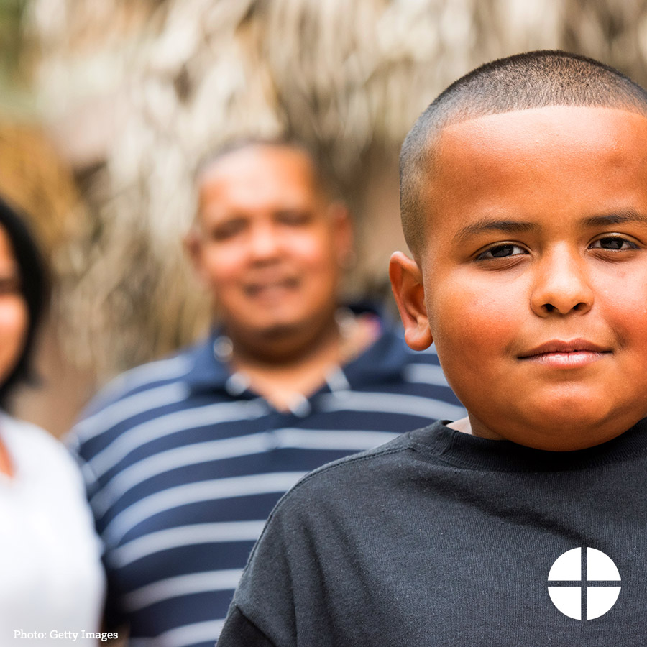
- This weekend is the collection for the Catholic Campaign for Human Development! Be part of the effort to break the cycle of poverty in the United States. #PowerOfCCHD #1church1mission http://goo.gl/I6FqfW
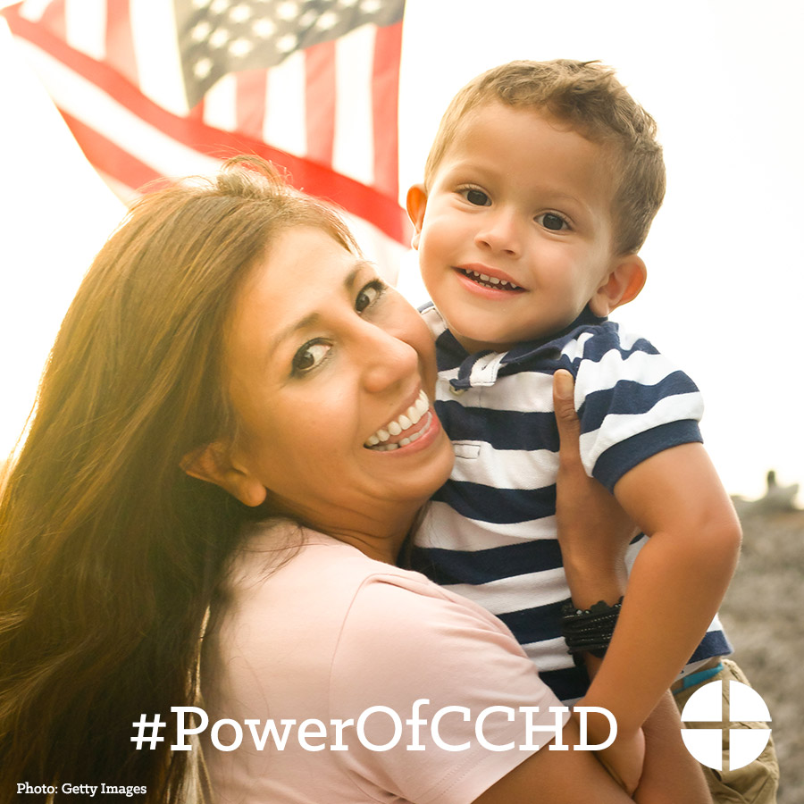

- Thank you for supporting the CCHD Collection this past weekend. If you missed it, it’s not too late to give! #PowerOfCCHD #1church1mission http://goo.gl/B3l390
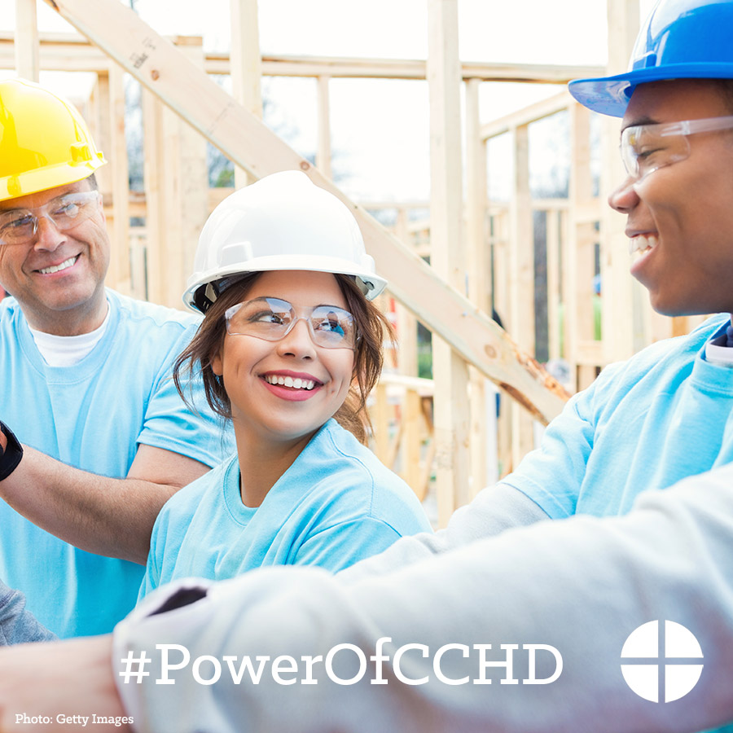

Twitter
- DYK over 43 million Americans live below the poverty line? Learn about @EndPovertyUSA #PowerOfCCHD www.povertyusa.org
- See life at the margins. Help the CCHD collection at Mass. #PowerOfCCHD https://goo.gl/MFO7fn
- Collection for @EndPovertyUSA supports groups by giving a hand up, not a hand out. #PowerOfCCHD http://goo.gl/I6FqfW
- Stay up-to-date on how CCHD breaks cycles of poverty. Sign up for the newsletter! #PowerOfCCHD http://goo.gl/iktA5H
- Help break the cycle of poverty in the US and support the CCHD collection at Mass. #PowerOfCCHD http://goo.gl/I6FqfW

- Who receives funding from @EndPovertyUSA collection? Watch “Meet Mary.” #PowerOfCCHD https://goo.gl/OouOcF
- Support the Catholic Campaign for Human Development collection at Mass! #PowerOfCCHD #1church1mission www.povertyusa.org
- This weekend is the CCHD collection! Help break the cycle of poverty in the US. #PowerOfCCHD http://goo.gl/I6FqfW
- DYK 25% of funds from the CCHD collection stay in our diocese? #PowerOfCCHD http://goo.gl/I6FqfW
- This weekend’s 2nd collection is for CCHD. Please be generous! #PowerOfCCHD http://goo.gl/I6FqfW

Instagram
- Did you know that over 43 million Americans live below the poverty line? Support the Collection for the Catholic Campaign for Human Development at Mass! #PowerOfCCHD #1church1mission www.povertyusa.org
- The Collection for the Catholic Campaign for Human Development supports the work of groups by giving a hand up, not a hand out. Support the collection at Mass! #PowerOfCCHD #1church1mission www.povertyusa.org

- Support the Catholic Campaign for Human Development collection at Mass! #PowerOfCCHD #1church1mission www.povertyusa.org
- This weekend is the collection for the Catholic Campaign for Human Development! Be part of the effort to break the cycle of poverty in the United States. #PowerOfCCHD #1church1mission http://goo.gl/I6FqfW

- This weekend, our second collection is for the Catholic Campaign for Human Development. 25 percent of funds collected will stay here in the diocese for anti-poverty projects. Please be generous! #PowerOfCCHD www.povertyusa.org

