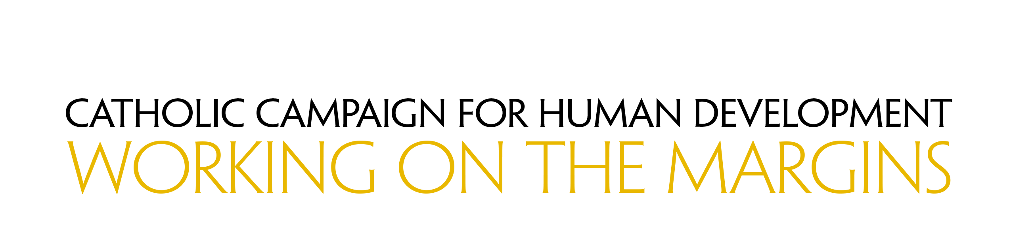

Bulletin Announcements

Week Before the Collection
Next week, our second collection will be for the Catholic Campaign for Human Development. Over 43 million people in the United States live in poverty. This collection supports programs to empower people to identify and address the obstacles they face as they work to bring permanent and positive change to their communities. Learn more about the Catholic Campaign for Human Development at www.usccb.org/cchd/collection.

Week of the Collection
Please be generous in this week’s second collection for the Catholic Campaign for Human Development. In the United States, one in seven people lives in poverty. With this collection you support programs that address the causes of poverty and provide a sustainable future for those who are struggling across the country. In addition, 25 percent of funds collected remains in our diocese to fund local anti-poverty projects. Please prayerfully consider how you can support this collection and work on the margins. More information about the Catholic Campaign for Human Development can be found at www.usccb.org/cchd/collection.

Week After the Collection
Thank you for your generous support last week to the collection for the Catholic Campaign for Human Development! As a parish, we raised $[amount] to support those on the margins who are living in poverty in the United States. If you missed the collection, it’s not too late to give! Visit www.usccb.org/nationalcollections, and click on “How to Give” on the left.

