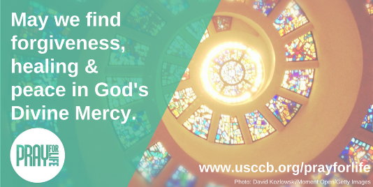[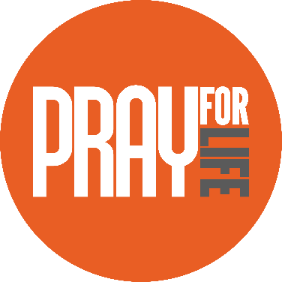](http://www.usccb.org/about/pro-life-activities/prayers/pray-for-life.cfm)

One Step Further

Read “Bridges of Mercy for Post-Abortion Healing” to learn how to extend God’s mercy to those who suffer from involvement in abortion ([usccb.org/bridges-of-mercy](http://www.usccb.org/about/pro-life-activities/respect-life-program/2016/bridges-of-mercy-for-post-abortion-healing.cfm)).

*Visit* [*www.bit.ly/other-formats-bridges-of-mercy*](http://www.bit.ly/other-formats-bridges-of-mercy) *to download as a bulletin insert or to order as a brochure!*

Did You Know?

The Church grants a plenary indulgence for celebrating the Sunday of Divine Mercy. Learn more at [www.bit.ly/Divine-Mercy-Indulgences](http://www.bit.ly/Divine-Mercy-Indulgences).

Acts of Reparation (choose one)

* On the Sunday of Divine Mercy (April 8th this year), take some time to learn about St. Faustina and the message of Divine Mercy ([usccb.org/divine-mercy](http://www.usccb.org/about/pro-life-activities/prayers/divine-mercy-sunday.cfm#Origin)). Then pray the Divine Mercy Chaplet in reparation for sins against life ([usccb.org/divine-mercy-chaplet](http://www.usccb.org/beliefs-and-teachings/how-we-teach/new-evangelization/year-of-faith/how-to-pray-the-chaplet-of-divine-mercy.cfm)).
* Reflect on one of the Mass readings for the Sunday of Divine Mercy ([www.bit.ly/april-8-readings](http://www.bit.ly/april-8-readings)). How is God speaking to you?
* Encounter Christ’s ready forgiveness in the Sacrament of Reconciliation, and then continue to place your trust in God’s mercy with this short prayer ([www.bit.ly/trust-prayer](http://www.bit.ly/trust-prayer)).

NABRE © 2010 CCD. Copyright © 2018, United States Conference of Catholic Bishops, Washington, DC. All rights reserved.

Prayers

*Our Father, 3 Hail Marys, Glory Be*

Reflection

As we prepare for the Sunday of Divine Mercy this weekend, we can reflect upon the mercy Christ shows us in His suffering, death, and Resurrection. By our sin, we distance or cut ourselves off from the life of God’s grace within us. But rather than leave us among the dead, our God wants to wipe away our sins and welcome us in friendship.

His forgiveness, which brings us to life in Him, is possible in the Sacrament of Reconciliation because He first offered Himself for our sake. Trusting in God’s mercy and the power of the Resurrection, let us ask His forgiveness for the times we have failed to respect one another or to cherish His gift of life.

Jesus’s Passion and death are not the end; they point to the joy of the Resurrection.

*“By his wounds, we were healed” (Isaiah 53:5).*

www.usccb.org/prayforlife

Pray for Life