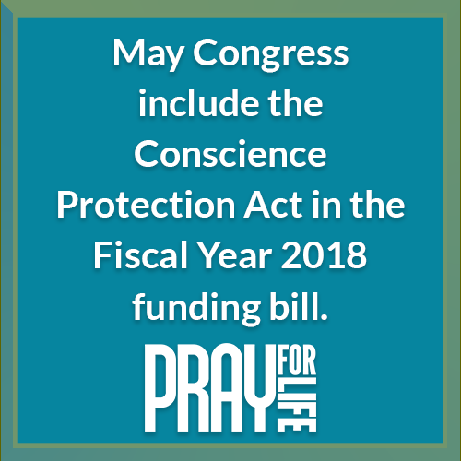<http://www.usccb.org/about/pro-life-activities/prayers/upload/pray-for-life-oct-2017-2.jpg>[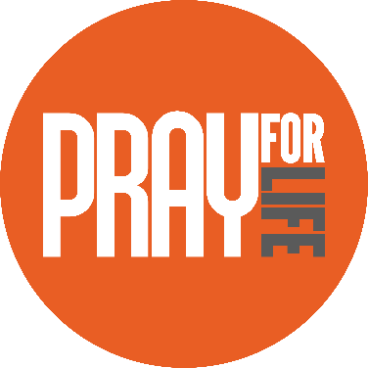](http://www.usccb.org/about/pro-life-activities/prayers/pray-for-life.cfm)

Acts of Reparation (choose one)

* Urge Congress to pass the Conscience Protection Act. Send your representatives a message today at www.[bit.ly/support-cpa](http://bit.ly/support-cpa)!
* Share the action alert with your friends and family; activate prayer chains and groups. (www.[bit.ly/support-cpa](http://bit.ly/support-cpa))
* Light up social media to raise awareness and prompt action. Downloadable images and sample Tweets are available at [usccb.org/conscience](http://www.usccb.org/conscience).

One Step Further

View and share a quick video ([www.bit.ly/CPA-Video](http://www.bit.ly/CPA-Video)) and the link [www.bit.ly/support-cpa](http://www.bit.ly/support-cpa) to invite your friends to stand up for conscience rights!

[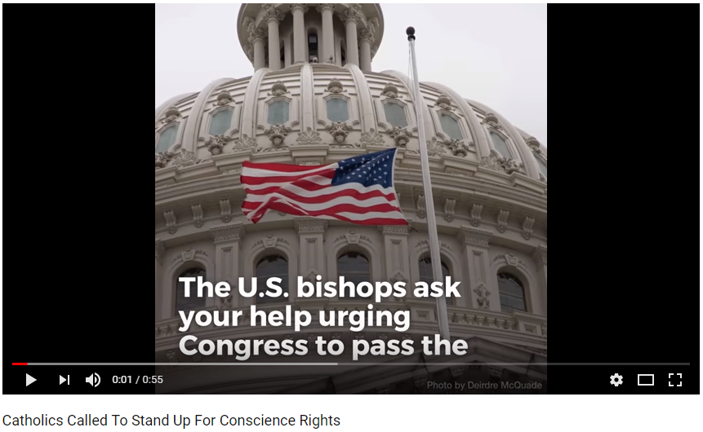](https://youtu.be/uTesQb1Kb9o)

Did You Know?

Sandra and Cathy are two nurses who were forced by their employers to choose between their jobs and their pro-life convictions.

Watch their stories at [www.bit.ly/cpa-stories](http://www.bit.ly/cpa-stories)!

Copyright © 2018, United States Conference of Catholic Bishops, Washington, DC. All rights reserved.

Prayers

*Our Father, 3 Hail Marys, Glory Be*

Reflection

Congress needs to hear from us! Health care providers and trainees, churches, and others are being forced to participate in abortion or provide coverage for it in their health care plans. Federal conscience laws prohibit such coercion, but these laws continue to be violated—mostly because they don't provide victims with the ability to defend their rights in court.

This week, Congress will likely decide whether to improve enforcement of these laws by enacting the Conscience Protection Act. No one should be forced to participate in abortion. Tell your representatives today at www.[bit.ly/support-cpa](http://bit.ly/support-cpa)!

Intention

www.usccb.org/prayforlife

Pray for Life