Action Guide
Father’s Day: June 21, 2020
www.respectlife.org/fathers-day

Introduction
While not a liturgical observance, Father’s Day is an appropriate time to recall the essential role of fathers in the life of the family and in building a culture of life. It is also an opportunity to highlight spiritual fatherhood, which all men are called to embrace.
Simple steps, sample intercessions, homily notes, and an activity are provided to help your parish celebrate and pray for the fathers in your community, whether you are able to gather in person or are socially distancing. Please feel free to adapt the following resources to fit the needs of your specific parish or ministry.

-------

Fatherhood has its origins in God, who chose to reveal Himself to us as Our Father, sending his only Son for the sake of our salvation. Fathers therefore have a special role “in revealing and in reliving on earth the very fatherhood of God” (Familiaris consortio 25). Indeed, the role of the father “is of unique and irreplaceable importance” (FC 25).
Although society increasingly tells fathers that they have no say in the lives of their children before birth and fails to recognize the dynamic and critically important role of fatherhood, it is both a biological and spiritual reality. Pope Saint John Paul II said fathers are called to exhibit “generous responsibility for the life conceived under the heart of the mother” (FC 25). They are uniquely entrusted with the protection and defense of both mother and child and, in this way, in safeguarding the sanctity of human life. Yet research continues to show that the top reasons women seek abortions include lacking support from the child’s father and financial challenges, which are only exacerbated by a father’s absence.
As a Church community, we need to encourage and support men to follow the example of St. Joseph and embrace their various roles as father. Even if a man is not a parent, he is still called to spiritual fatherhood—a fatherhood that fosters others’ relationship with God, protecting them from evil and providing an example of Christ’s love.
St. Joseph, himself, was unexpectedly called to both practical and spiritual fatherhood, and amid very difficult circumstances. But despite all obstacles, Joseph was faithful. He welcomed life, offering care and protection to Mary and Jesus. We pray that each expectant father will find courage in the example of St. Joseph and offer loving, life-affirming support to the mother of his child.

Simple Steps
Here is a list of simple steps that offer ideas on how to use the provided resources. Each step may not apply to your specific circumstance, but most can be adapted to suit your needs.
- Consider how your parish could observe Father’s Day.
Many parishes already observe Father’s Day in some way. Find out whether your parish currently has any plans in progress. Review the Father’s Day resources available below, and prayerfully consider which may work best in your parish and, if your parish already has plans in motion, whether there is a way to complement or integrate with those plans.
- Contact your pastor.
Ask your pastor whether it might be possible for your parish, on Father’s Day, to highlight a father’s integral role in the life of the family and in safeguarding the sanctity of human life. Let him know sample homily reflection points are available, in case he’d like to take a look at them. Share the sample intercessions, and ask if one or more could be included in the Prayer of the Faithful during Masses taking place Father’s Day weekend (June 20-21). Share any other ideas you have, and ask whether any of them might be appropriate for your parish. Be open to the guidance of the Holy Spirit and your pastor.
- Make necessary preparations.
Once you have determined with your pastor how your parish will celebrate Father’s Day, begin making the appropriate plans and preparations in collaboration with relevant parish staff and volunteers. This could include tasks like submitting bulletin announcements, arranging special intercessions for Mass, drafting sections for the parish newsletter, or scheduling social media posts.
- Pray for all fathers.
No matter how your parish has decided to observe Father’s Day, prayer should be the basis of everything we do. As you plan and prepare, remember to lift up in prayer all fathers. Seek the intercession of St. Joseph, patron of fathers, especially for those who are struggling with some aspect of their fatherhood, such as feeling overwhelmed with the news of an unexpected pregnancy.

Sample Announcements
If you are planning to do the Father’s Day activity, use these sample announcements and graphics to invite parishioners to participate.
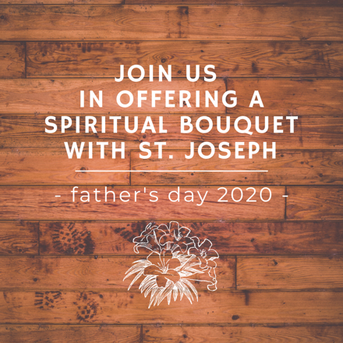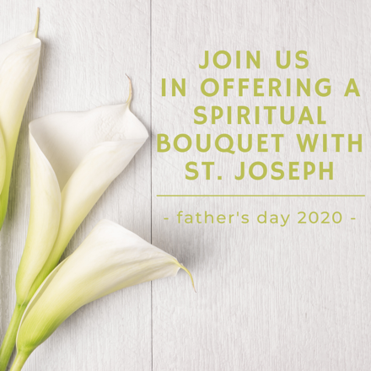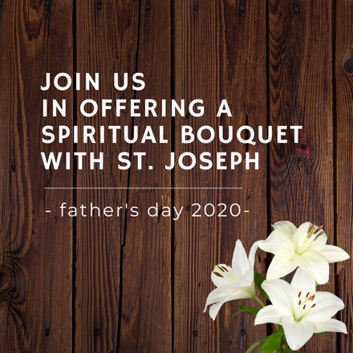
Download Download Download

Sample Announcement (bulletins and newsletters)
(Suggested Weekends: June 13-14 and/or 20-21, 2020)
This Father’s Day weekend, we invite you to join us in offering a spiritual bouquet honoring St. Joseph, patron of fathers, and seeking his intercession. We invite you to share with us your prayer intentions to be entrusted to St. Joseph. We also encourage you to offer a spiritual bouquet to St. Joseph in your own homes using or adapting the suggestions in this sample activity guide (www.respectlife.org/fathers-day-activity). If you participate from home, please consider sharing pictures with our parish family. We would love to see them! [Explain how parishioners can share pictures – for example, by emailing them to be shared by parish staff or by posting directly on parish social media accounts.]
As we celebrate the gift of fathers and honor St. Joseph, we also recognize that Father’s Day can be a difficult holiday for some. We hope this spiritual bouquet provides an opportunity to pray for the intentions brought to your heart by Father’s Day.

Sample Social Media Posts
- Join us in offering a spiritual bouquet to St. Joseph, patron of fathers, for Father’s Day! We invite you to comment with prayer intentions you’d like to be entrusted to St. Joseph. We also encourage you to participate from home with these simple suggestions: www.respectlife.org/fathers-day-activity
As we celebrate the gift of fathers and honor St. Joseph, we also recognize that Father’s Day can be a difficult holiday for some. We hope this spiritual bouquet provides an opportunity to pray for the intentions in your heart today.

- On #FathersDay we celebrate our earthly and spiritual fathers. Add to our spiritual bouquet by commenting with prayer intentions for the men who have been as fathers to you, like your godfather, mentor, or parish priest. #prayforpriests #godfather

Sample Pulpit Announcements
(Suggested Weekends: June 13-14 and/or 20-21, 2020)
Option 1
We invite you to join us in offering a spiritual bouquet to St. Joseph for Father’s Day. Please see the parish website for more information.

Option 2
We invite you to join us in offering a spiritual bouquet to St. Joseph, patron of fathers, for Father’s Day. Simple suggestions for you to participate from home are available on the parish website.
As we celebrate the gift of fathers and honor St. Joseph, we also recognize that Father’s Day can be a difficult holiday for some. We hope this spiritual bouquet provides an opportunity to pray for the intentions in your heart today.

Intercessions
Consider utilizing the provided sample intercessions in the Prayer of the Faithful during the Masses on Father’s Day weekend (June 20-21). They can also be printed in the weekly bulletin, featured in email newsletters, shared on social media platforms, or prayed during personal or family prayer times.
Some intercessions pray for fathers, while others focus on those who may find Father’s Day a difficult occasion. Addressing both is a beautiful way to celebrate fatherhood, while also extending compassion and solidarity. It is especially important to acknowledge those for whom Father’s Day is hard if you plan to offer a blessing for fathers following the Prayer of the Faithful or as a solemn blessing at the end of Mass.

May expectant fathers lovingly support
the mothers of their children
in welcoming new life;
We pray to the Lord:

For expectant fathers:
May they find courage
in the example of St. Joseph,
as they prepare to love, protect, and provide for their child;
We pray to the Lord:

For all priests:
That through the intercession of St. Joseph, they will be filled with the wisdom, understanding, and strength they need to follow in the footsteps of Jesus;
We pray to the Lord:

For all married couples
struggling to have a child:
May the Lord grant them
peace and comfort;
We pray to the Lord:

For all those longing to welcome a child through adoption:
May the Lord guide their journey
and grant them peace along the way;
We pray to the Lord:

For fathers who mourn the loss of a child:
May they find peace and consolation
in the heart of God the Father;
We pray to the Lord:

Homily Considerations and Reflections
Sunday, June 21, 2020
Twelfth Sunday in Ordinary Time
First Reading: Jeremiah 20:10-13
Responsorial Psalm: Psalm 69:8-10, 14, 17, 33-35
Second Reading: Romans 5:12-15
Gospel Acclamation: John 15:26B, 27A
Gospel: Matthew 10:26-33

Rather than drawing from the readings of the day, some general points are provided for consideration as you honor fathers and highlight the gift and responsibility of fatherhood, while also showing sensitivity and compassion to all who may find this holiday especially challenging.
One or more of these reflections on fatherhood could be included as part of a larger homily, and other ministry leaders could also use these reflections as the basis for small group discussions or other faith-sharing scenarios.
- All men are called to the vocation of spiritual fatherhood; some are also called to live this out as fathers of biological, adopted, or foster children. The societal observance of Father’s Day, in addition to the traditional observance of the holiday, is also an opportunity to highlight the spiritual fatherhood of godparents, priests, deacons, uncles, and other men who often serve as fathers in important ways within extended family, parish communities, or individuals’ lives.
- Fatherhood has its origins in God, who chose to reveal Himself to us as Our Father, sending his only Son for the sake of our salvation. Fathers therefore have a special role “in revealing and in reliving on earth the very fatherhood of God” (Familiaris consortio 25).
- In our efforts to honor, offer thanksgiving, and pray for fathers, it is also important to remember that Father’s Day can be a difficult holiday for some, such as those who have lost or are estranged from their fathers, couples who are struggling with infertility, and fathers who have lost one or more children through miscarriage, abortion, or in some other way. You may want to take a moment to verbally acknowledge there are some who may find this holiday to be painful and invite the congregation to pray for them. Those struggling with feelings of loss, emptiness, or loneliness on this holiday may feel overlooked, and this simple gesture can communicate a sense of understanding and support.
- Fathers need to be encouraged to support the mothers of their children in welcoming new life. Research continues to show that the top reasons women seek abortions include lacking support from the child’s father and financial challenges, which are only exacerbated by a father’s absence. Fathers should be informed of and formed in the irreplaceable role they hold in the lives of their children and the responsibility they share in welcoming God’s gift of new life.
- Pope Saint John Paul II said fathers are called to exhibit “generous responsibility for the life conceived under the heart of the mother” (Familiaris consortio 25). They are uniquely entrusted with the protection and defense of both mother and child and, in this way, in safeguarding the sanctity of human life.
- Pope St. John Paul II also wrote that, in the case of an abortion decision “the father of the child may be to blame, not only when he directly pressures the woman to have an abortion, but also when he indirectly encourages such a decision on her part by leaving her alone to face the problems of pregnancy: in this way the family is thus mortally wounded and profaned in its nature as a community of love and in its vocation to be the ‘sanctuary of life’” (Evangelium vitae 59).
- Although men do not bear the physical challenges of carrying a child within themselves, they can still be overwhelmed by the news of an unexpected or difficult pregnancy. Further, society increasingly tells them that they should have no say in the lives of their children before birth.
- As a Church community, we need to encourage and support men to follow the example of St. Joseph and embrace their role as father. Joseph, himself, was unexpectedly called to fatherhood amid difficult circumstances. But despite all obstacles, he was faithful. He welcomed life, offering care and protection to Mary and Jesus.
Sample Father’s Day Activity
A Spiritual Bouquet with St. Joseph, Patron of Fathers
Father’s Day provides a beautiful opportunity to pray for and honor fathers. However, it can also be a difficult holiday for some, such as those who have lost their own father, those who have lost a child, and those who are struggling to have a child.
This activity seeks to lift up the many intentions brought to our hearts by the observance of Father’s Day, entrusting them to the intercession of St. Joseph, Patron of Fathers. It also provides a way to honor St. Joseph for his own example of embracing the call to fatherhood amid difficult circumstances. Despite all obstacles, he was faithful, welcoming the life of the Christ Child and offering care and protection to both Mary and Jesus.
On the weekend of Father’s Day (June 20-21), parishioners are invited to write a prayer intention on a slip of paper and place it, along with a flower or some other type of gift, beneath a statue, icon, or image of St. Joseph. (If you don’t have one, you could look for an image online to print or temporarily display on a screen.)
When the activity is complete, you will have a spiritual and physical “bouquet” of prayer intentions and gifts serving as a visual reminder of the powerful intercession and protection of St. Joseph.
While the following directions describe completing this activity within the home, this can be easily adapted for use in other scenarios. Assess what works best for your circumstances and make adaptations or changes as needed!
Materials
- *Flowers, greenery, or some other type of small gift like flowers, hearts cut out of colored construction paper, or even a favorite food
- Small note cards or slips of paper
- Pens, crayons, or markers
- Small basket or other container to hold the prayer intentions (Optional: If doing this activity within a family setting, a father could supervise his child/ren in making a homemade keepsake box for this purpose.)
- Vase of water (if using fresh flowers or greenery) or other container to hold gifts
- **Statue, icon, or image of St. Joseph
- Copies of the June issue of Pray for Life or a prayer seeking St. Joseph’s intercession, such as the Prayer to St. Joseph after the Rosary or a Litany of St. Joseph

*This activity can also be completed without flowers or any other type of gift. Simply place your written intentions in a basket before the designated statue or image of St. Joseph. Or, you could draw a flower, candle, or some other image next to your prayer intention on the paper.
**If you don’t have any of these in your home, find an image online to print or display on a computer or other type of screen.
Directions
- Gather your materials. Look around your own yard for flowers or greenery that might be available. If constructing a homemade box, do so a day or so ahead of time.
- Set up a small table for your spiritual bouquet. Place on the table your statue or image of St. Joseph with a small basket, homemade keepsake box, or other container for prayer intentions and a vase with water or other receptacle for your little gifts. Have writing utensils and a hard surface to write on available nearby.
- Pre-cut notecards or small slips of paper.
- Invite household members to participate in the spiritual bouquet. Participants can write down on the notecards or slips of paper what they would like to ask St. Joseph to intercede for. They can then be invited to place their prayer intentions in the basket, as well as to place their flowers or other gifts in the vase or other receptacle in honor of St. Joseph.
- When all participants have presented their prayer intentions and gifts to St. Joseph, offer a prayer of your choosing for your own intentions and for all fathers—especially those who are reluctant to offer loving, life-affirming support to the mothers of their unborn children. Some options are this Litany of St. Joseph or the Rosary, followed by the Prayer to St. Joseph after the Rosary. You could also take it a step further and go through the June issue of Pray for Life.
- Encourage family members to pray throughout the week for all the intercessions placed under the care of St. Joseph.

Excerpts from Familiaris consortio (On the Family), no. 25 and 59 © 1981, Libreria Editrice Vaticana. Used with permission. All rights reserved. Copyright © 2020, United States Conference of Catholic Bishops. All rights reserved.

