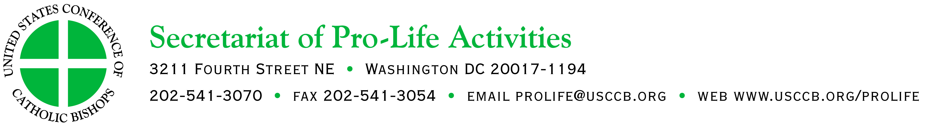

“Each of Us is a Masterpiece of God’s Creation”
Reflections for Respect Life Month, October, 2014

My dear friends in Christ:

Pope Francis has captivated the world with his humility, warmth and compassion for each person. Vivid accounts of his tenderness for “the least of these”—the elderly, the imprisoned, those with disfiguring disabilities, the unborn, and many more—seize our attention. Why?

At the heart of each of these interactions is a truth which resonates in our hearts, revealing to us something essential to understanding ourselves and our purpose.

We are loved.

In his 2013 Day for Life Greeting, Pope Francis conveyed that “even the weakest and most vulnerable, the sick, the old, the unborn and the poor, are masterpieces of God’s creation, made in his own image, destined to live forever, and deserving of the utmost reverence and respect.” We see Pope Francis living out the truth of these words in his actions.

We want to be part of a society that makes affirmation and protection of human rights its primary objective and its boast. Yet to women faced with an unexpected pregnancy, abortion is often presented as their only “choice.” A large percentage of children pre-diagnosed as having Down syndrome are never given the chance to live outside their mothers’ wombs. Elderly members of our families fear they will become burdensome and seek physician assisted suicide. We see these and many more of our brothers and sisters pushed to the periphery.

These tragedies go directly against respect for life, and they represent a direct threat to the entire culture of human rights. Rather than societies of “people living together,” our cities risk becoming societies of people who are marginalized, uprooted and oppressed.

What can be done to prevent this? We must draw close to Jesus in prayer and in the sacraments. We must ask the Lord for the grace to see ourselves and others as he sees us—as masterpieces of his creation. When God created each of us, he did so with precision and purpose, and he looks on each of us with love that cannot be outdone in intensity or tenderness. We must look at ourselves and at others in light of this truth and treat all people with the reverence and respect which is due.

The Church’s antidote to an individualism which threatens the respect for human dignity is community and solidarity. Are we moved by the suffering of those without shelter? Do we seek to alleviate the fear, confusion and panic that women facing unexpected pregnancies may be experiencing? Do our hearts ache for elderly patients in nursing homes who feel abandoned and unwanted, having no one to visit them?

Our mission is to show each person the love of Christ. As uniquely created individuals, we each have unique gifts which we are called to use to share Christ’s love. We are continually given opportunities to do so in our interactions with the cashier at the grocery store, our spouses, children, friends and even the people we encounter in traffic. Each of these moments is valuable beyond our realization. We may never know how much a simple gesture of compassion may affect someone’s life.

As the 2014 Respect Life Program begins, let us take a moment to reflect on the theme, “Each of Us is a Masterpiece of God’s Creation,” and how this truth affects both our understanding of ourselves and others and the way we live. Pastoral and educational resources of the program can be found at www.usccb.org/respectlife.

Although we set aside October to particularly pray for respect for all human life, let us never cease this urgent work. I’m grateful to the many parishes and schools nationwide which participate in the program during October, Respect Life Month, and throughout the year.

Love and justice must motivate each of us to work for a transformation of our own hearts so that we can transform the world around us. This is the message of Pope Francis. May the Risen Lord put the Gospel of joy in our hearts so that we may bear witness to the greatest love story ever told.

Sincerely yours in Christ,

Cardinal Seán P. O’Malley, O.F.M. Cap.
Chairman
USCCB Committee on Pro-Life Activities

October 2014

