**Word of Life: December 2017**

***[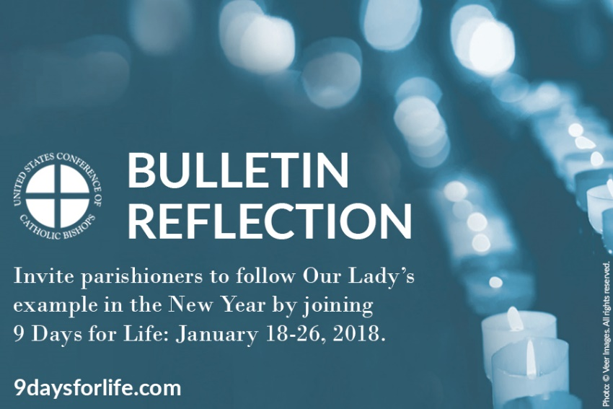](http://www.usccb.org/about/pro-life-activities/january-roe-events/living-out-christmas-in-the-new-year.cfm)****Recommended dates are provided, but you are welcome to use these materials at any time!*

**FEATURED THIS MONTH**

**WHAT:** A brief reflection inviting people to join 9 Days for Life from January 18 – January 26, 2018.

**WHEN:** Suggested for use the weekend of December 30-31 or the weekend of January 6-7, but can be used any time.

**WHERE:** Use for your parish bulletin, e-newsletter(s), website, social media, or anywhere else you communicate.

**HOW:** Copy and paste the text below into your bulletin or other communications. Download the image below, and use it with the text or on its own.

[](http://www.usccb.org/about/pro-life-activities/january-roe-events/upload/new-years-reflection-9-days.jpg)[](http://www.usccb.org/about/pro-life-activities/january-roe-events/living-out-christmas-in-the-new-year.cfm)

**[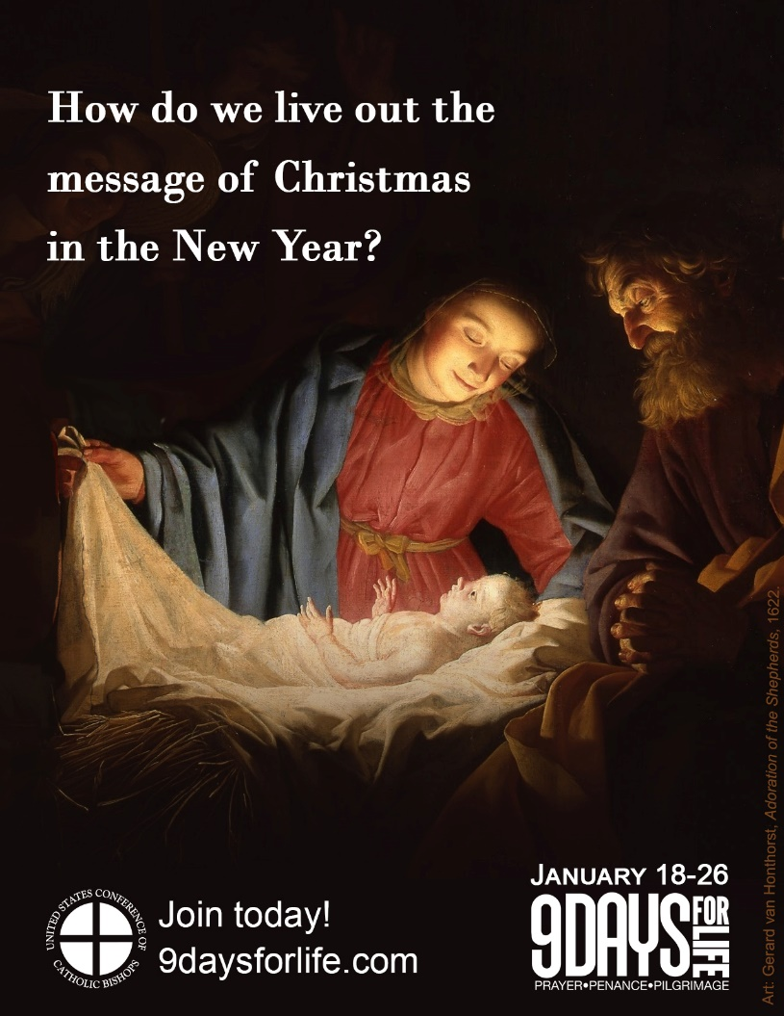](http://www.usccb.org/about/pro-life-activities/january-roe-events/upload/new-years-reflection-9-days.jpg)**

**Living out Christmas in the New Year**

How do we live out the message of Christmas in the New Year, rather than pack it away with the ornaments?

Each year the Octave Day of Christmas falls on the first day of the New Year, on which we also celebrate the Solemnity of the Blessed Virgin Mary, the Mother of God.

Her open heart and courageous “yes” to God show us how to live year-round—with hearts open to the Lord, following where He leads. We are called to place our trust in Him, to enter compassionately into the suffering of others, and to love one another as Christ loves us. Like Our Blessed Mother welcomed Jesus, we are called to cherish and protect the gift of human life, at every stage and in every circumstance.

One way to live out the message of Christmas and follow Our Lady’s example is to join 9 Days for Life, a digital pilgrimage of prayer and charitable action.

The U.S. Catholic bishops invite you to join thousands of Catholics nationwide from Thursday, January 18 – Friday, January 26.

Join today at [www.9daysforlife.com](http://www.9daysforlife.com)!

**Word of Life – December 2017**

**Intercessions for Life**

**December 3rd First Sunday of Advent**

For Catholics:

May God keep us steadfast in protecting   
the sacred gift of human life;

*We pray to the Lord:*

**December 8th Solemnity of the Immaculate Conception**

May our Blessed Mother help us trust in God,

that we may peacefully care for those

whose lives are entrusted to us;

*We pray to the Lord:*

**December 10th Second Sunday of Advent**

For those grieving after abortion:

May they trust in God’s patient mercy

and find healing through his Church;

*We pray to the Lord:*

**December 17th Third Sunday of Advent**

For those who feel lonely or abandoned:

May their hearts be consoled by

the genuine and loving care of others;

*We pray to the Lord:*

**December 24th** **Fourth Sunday of Advent**

For couples longing for a child:

May God strengthen and comfort them

as they strive to follow his plan;

*We pray to the Lord:*

**December 25th The Nativity of the Lord**

For new parents:

May family and friends

provide ongoing support

as they welcome their child;

*We pray to the Lord:*

**December 31th The Holy Family of Jesus, Mary,**

For families in times of illness: **and Joseph**

May they find strength and hope

in the example of the Holy Family;

*We pray to the Lord:*

**Word of Life – December 2017**

**Bulletin Quotes**

|  |  |
| --- | --- |
| **December 3rd**  “When we encounter Christ, experience his love, and deepen our relationship with him, we become more aware of our own worth and that of others.”  USCCB Secretariat of Pro-Life Activities  “How to Build a Culture of Life,” [www.goo.gl/yAt6Gk](http://www.goo.gl/yAt6Gk) | [RLP 2017](http://store.usccb.org/How-to-Build-a-Culture-of-Life-p/c1742.htm) [Order](http://store.usccb.org/How-to-Build-a-Culture-of-Life-p/c1742.htm) [Download](http://www.usccb.org/about/pro-life-activities/respect-life-program/2017/respect-life-program-2017-articles.cfm#build) |
| **December 10th**  “If you know someone who has had an abortion, express your sympathy for her loss. Assure her of God’s unconditional love, and encourage her to seek healing and forgiveness.”  USCCB Secretariat of Pro-Life Activities  “Bridges of Mercy for Post-Abortion Healing,” [www.goo.gl/MpC7RG](http://www.goo.gl/MpC7RG) | [Bridges of Mercy for Post-Abortion Healing](http://store.usccb.org/Bridges-of-Mercy-for-Post-Abortion-Healing-p/c1641.htm) [Order](http://store.usccb.org/Bridges-of-Mercy-for-Post-Abortion-Healing-p/c1641.htm) [Download](http://www.usccb.org/about/pro-life-activities/respect-life-program/2016/respect-life-program-2016-articles.cfm#healing) |
| **December 17th**  “He is *always* with us. Jesus promised this when he gave the disciples the same mission he gives to each of us: Go. … Walk with each other. Do not be afraid to embrace God’s gift of life. Whatever storms or trials we face, we are not alone. He is with us.”  USCCB Secretariat of Pro-Life Activities  2017-18 Respect Life Reflection, [www.bit.ly/2x31e1X](http://www.bit.ly/2x31e1X) | [RLP 2017](http://www.usccb.org/about/pro-life-activities/respect-life-program/2017/2017-18-respect-life-reflection.cfm) [Order](http://store.usccb.org/2017-2018-Respect-Life-Program-Reflection-Flyer-p/c1706.htm) [Download](http://www.usccb.org/about/pro-life-activities/respect-life-program/2017/2017-18-respect-life-reflection.cfm) |
| **December 25th**  “An unexpected pregnancy can be a difficult and frightening time, and it’s important that your friend knows you are thinking of her and supporting her. …Your support might be the only support she receives. Even if we never know how, the smallest things we do can change someone’s life.”  USCCB Secretariat of Pro-Life Activities  “10 Ways to Support Her When She’s Unexpectedly Expecting,” [www.bit.ly/10WaysRespectLife](http://www.bit.ly/10WaysRespectLife) | [Order](http://store.usccb.org/10-Ways-to-Support-Her-When-She-s-Unexpectedly-Exp-p/c1541.htm) [Download](http://www.usccb.org/about/pro-life-activities/respect-life-program/2015/upload/10-ways-to-support-her-when-she-is-unexpectedly-expecting-eng-2.pdf) |
| **December 31st**  “Your own quiet, patient presence can provide important support as your loved one prepares emotionally and spiritually for his or her passing.”  USCCB Secretariat of Pro-Life Activities  “Caring for Loved Ones at Life’s End,” [www.goo.gl/fvSEYp](http://www.goo.gl/fvSEYp) | [Order](http://store.usccb.org/Caring-for-Loved-Ones-at-Life-s-End-p/c1642.htm) [Download](http://www.usccb.org/about/pro-life-activities/respect-life-program/2016/respect-life-program-2016-articles.cfm#caring) |

**Word of Life - December 2017**

**Bulletin Art**

*You are welcome to use these and other downloadable images from the online* [**Respect Life image gallery**](http://www.usccb.org/about/pro-life-activities/respect-life-program/respect-life-image-gallery.cfm)*, provided they are not altered in any way, other than the size. Thank you!*

**Sunday, December 10th, 2017**

*If you have any issues with file security settings, please email* [prolife@usccb.org](mailto:prolife@usccb.org)*.*

**Featuring “**[**Bridges of Mercy for Post-Abortion Healing**](http://www.usccb.org/about/pro-life-activities/respect-life-program/2016/bridges-of-mercy-for-post-abortion-healing.cfm)**”**

* Bulletin Insert: [English](http://www.usccb.org/about/pro-life-activities/respect-life-program/2016/upload/rlp-16-flyer-bridges-of-mercy-for-post-abortion-healing.pdf) | [Spanish](http://www.usccb.org/about/pro-life-activities/respect-life-program/2016/upload/rlp-16-flyer-abortion-spanish.pdf) ([other formats](http://www.usccb.org/about/pro-life-activities/respect-life-program/2016/respect-life-program-2016-articles.cfm#healing))
* Download Image: [English](http://www.usccb.org/about/pro-life-activities/respect-life-program/2016/upload/rlp-16-shareable-image-bridges-of-mercy-3.jpg) | [Spanish](http://www.usccb.org/about/pro-life-activities/respect-life-program/2016/upload/rlp-16-shareable-image-bridges-of-mercy-3-spa.jpg)

[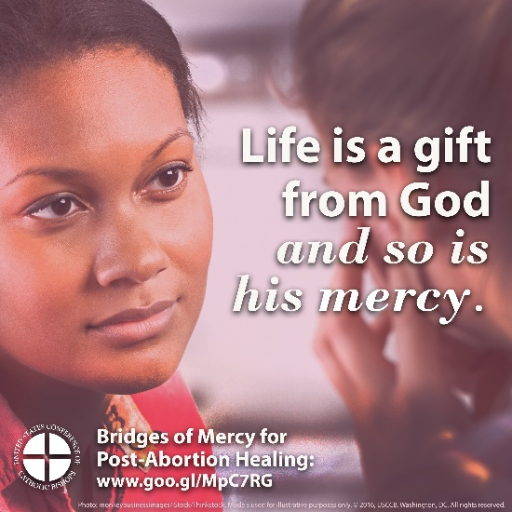](http://www.usccb.org/about/pro-life-activities/respect-life-program/2016/upload/rlp-16-shareable-image-bridges-of-mercy-3.jpg)

**Sunday, December 24th, 2017**

**Featuring “**[**10 Ways To Support Her When She's Unexpectedly Expecting**](http://www.usccb.org/about/pro-life-activities/respect-life-program/2015/10-ways-to-support-her-when-shes-unexpectedly-expecting.cfm)**”**

* Bulletin Insert (color): [English](http://www.usccb.org/about/pro-life-activities/respect-life-program/2015/upload/10-ways-to-support-her-when-she-is-unexpectedly-expecting-eng-2.pdf) | [Spanish](http://www.usccb.org/about/pro-life-activities/respect-life-program/2015/upload/10-ways-to-support-her-when-she-is-unexpectedly-expecting-esp.pdf)
* Bulletin Insert (grayscale): [English](http://www.usccb.org/about/pro-life-activities/respect-life-program/2015/upload/B-W-10Ways.pdf) | [Spanish](http://www.usccb.org/about/pro-life-activities/upload/B-W-10Ways-Spanish.pdf)
* Download Image: [English](http://www.usccb.org/about/pro-life-activities/respect-life-program/2015/upload/2015-rlp-shareable-graphic-18.jpg) | [Spanish](http://www.usccb.org/about/pro-life-activities/respect-life-program/2015/upload/shareable-graphic-18-2015-rlp-spanish.jpg)

[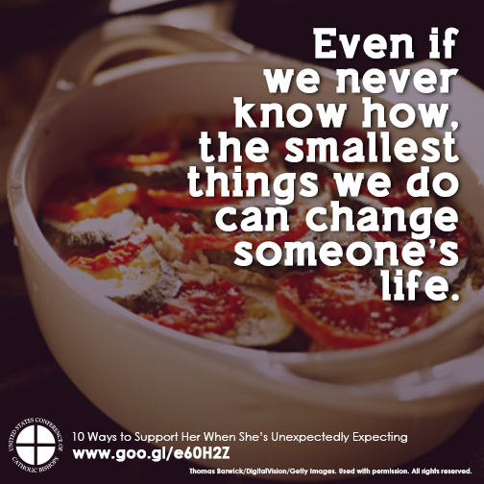](http://www.usccb.org/about/pro-life-activities/respect-life-program/2015/upload/2015-rlp-shareable-graphic-18.jpg)