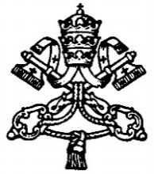

PONTIFICAL COUNCIL FOR
INTERRELIGIOUS DIALOGUE

Christians and Jains:
together to promote care for the elderly

Message for Mahavir Jayanti
2015

Vatican City

Dear Jain Friends,

- The Pontifical Council for Interreligious Dialogue most happily extends its greetings to you on the Birth Anniversary of Tirthankar (Path-Finder) Vardhaman Mahavir celebrated worldwide on 2 April this year. May the celebrations marking the feast reinforce and rejuvenate friendship and fellowship among individuals and families, as well as, strengthen your commitment to promote the care of all beings, especially the elderly in the families and communities, for enhanced peace, harmony and happiness in the world.

- Carrying forward our cherished tradition, this year we reflect on how we, both Christians and Jains, can together promote the care of the elderly. In many societies across the world people tend to reject the elderly. Also worrisome and deplorable is the fact that many elderly people, especially the sick and lonely, are abandoned by their families and relatives because they feel these are a bother, burden and waste, or these are treated as the neo-outcaste of the contemporary world served with a modicum of contact and care. This trend is growing and causing concern for our society. Pope Francis rightly points out that every society “where the elderly are discarded carries within it the virus of death”(To Participants in the Plenary of the Pontifical Academy for Life, 5 March 2015) and a people “who don’t protect their elderly…is a people without a future, a people without hope”(Address to the Sant’Egidio Community, 15 June 2014). The task of guaranteeing the care due to the elderly, therefore, becomes a noble priority for all, as well as, an ethical imperative binding on all governments and political communities.

- The elderly are the primary pillars of our multi-generational families. They live with us as our treasure and blessing because they transmit to us not only their rich life and faith experiences but also the history of our families and communities. These ‘treasures’ are to be fondly protected and gratefully cared for so that they continue to inspire and guide people with their wisdom of a lifetime. There is no denying the fact that there is still a large number of families around the world that, true to their traditions, values and convictions, gives exemplary care to their aged: Children in these families and even their relatives and friends often make great sacrifices and go an extra mile to serve the elderly. This is praiseworthy because they are doing what is right and just in respect of their parents, grandparents and relatives who are old and in need of care, attention and assistance. While looking after the elderly is a sacred and moral duty binding on individuals and society, the professional and medical assistances offered by competent and charitable healthcare workers are best seen as steps the society takes towards ensuring care for the elderly.

- All religions expound the moral obligations the children have towards their parents and elders, especially caring for them, with respect and love, till the end of their earthly life. The Holy Bible says, “Honour your father and mother, so that your days may be long in the land that the Lord your God is giving you” (Exodus 20:12). But it also says, “If anyone does not provide for his relatives and especially for members of his household, he has denied the faith and is worse than an unbeliever” (1 Timothy 5:8). Jainism lays so much emphasis on respect for life; in regard to humans this respect means upholding the dignity of every person and all that it entails.

- The growing neglect of the elderly by the young and the tendency to abdicate filial responsibility towards the parents and grandparents, therefore, invite us all, believers and others, to re-awaken in us, both at a personal and collective level, a sense of gratitude, affection and responsibility towards our parents, grandparents and other elderly people. Making them feel that they are a living part of our families, communities and society and that we are ever indebted to them is a sure way of challenging the ‘throw- away’ culture. This is possible only “with the superabundant joy of a new embrace between the young and the elderly” (Pope Francis, General Audience, 11 March 2015). May we Christians and Jains, as persons grounded in our own respective religious traditions and conscious of our shared responsibility towards the society, joining hands with others, promote a culture where the elderly are loved, respected and cared for.

Wish you all A Happy Mahavir Jayanti!
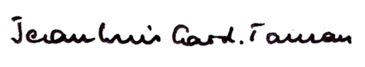

Jean-Louis Cardinal Tauran
President

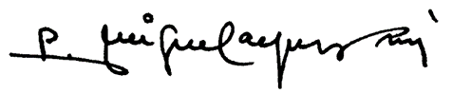

Father Miguel Ángel Ayuso Guixot, MCCJ
Secretary

Pontifical Council for Interreligious Dialogue
00120 Vatican City

Tel: +39.06.6988 4321
Fax: +39.06.6988 4494

E-mail: dialogo@interrel.va
http://www.pcinterreligious.org/

