Social Media Tool Kit

Post 1: Before the Collection
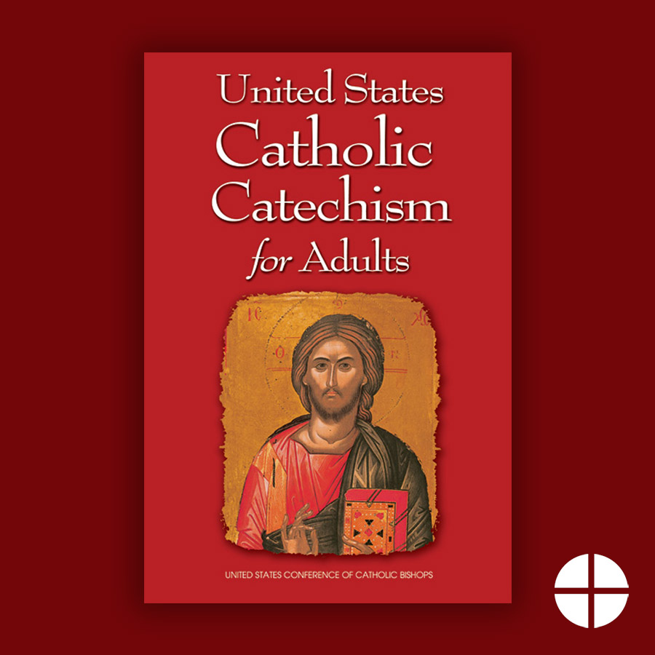
Facebook/Instagram:
Faith fundamentals are a click away with the online version of the popular “United States Catholic Catechism for Adults,” made possible in part by the Catholic Communication Campaign. Support the collection at Mass! #1church1mission #ConnectWithChrist http://ccc.usccb.org/flipbooks/uscca/
Twitter:
Online “US Catholic Catechism for Adults” made possible by Catholic Communication Campaign. Support the collection! http://ccc.usccb.org/flipbooks/uscca/
Post 2: Before the Collection
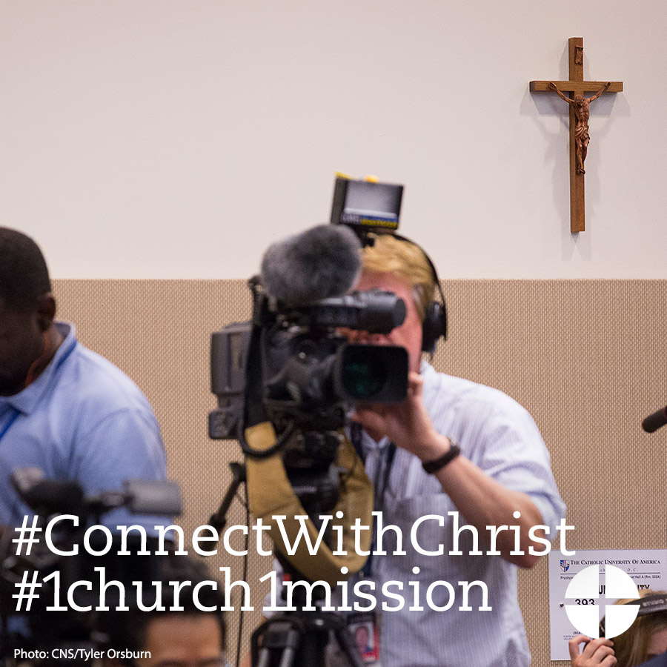
Facebook/Instagram:
Help people connect with Christ by supporting the Catholic Communication Campaign! #1church1mission #ConnectWithChrist Learn more: www.usccb.org/ccc

Twitter:
Help people connect with Christ by supporting the Catholic Communication Campaign! #ConnectWithChrist Learn more: www.usccb.org/ccc

Post 3: Week of the Collection
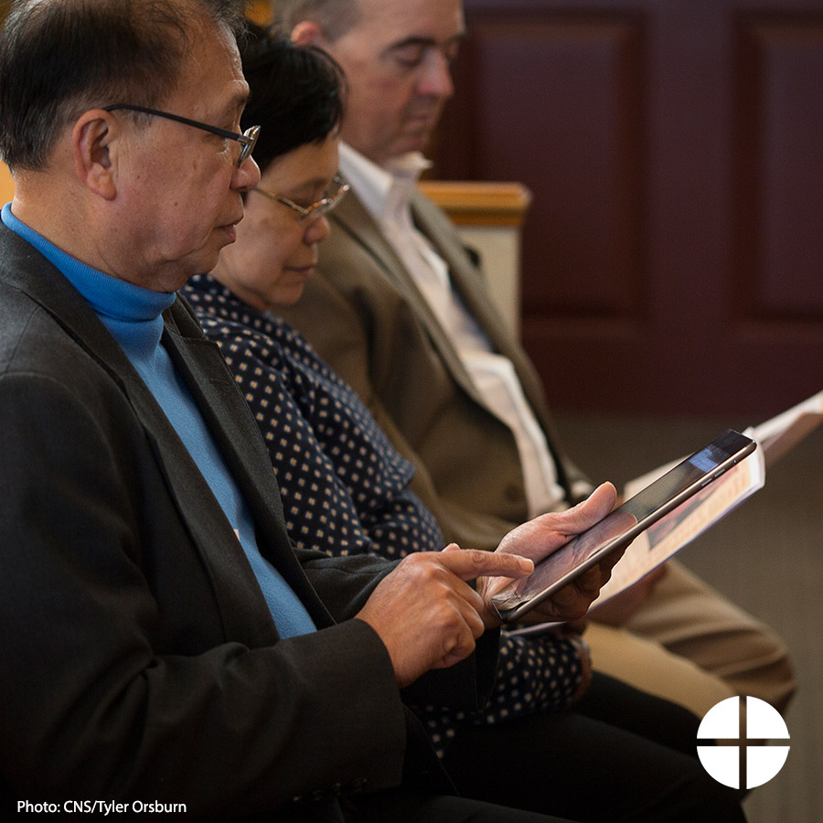
Facebook/Instagram:
The Catholic Communication Campaign supports communications projects here in the US and abroad. And half of the funds collected stay in our diocese to support local projects! Please be generous to the collection! #1church1mission #ConnectWithChrist www.usccb.org/ccc

Twitter:
DYK that half of the contributions to the Catholic Communication Campaign stay in our diocese for local projects? www.usccb.org/ccc

Post 4: Week of the Collection
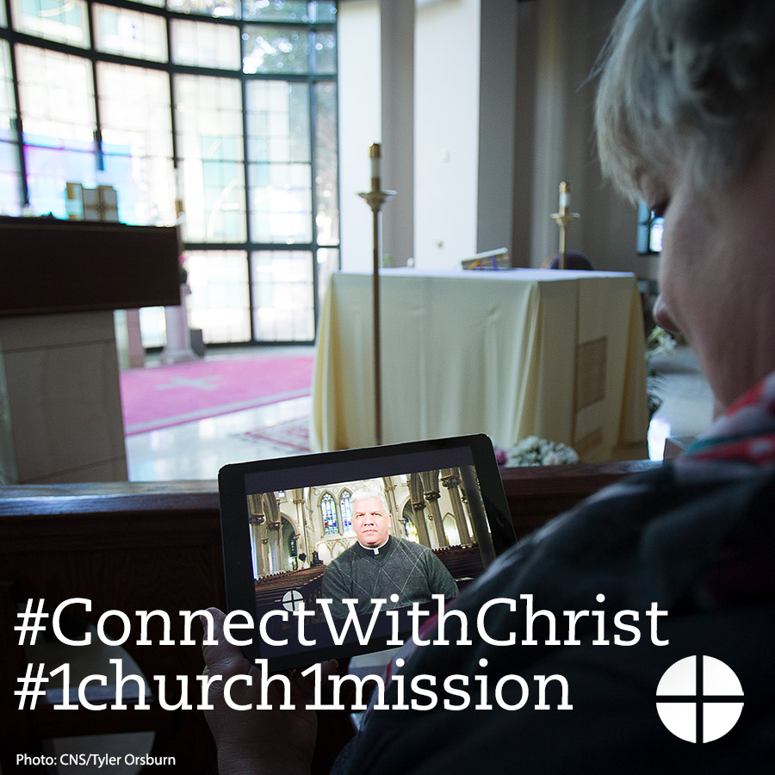
Facebook/Instagram:
Your support of the Catholic Communication Campaign (CCC) brings the message of #PopeFrancis to all. Give to the CCC at Mass! #1church1mission www.usccb.org/ccc

Twitter:
Share the message of #PopeFrancis & support the Catholic Communication Campaign at Mass! http://goo.gl/GnQB9O

Post 5: Week of the Collection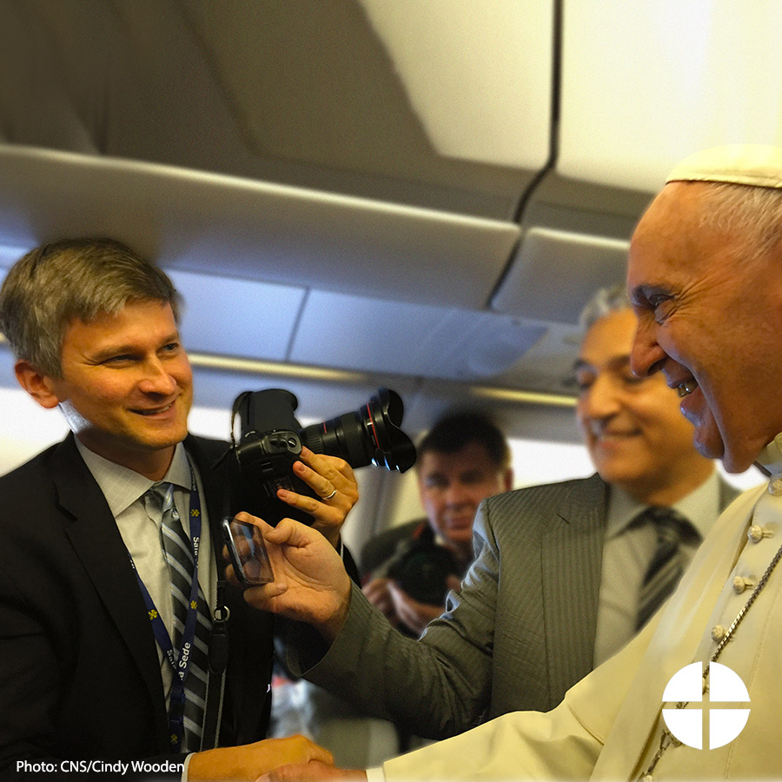
Facebook/Instagram:
Support the Catholic Communication Campaign at Mass and connect people around the world with Christ. #1church1mission #ConnectWithChrist www.usccb.org/ccc

Twitter:
Support the Catholic Communication Campaign and connect people around the world with Christ! #1church1mission www.usccb.org/ccc

Post 6: Week of the Collection
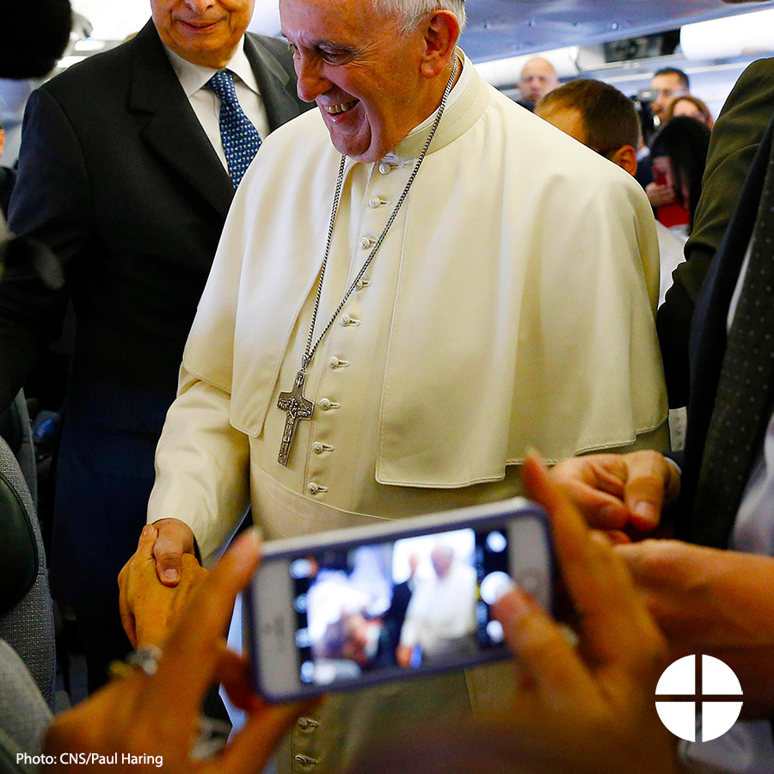
Facebook/Instagram:
The Catholic Communication Campaign is this weekend! Half of the proceeds stay here in the diocese to support our communications projects, while the other half supports national and international communications efforts! Please be generous! #1church1mission #ConnectWithChrist http://goo.gl/GnQB9O

Twitter:
The Catholic Communication Campaign is this weekend! Support the collection at Mass #1church1mission http://goo.gl/GnQB9O

Post #7: Week of the Collection
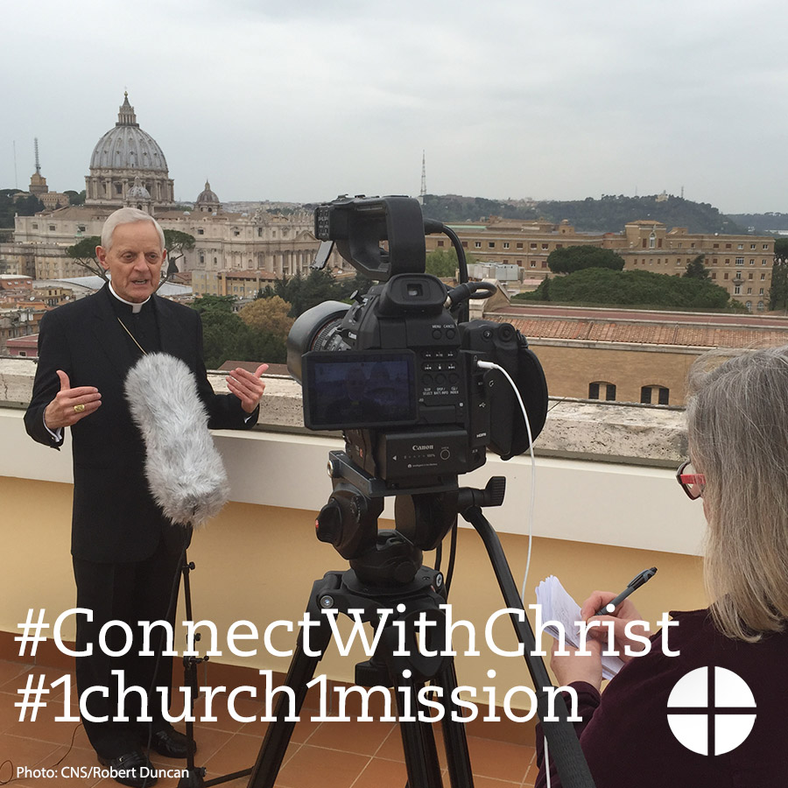
Facebook/Instagram:
Help share the Gospel message and connect with Christ! The Catholic Communication Campaign is this weekend. #1church1mission #ConnectWithChrist www.usccb.org/ccc

Twitter:
Help share the gospel message and connect with Christ! The Catholic Communication Campaign is this weekend! www.usccb.org/ccc

Post #8: Day of the Collection
Facebook/Instagram:
Today is the collection for the Catholic Communication Campaign! Don't forget to support the collection this weekend and share the good news. #1church1mission #ConnectWithChrist http://goo.gl/GnQB9O

Twitter:
Today is the Catholic Communication Campaign! Support the collection at Mass! #1church1mission http://goo.gl/GnQB9O

