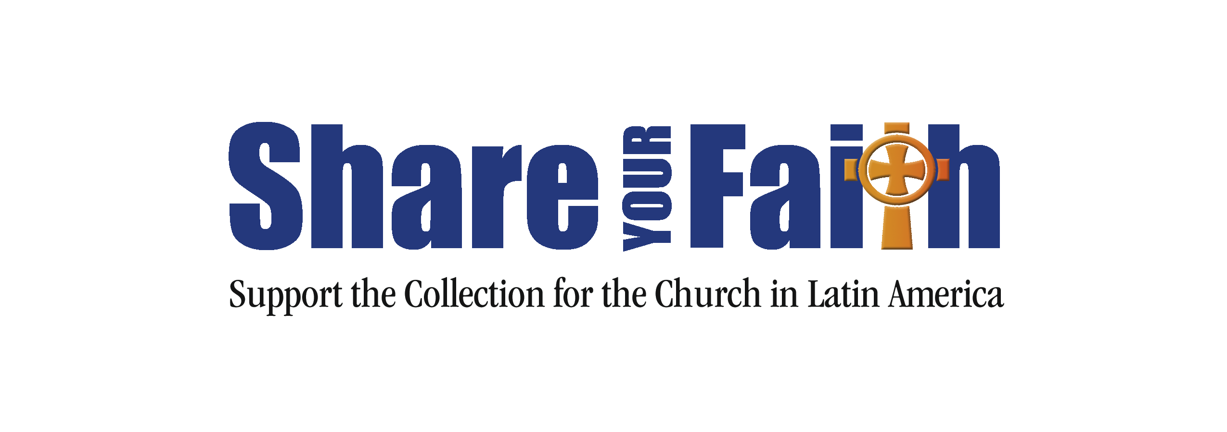
Sample Bishop’s Letter
May be read from the pulpit, inserted into the parish bulletin,
or printed in the (arch)diocesan paper.

Dear Brothers and Sisters in Christ,

This year we celebrate the important milestone of 50 years of solidarity with the Church in Latin America and the Caribbean. The Church there faces many challenges, including lack of access to resources the faithful need to nourish their spiritual lives. Often, there are too few priests to meet the needs of the many communities they serve, or the communities themselves are simply too isolated to have access to other important resources for the faith. Strategies to train and support evangelization leaders are vital to reach those who are disconnected from the life and mission of the Church.
For the past 50 years, the United States Conference of Catholic Bishops through its Subcommittee on the Church in Latin America has helped 25 countries in Central and South America as well as the Caribbean confront challenges to the faith. With your help and the support of the Catholic faithful, we have helped develop evangelization and catechetical programs. We have also funded activities that promote an encounter with Jesus Christ, so that the faithful can become missionary disciples.
For example, in the Diocese of Garzon, Colombia, the parish of Our Lady of Guadalupe is blessed with a large community; however, there are only a few priests to address its many needs. Through a grant from the Collection for the Church in Latin America, the parish was able to train pastoral and evangelization leaders for the parish community. These leaders participated in formation on leadership and teaching catechesis, as well as in spiritual retreats, so they could reach out to the larger community. The parish also created “Catholic Faith” kits to aid in evangelization and teaching catechesis to those in the community. Through this project, the parish was able to achieve its goal of creating an evangelization program that can reach the 3,700 families of the parish.
Our (arch)diocese takes up this collection the weekend of [insert date here]. Please be generous in this collection, and take this opportunity to share your faith with families in Latin America and the Caribbean. Your support will truly make a difference. Thank you and God bless you for your generosity.
Sincerely yours in Christ,

(Bishop’s name, title, and signature)

For more information on the Church in Latin America and the projects funded by the collection,
please visit www.usccb.org/latin-america.

