Social Media Tool Kit

Facebook
- Check out how the Collection for the Church in Latin America helped to translate the catechism into the Mayan language Q’eqchi’ for the first time and support the collection at Mass! #ShareYourFaith #1church1mission https://goo.gl/ZTq2zZ
- The Collection for the Church in Latin America is an opportunity to #ShareYourFaith with our brothers and sisters in Latin America and the Caribbean. Please be generous to the collection at Mass!
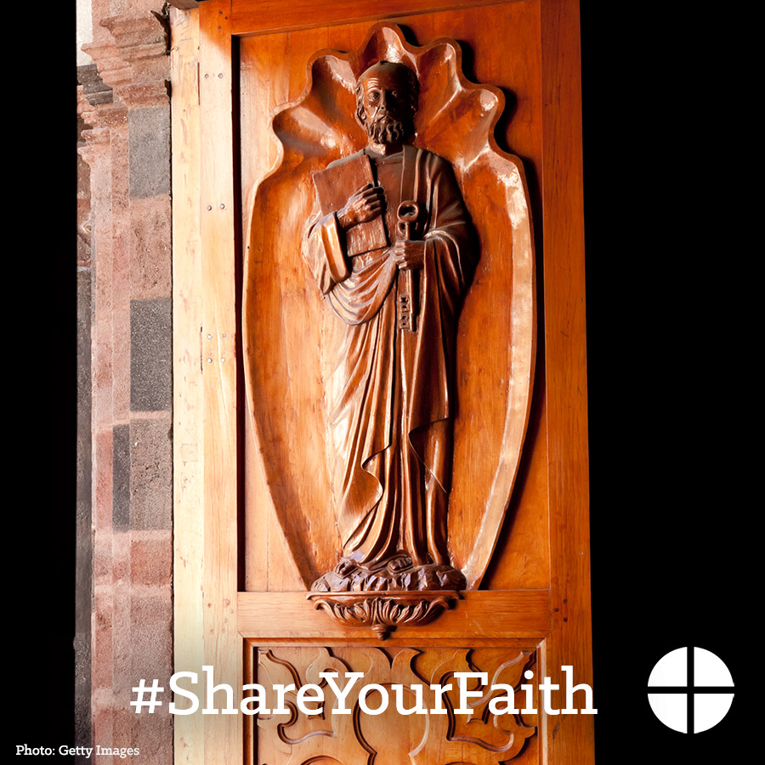

- For over 50 years, the Collection for the Church in Latin America has been a way for us to be in solidarity with our brothers and sisters in Latin America and the Caribbean. Support the collection at Mass! #ShareYourFaith #1church1mission http://goo.gl/b8FxQB
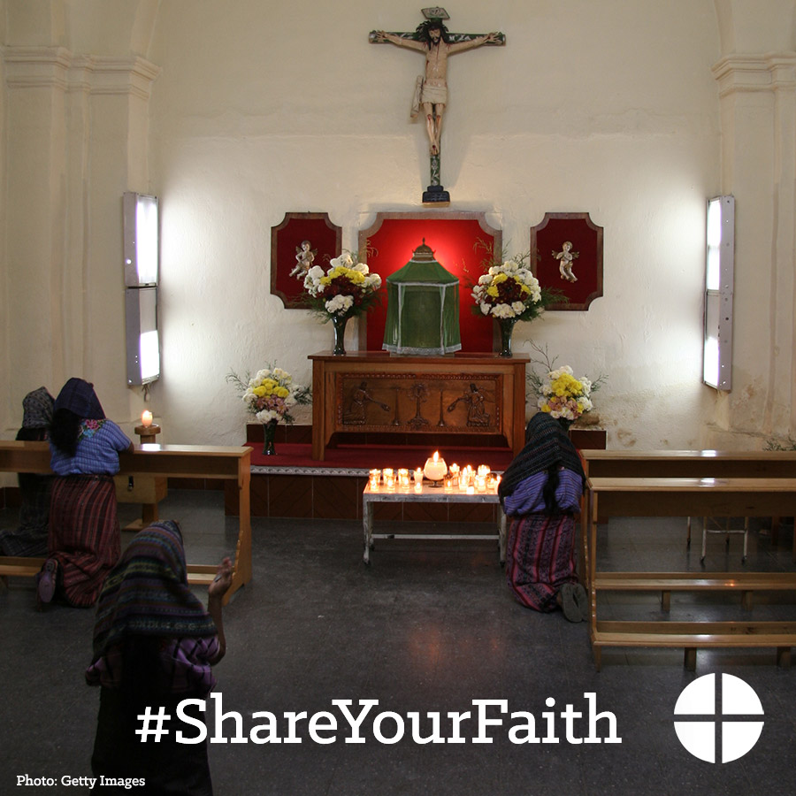

- #ShareYourFaith and support the Collection for the Church in Latin America this weekend at Mass! #1church1mission http://goo.gl/b8FxQB
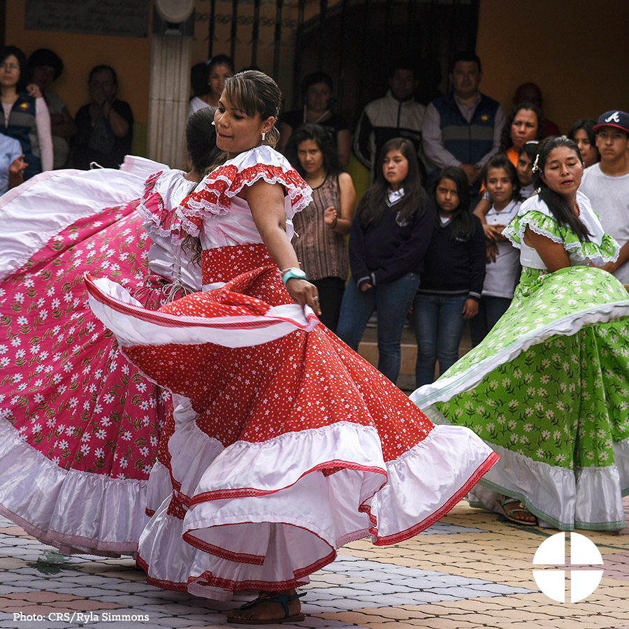
- This weekend, our second collection is for the Church in Latin America. Funds collected will go to support seminary formation, family ministry, and lay leadership training for those in need in Latin America and the Caribbean. Please be generous! #ShareYourFaith #1church1mission http://goo.gl/b8FxQB
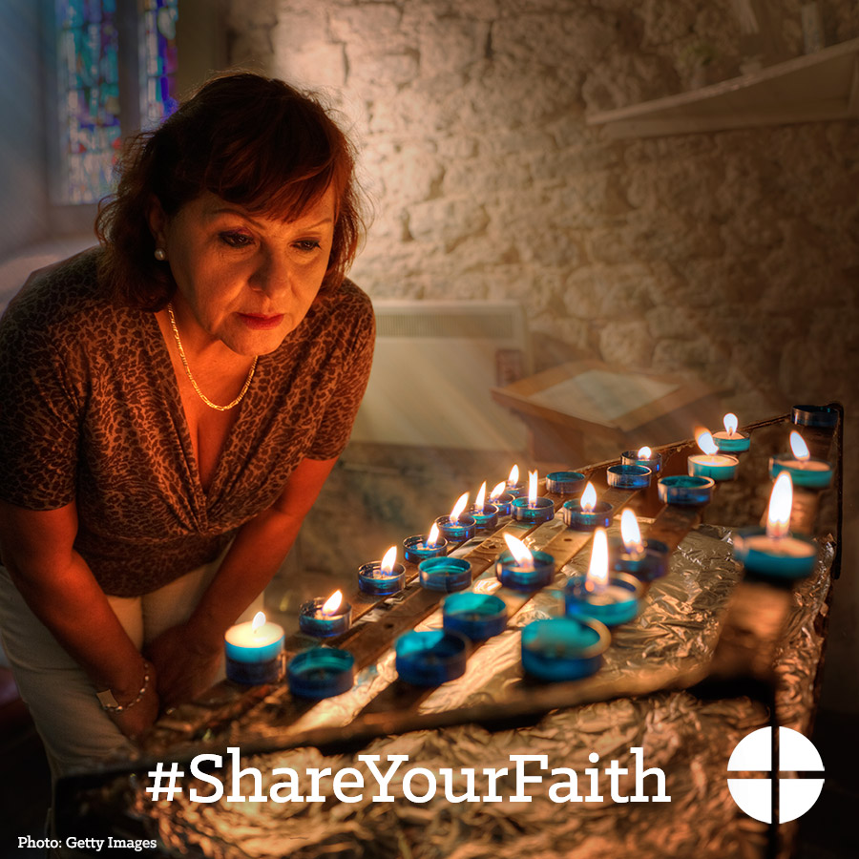
- Bishop Eusebio Elizondo tells how donations to the Collection for the Church in Latin America helped one parish in El Salvador. This is one example of many! Support the Collection for the Church in Latin America! #ShareYourFaith #1church1mission https://goo.gl/Nxuopf
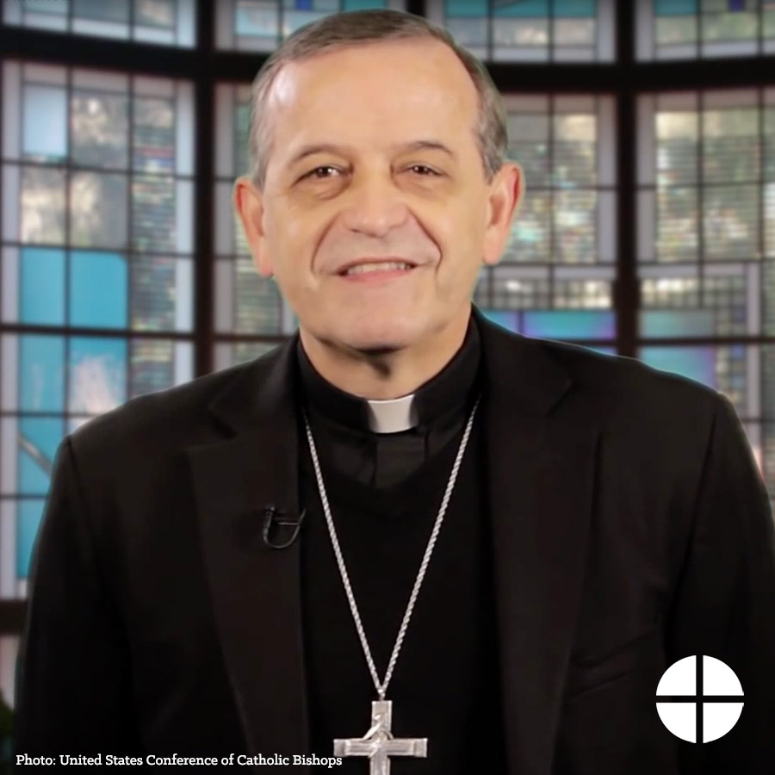
- This weekend is the Collection for the Church in Latin America! Your support will help fund projects throughout Latin America and the Caribbean to build the faith of the people there! #ShareYourFaith
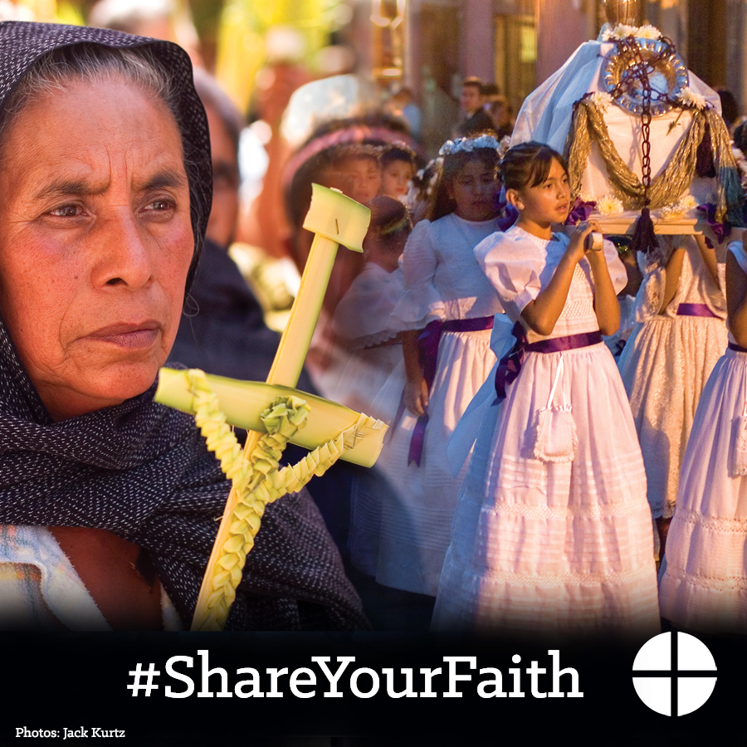
Twitter
- The Collection for the Church in Latin America helped translate the catechism into Q’eqchi’ #ShareYourFaith https://goo.gl/ZTq2zZ
- The Collection for the Church in Latin America is a way to be in solidarity. Support the collection at Mass! http://goo.gl/b8FxQB
- #ShareYourFaith, and support the Collection for the Church in Latin America this weekend at Mass! #1church1mission http://goo.gl/b8FxQB
- Our second collection this week is for the Church in Latin America. Please be generous! #ShareYourFaith http://goo.gl/b8FxQB
- A message from Bishop Elizondo about the Church in Latin America. Collection is this weekend! #ShareYourFaith https://goo.gl/Nxuopf

Instagram
- The Collection for the Church in Latin America is an opportunity to #ShareYourFaith with our brothers and sisters in Latin America and the Caribbean. Please be generous to the collection at Mass!
- For over 50 years, the Collection for the Church in Latin America has been a way for us to be in solidarity with our brothers and sisters in Latin America and the Caribbean. Support the collection at Mass! #ShareYourFaith
- #ShareYourFaith, and support the Collection for the Church in Latin America this weekend at Mass!
- This weekend our second collection is for the Church in Latin America. Funds collected will go to support seminary formation, family ministry, and lay leadership training for those in need in Latin America and the Caribbean. Please be generous! #ShareYourFaith

- This weekend is the Collection for the Church in Latin America! Your support will help fund projects throughout Latin America and the Caribbean to build the faith of the people there! #ShareYourFaith

