Social Media Tool Kit

Post 1: Before the Collection
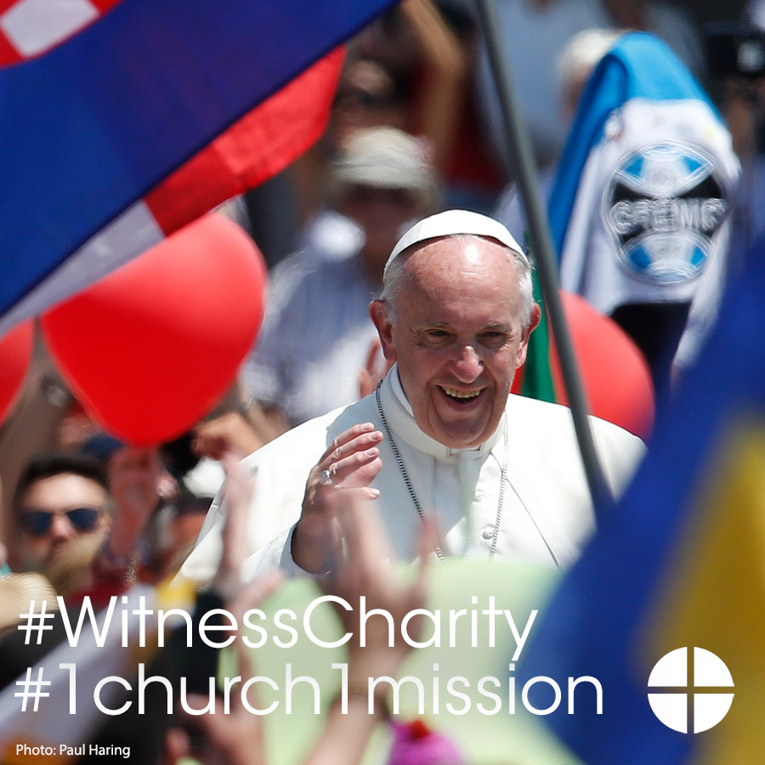
Facebook/Instagram:
Do you follow #PopeFrancis as he travels the world to help the suffering? Support the Peter's Pence Collection to help his message of mercy travel even further. #WitnessCharity #1church1mission
Twitter:
Support the Peter's Pence Collection to help spread Pope Francis's message of mercy. #WitnessCharity #1church1mission www.usccb.org/peters-pence

Post 2: Before the Collection
The link in the posts directs to USCCB website information about Peter's Pence. Be sure to copy the whole link!
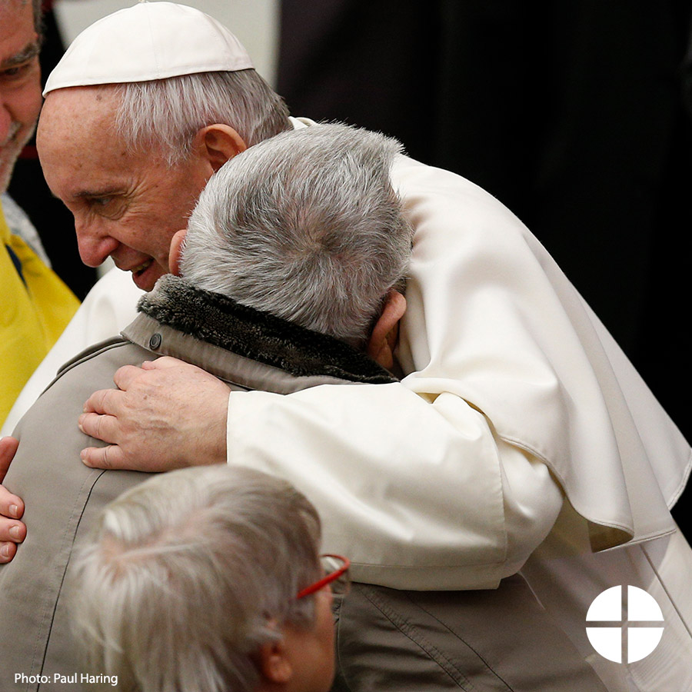
Facebook:
Learn more about the Peter's Pence Collection and support #PopeFrancis and his works! #WitnessCharity #1church1mission http://goo.gl/sDr2tE

Twitter:
Learn about the Peter's Pence Collection and support #PopeFrancis! #WitnessCharity http://goo.gl/sDr2tE

Post 3: Before the Collection
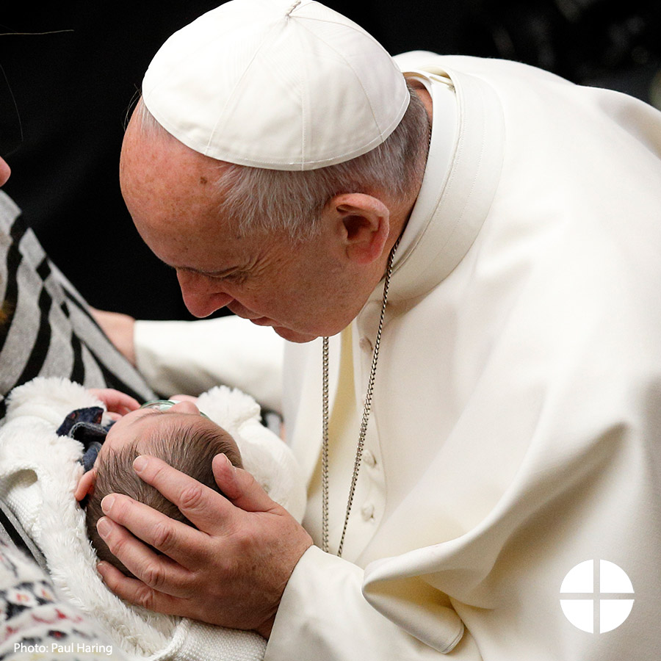
Facebook/Instagram:
Contributions to the Peter's Pence Collection support the charitable works of #PopeFrancis as he reaches out to victims of war and natural disaster. Support the collection at Mass! #WitnessCharity #1church1mission http://goo.gl/sDr2tE

Twitter:
Peter's Pence Collection helps #PopeFrancis serve victims of war & natural disaster. #WitnessCharity http://goo.gl/sDr2tE

Post 4: Before the Collection
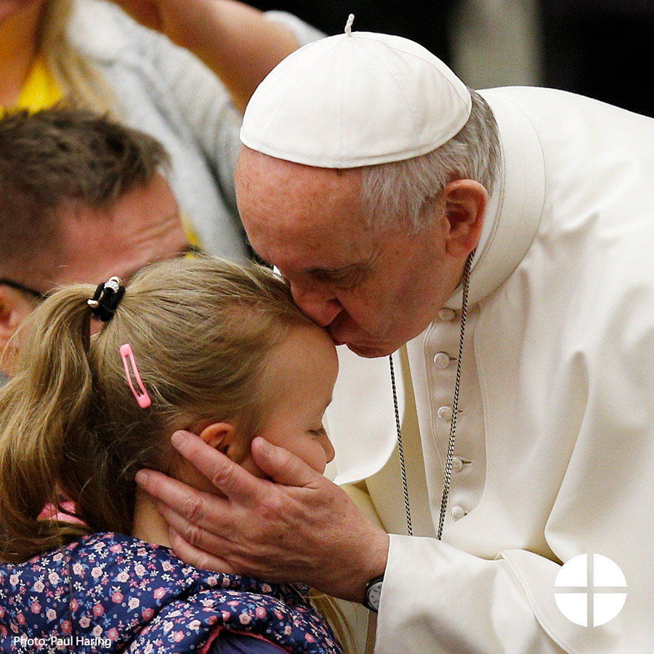
Facebook/Instagram:
Your support of the Peter's Pence Collection goes directly to helping #PopeFrancis and his charitable works. Give at Mass to help spread his message of mercy! #WitnessCharity #1church1mission http://goo.gl/sDr2tE

Twitter:
2nd collection this weekend is for Peter's Pence. Please be generous and help #PopeFrancis. #WitnessCharity http://goo.gl/sDr2tE

Post 5: Week of the Collection
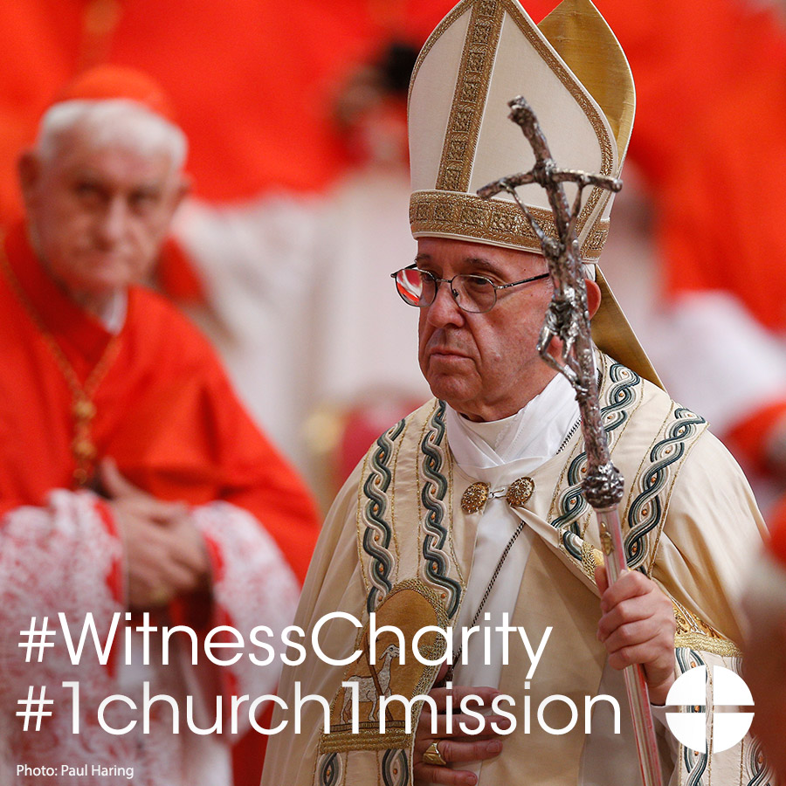
Facebook/Instagram:
Help #PopeFrancis to continue his charitable works, support the Peter’s Pence Collection this weekend at Mass! #WitnessCharity #1church1mission www.usccb.org/peters-pence

Twitter:
Learn how your Peter’s Pence donations allow the Holy Father to continue his charitable works. www.usccb.org/peters-pence

Post 6: Week of the Collection
The link in the posts directs to USCCB website information about Peter's Pence. Be sure to copy the whole link!
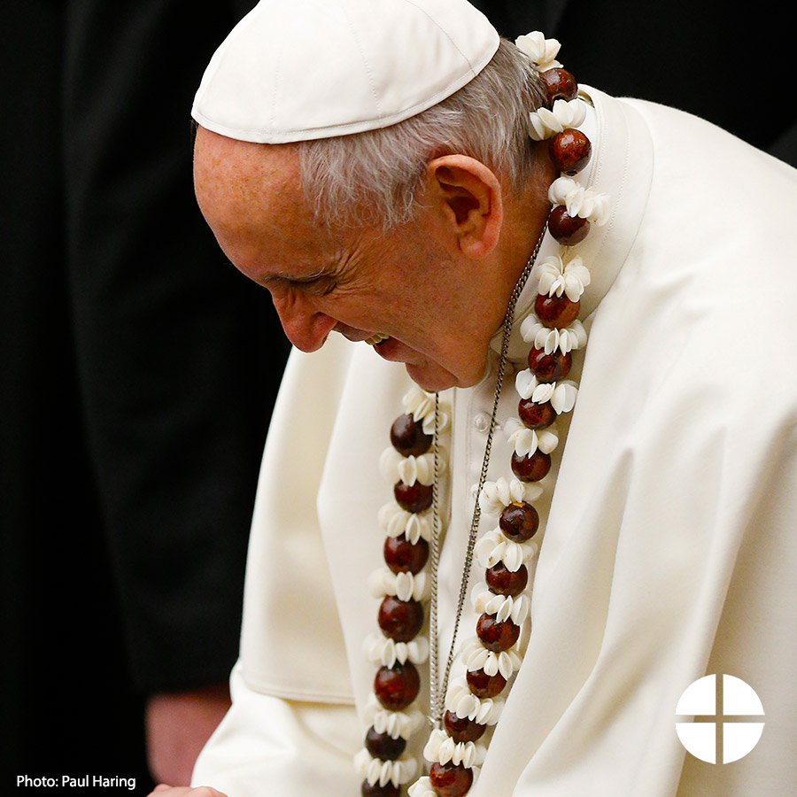
Facebook:
Did you know the Peter's Pence Collection has its roots in ancient Christianity? Learn more about this collection and #WitnessCharity by supporting it this weekend at Mass! #1church1mission http://www.usccb.org/peters-pence

Twitter:
DYK the Peter's Pence Collection has roots in ancient Christianity? #WitnessCharity www.usccb.org/peters-pence

Post 7: Week of the Collection
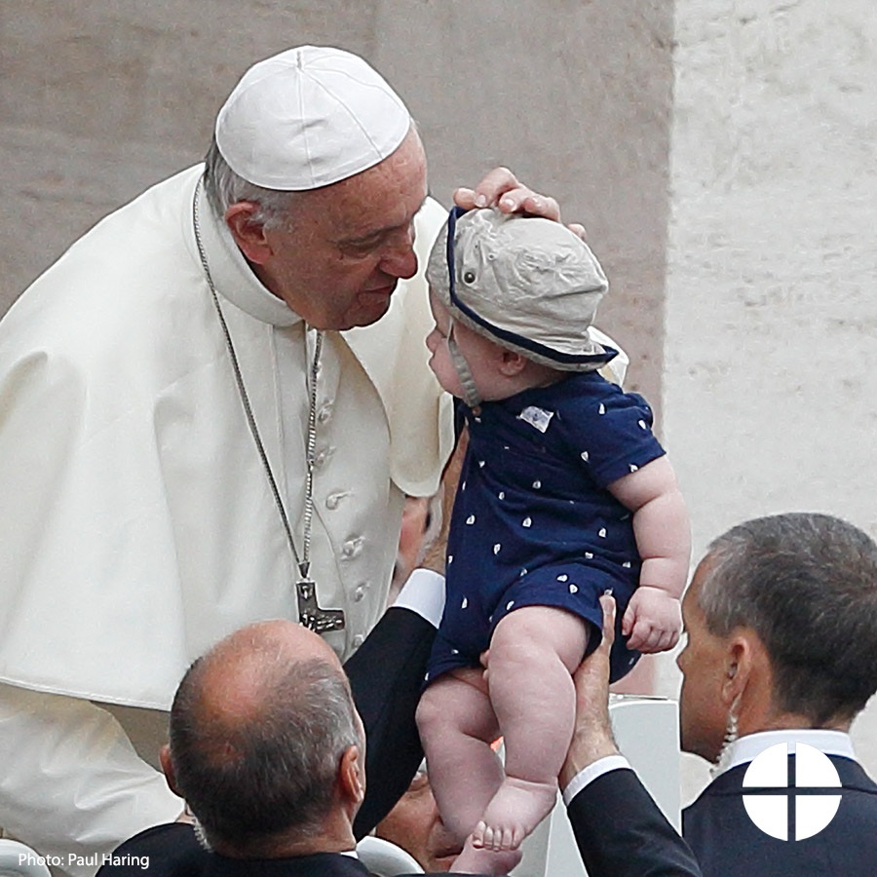
Facebook/Instagram:
Support for the Peter's Pence Collection is support for #PopeFrancis and his works. Please be generous at Mass this weekend! #WitnessCharity #1church1mission www.usccb.org/peters-pence

Twitter:
Support the Peter's Pence Collection and help #PopeFrancis spread his message of mercy! #WitnessCharity http://goo.gl/sDr2tE

Post 8: Day of the Collection
Facebook/Instagram:
Today is the Peter’s Pence Collection! Your generosity will go to Pope Francis and support his charitable works! Please prayerfully consider how you can support the collection this year. #WitnessCharity #1church1mission www.usccb.org/peters-pence

Twitter:
Today is the Peter’s Pence Collection! Your generosity will go to Pope Francis and support his charitable works! www.usccb.org/peters-pence

