Social Media Tool Kit

Facebook
- The Solidarity Fund for the Church in Africa is an opportunity to support the faith of our African brothers and sisters. Please be generous to the collection at Mass! #StandWithAfrica #1church1mission http://goo.gl/whIaol
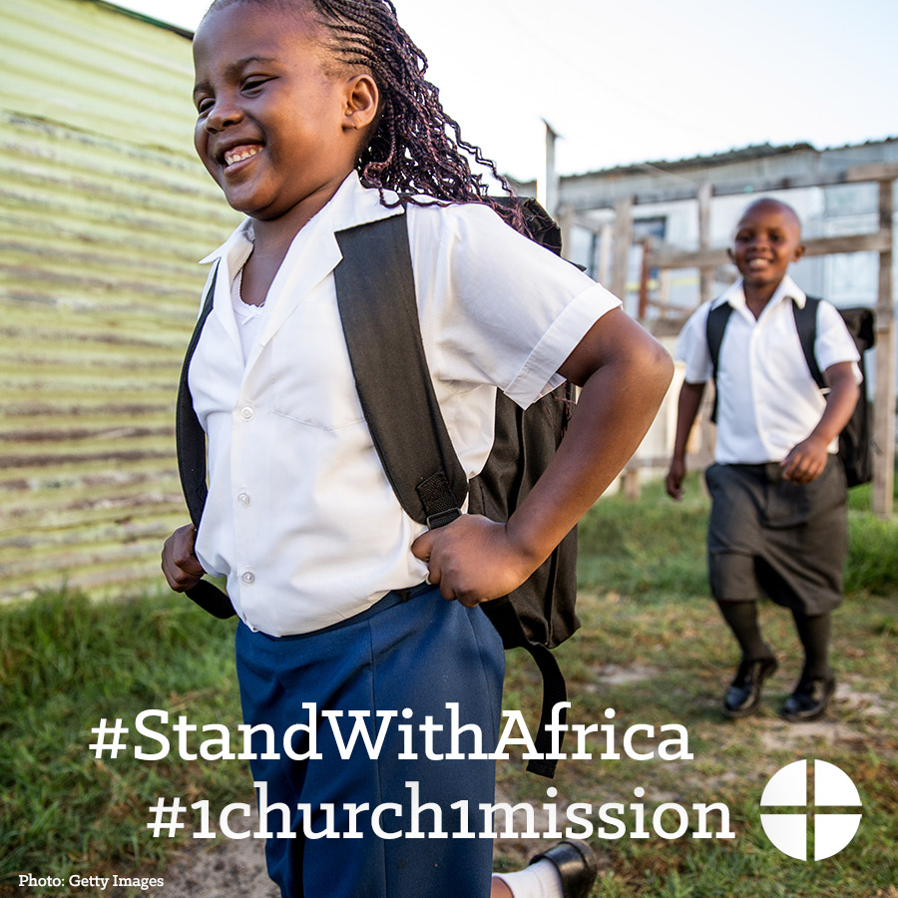

- Despite challenges like migration, disease, and poverty, the Church in Africa continues to grow rapidly. Our second collection this weekend will support the Church in Africa and the faithful there. #StandWithAfrica #1church1mission http://goo.gl/whIaol
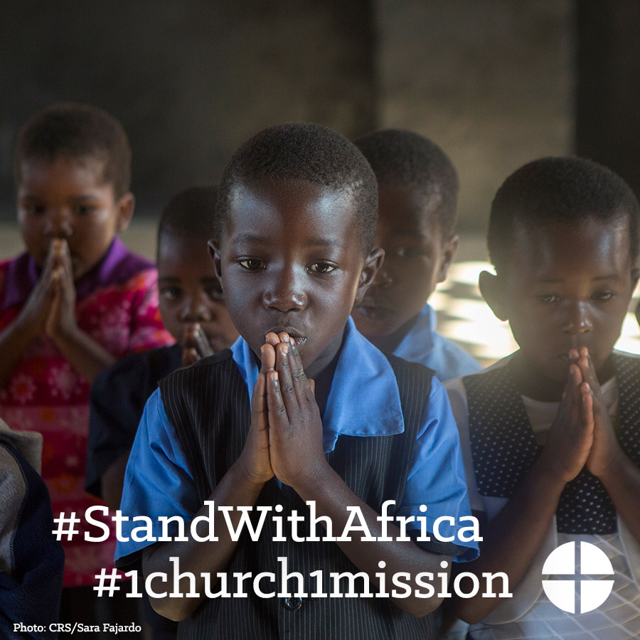

- Your support of the Solidarity Fund for the Church in Africa makes a real difference in the lives of Catholic faithful across the African continent. Please be generous this weekend at Mass! #StandWithAfrica #1church1mission http://goo.gl/whIaol
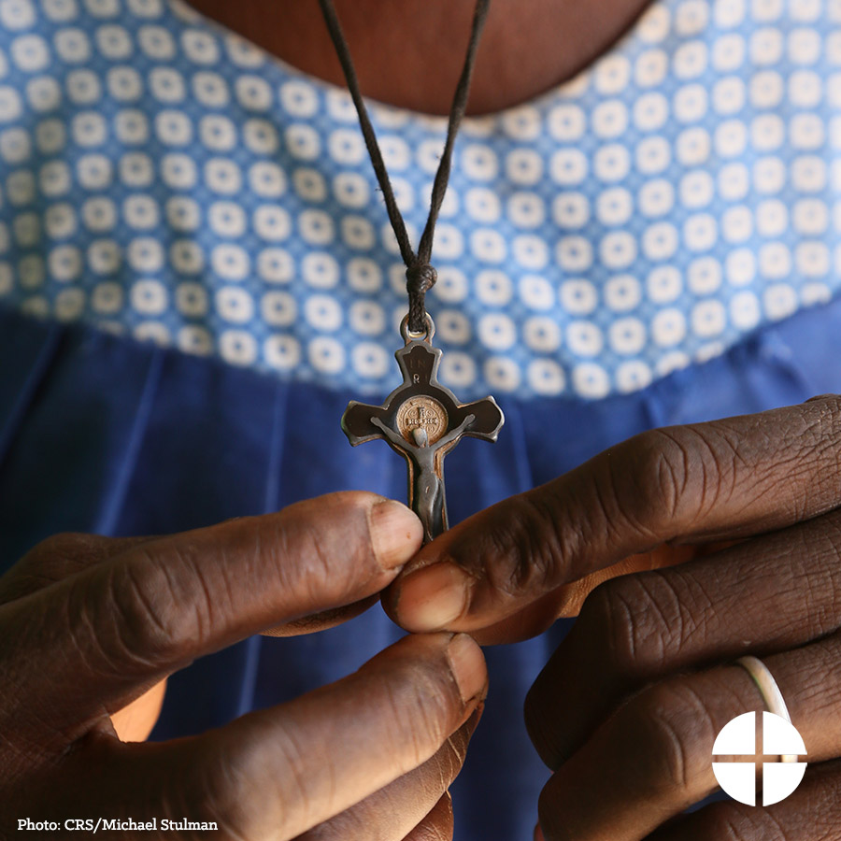

- #StandWithAfrica and support the Solidarity Fund for the Church in Africa! Our second collection this weekend will support pastoral outreach and support to Catholics there. #1church1mission http://goo.gl/whIaol
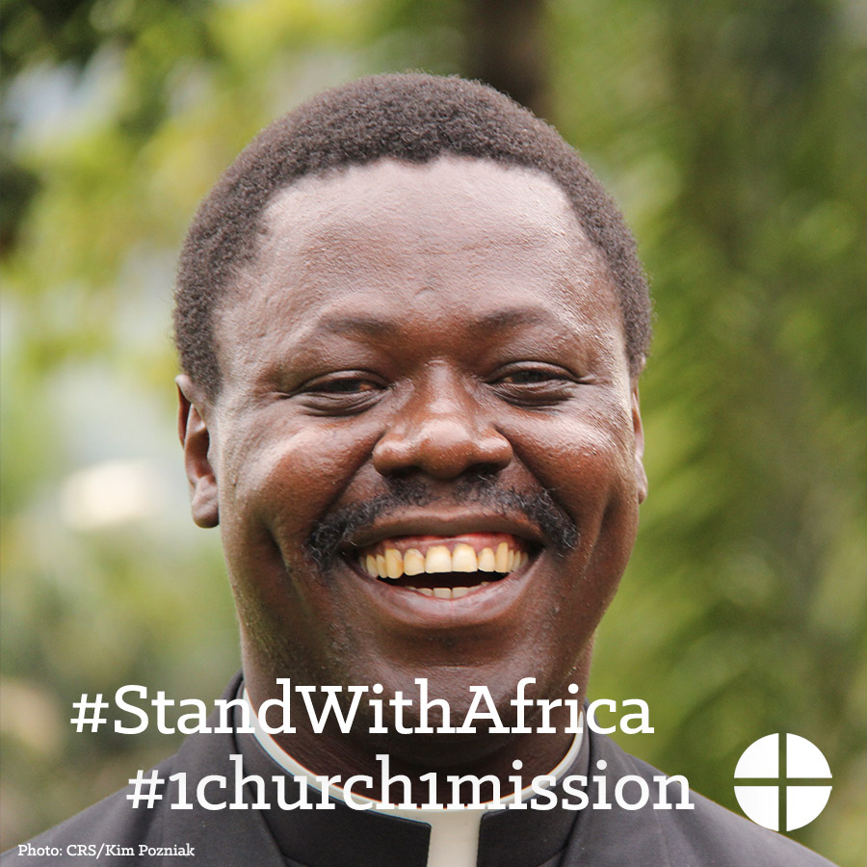

- Our second collection this weekend is for the Solidarity Fund for the Church in Africa. Funds collected support schools, evangelization and outreach projects, and education of clergy and religious. Please be generous and #StandWithAfrica #1church1mission http://goo.gl/whIaol
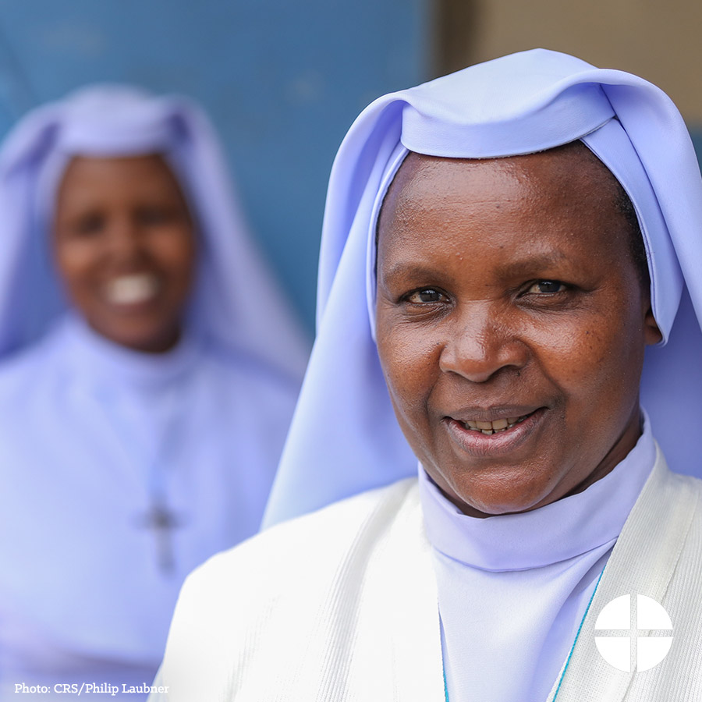

Twitter
- The Solidarity Fund for Africa supports the faith of our brothers and sisters. Please be generous to the collection! #StandWithAfrica
- Despite many challenges, the Church in Africa grows rapidly. Our second collection this weekend will help us #StandWithAfrica.
- Support to the Solidarity Fund for Africa makes a real difference in many lives. Please be generous at Mass! http://goo.gl/whIaol

- Our second collection this weekend will support the pastoral outreach and support to Catholics throughout Africa. #StandWithAfrica
- Our second collection this weekend is for the Solidarity Fund for the Church in Africa. Please be generous! http://goo.gl/whIaol

Instagram
- The Solidarity Fund for the Church in Africa is an opportunity to support the faith of our African brothers and sisters. Please be generous to the collection at Mass! #StandWithAfrica #1church1mission

- Despite challenges like migration, disease, and poverty, the Church in Africa continues to grow rapidly. Our second collection this weekend will support the Church in Africa and the faithful there. #StandWithAfrica #1church1mission

- Your support of the Solidarity Fund for the Church in Africa makes a real difference in the lives of Catholic faithful across the African continent. Please be generous this weekend at Mass! #StandWithAfrica #1church1mission
- #StandWithAfrica and support the Solidarity Fund for the Church in Africa! Our second collection this weekend will support pastoral outreach and support to Catholics there. #1church1mission

- Our second collection this weekend is for the Solidarity Fund for the Church in Africa. Funds collected support schools, evangelization and outreach projects, and education of clergy and religious. Please be generous and #StandWithAfrica. #1church1mission

