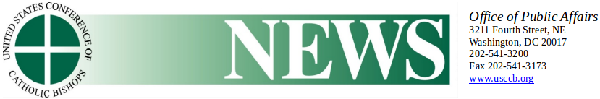

**Catholic Bishops’ Pro-Life Chairman Says Senate Rejection of Born-Alive Abortion Survivors Protection Act should horrify and anger the American people**

February 27, 2019

WASHINGTON–Monday night, the Senate failed to advance the Born-Alive Abortion Survivors Protection Act—legislation that prohibits infanticide by ensuring that a child born alive following an abortion would receive the same degree of care to preserve her life and health as would be given to any other child born alive at the same gestational age. The Senate rejected a motion to advance the bill on a vote of 53 to 44 with 3 not voting. In the Senate, 60 votes are needed to overcome a filibuster and pass a bill.

Archbishop Joseph F. Naumann, chair of the U.S. Conference of Catholic Bishops’ (USCCB) Committee on Pro-Life Activities, issued the following statement in response:

“There should be no bill easier for the Senate to pass than one that makes clear that killing newborn babies is wrong and should not be tolerated. That even one senator, let alone 44 senators voted against the Born-Alive Abortion Survivors Protection Act, is an injustice that should horrify and anger the American people and commit us to decisive political action. A vote against this bill is a vote to extend *Roe v. Wade*’s license for killing unborn children to killing newborn babies. The American people, the vast majority of whom support this bill, must demand justice for innocent children.”

---  
Keywords: U.S. Conference of Catholic Bishops, USCCB, Archbishop Joseph Naumann, Committee on Pro-Life Activities, pro-life, abortion

###

Media Contact:

[Judy Keane](mailto:media-relations@usccb.org)

202-541-3200