Word of Life: August 2018
Recommended dates are provided, but you are welcome to use these materials at any time!

Intercessions for Life

August 5th Eighteenth Sunday in Ordinary Time
For married couples considering adoption:
May the Holy Spirit guide their discernment,
grant them peace, and make possible his holy will;
We pray to the Lord:

August 12th Nineteenth Sunday in Ordinary Time
For young people:
May they discover the freedom and peace
that comes from following Jesus’ call to purity;
We pray to the Lord:

August 19th Twentieth Sunday in Ordinary Time
For the times we are pressured
to compromise respect for human life:
May the Lord strengthen
our courage and resolve;
We pray to the Lord:

August 26th Twenty-first Sunday in Ordinary Time
May friends and families of women
who are unexpectedly pregnant
provide loving, life-affirming support
for both mother and child;
We pray to the Lord:

Word of Life – August 2018

Bulletin Quotes

August 5th
Special Feature!
Adoption Prayer
and Educational Resources
www.usccb.org/adoption-resources
“We felt we had no control, but God reminded us again that He is always in control and that we could trust in Him. ... Andrew* is two years old now, and... we can’t imagine loving a child whom we conceived more than we love Andrew.”
*Name changed for privacy.
“An Adoption Love Story,” 2014-15 Respect Life Program
USCCB Secretariat of Pro-Life Activities
August 12th
“[W]e know what true, authentic love looks like. It looks like the man on the Cross. This deep, pure love that motivated Jesus to offer his life for ours, is the love that will answer the longing in our hearts, if we let it.”
“10 Surprising Tips for Love the Culture Won’t Tell You”
2015-16 Respect Life Program, USCCB Secretariat of Pro-Life Activities
August 19th
“Never tire of firmly speaking out in defense of life from its conception and do not be deterred from the commitment to defend the dignity of every human person with courageous determination. Christ is with you: be not afraid!”

Address of John Paul II to the Bishops and Apostolic Administrators of Albania on their “Ad Limina” Visit, February 3, 2001 © 2001 Libreria Editrice Vaticana. Used with permission. All rights reserved.
August 26th
“‘Perhaps one of your friends has become pregnant unexpectedly. As someone who has been there, I encourage you to support your friend in her new journey of being a mother. Not sure how to help or what to say?’ Learn more at www.usccb.org/support-her.”

“10 Ways to Support Her When She’s Unexpectedly Expecting”
2015-16 Respect Life Program, USCCB Secretariat of Pro-Life Activities

Word of Life - August 2018

Bulletin Art
You are welcome to use these and other downloadable images from the online Respect Life image gallery, provided they are not altered in any way, other than the size. Thank you!
Sunday, August 12th, 2018
Featuring “10 Surprising Tips for Love the Culture Won’t Tell You”
- Bulletin Insert: Color | Grayscale
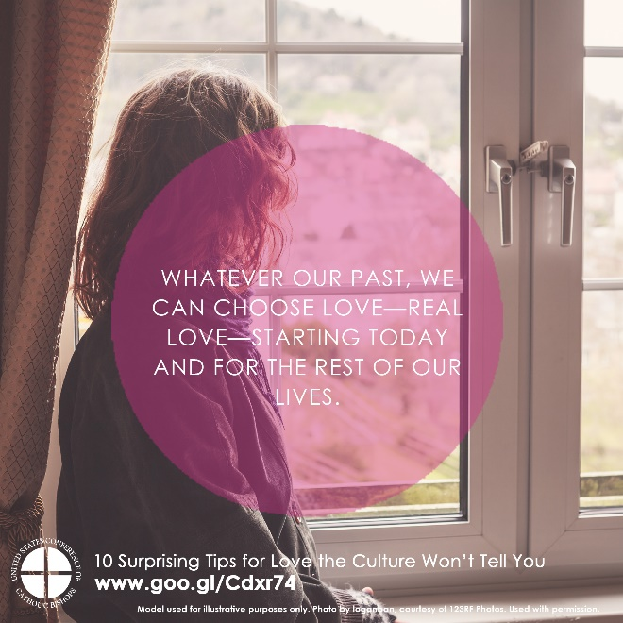
- Download Image: English | Spanish

Sunday, August 26th, 2018
Featuring “10 Ways to Support Her When She’s Unexpectedly Expecting”
- Bulletin Insert: Color | Grayscale
- Download Image: English | Spanish
