Word of Life: November 2018
Recommended dates are provided, but you are welcome to use these materials at any time!

Featured this Month…
The Solemnity of Our Lord Jesus Christ, King of the Universe
(November 25, 2018)

Resources are available to help educate the faithful about the Solemnity of Christ the King and its connection to religious liberty.
These materials include:
- Lectionary Notes and Intercessions for the Prayer of the Faithful (English & Spanish)
- Christ the King Bulletin Insert (English and Spanish)
- Graphics
- Reflections on the Meaning of Christ the King for the Faithful Today
All materials are available at www.usccb.org/freedom. ¡Viva Cristo Rey!
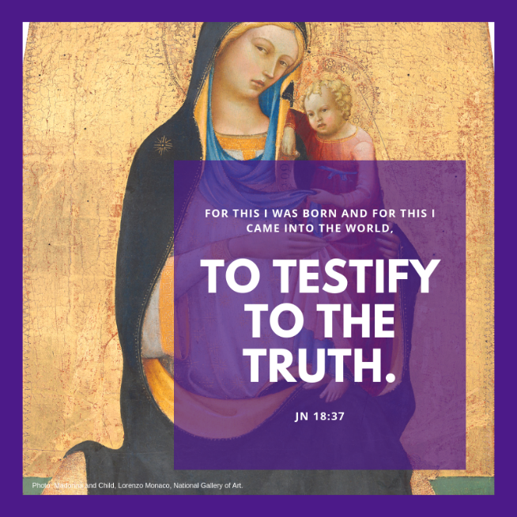
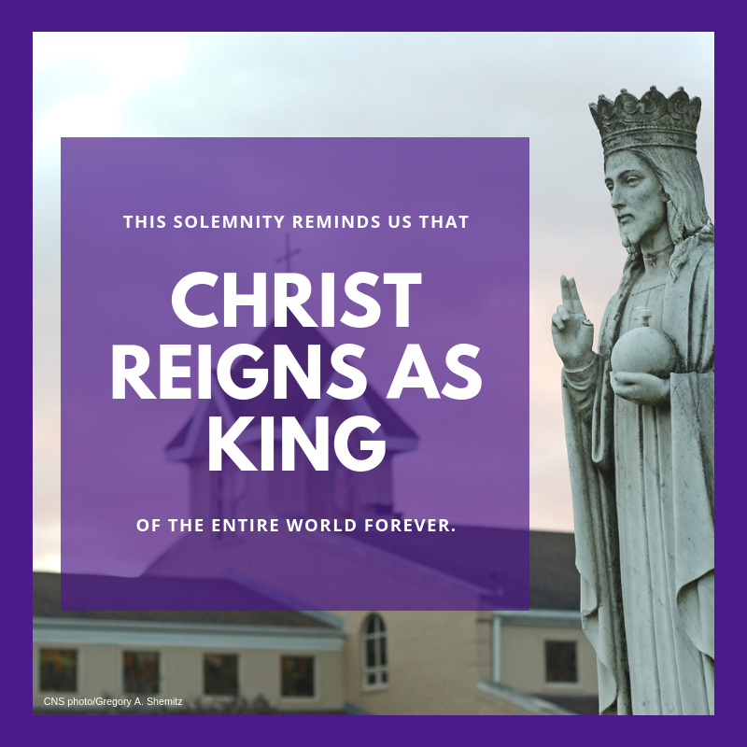

Word of Life – November 2018
Intercessions for Life
November 1st Solemnity of All Saints
For all Christians:
May we look forward to
the resurrection of the dead
by preparing now, in hope,
for our passage from this life into eternal life;
We pray to the Lord:

November 4th Thirty-first Sunday in Ordinary Time
For those nearing the end of life:
May they place their faith in Christ
and be strengthened in hope
for eternal life with Him;
We pray to the Lord:

November 11th Thirty-second Sunday in Ordinary Time
For married couples,
that their faith in Christ
will nourish their love for each other
and strengthen their commitment
of openness to new life;
We pray to the Lord:

November 18th Thirty-third Sunday in Ordinary Time
For all of us gathered in prayer:
May God grant us the wisdom and courage
to lovingly protect his gift of life;
We pray to the Lord:

November 25th The Solemnity of Our Lord Jesus Christ,
On this feast of Christ the King and always, King of the Universe
May all recognize God as the author of life
and give thanks for His priceless gift;
We pray to the Lord:

Word of Life – November 2018

Bulletin Quotes
November 1st  “Those who die in God’s grace and friendship live forever with Christ. Heaven is a true and lasting relationship with God that is beyond all earthly description and understanding.”  USCCB Secretariat of Pro-Life Activities  “Catholic Considerations for Our Earthly Passing”  www.usccb.org/end-of-life-considerations | 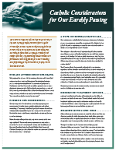  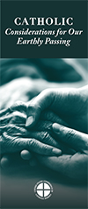  Order Download
November 4th  “The dying process is a sacred time—a final season to seek closure in this life and prepare for the next in the hope of sharing in Christ’s Resurrection. As you enter into this season with your friend or family member, ask God to accompany both of you.”  USCCB Secretariat of Pro-Life Activities  “Caring for Loved Ones at Life’s End,” www.usccb.org/endoflifecare | 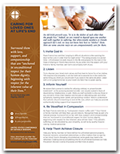  Order | Download
November 11th  “Through the Church's teaching, God invites us to a fuller, richer, deeper way of life and love.”  USCCB Secretariat of Pro-Life Activities  “Another Look at Contraception,” www.usccb.org/contraception | 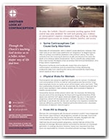  Order | Download
November 18th  “Our love for our children has nothing to do with their abilities. We love them simply because of who they are, and understanding this teaches us how to truly love everyone.”  USCCB Secretariat of Pro-Life Activities  “A Perfect Gift,” www.usccb.org/perfect-gift | 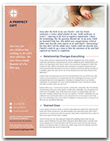  Order | Download
November 25th  “Let us rededicate ourselves this year to recognizing the reign of Jesus Christ and his Sacred Heart in every aspect of our lives.”  USCCB Office of Religious Liberty  “Solemnity of Christ the King” Bulletin Insert | 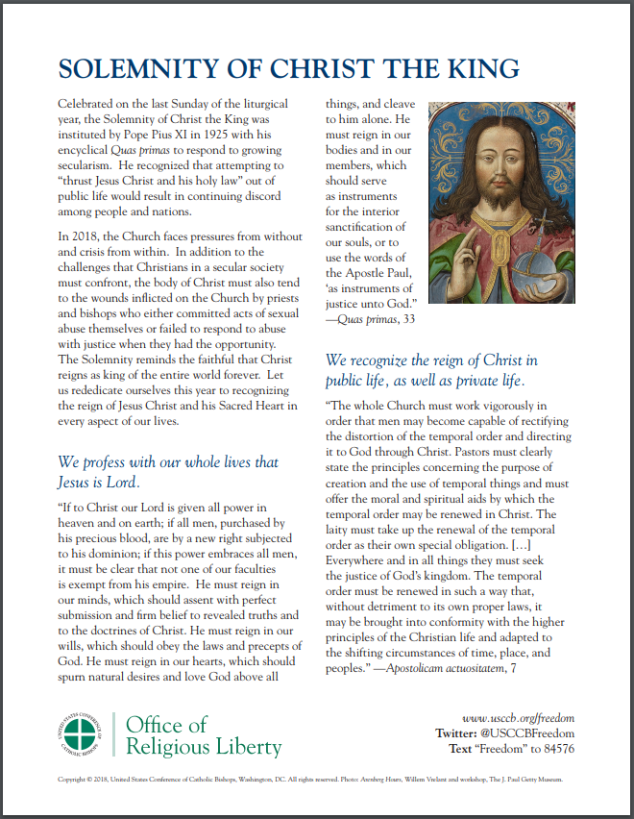Download

Word of Life - November 2018

Bulletin Art
You are welcome to use these and other downloadable images from the online Respect Life image gallery, provided they are not altered in any way, other than the size. Thank you!

Sunday, November 4th, 2018
Featuring “Caring for Loved Ones at Life’s End”
- Bulletin Insert (Color): English / Spanish
- Bulletin Insert (Black-and-White): English / Spanish
- Download Image: English / Spanish

Sunday, November 25th, 2018
Featuring the Solemnity of Christ the King
- Bulletin Insert
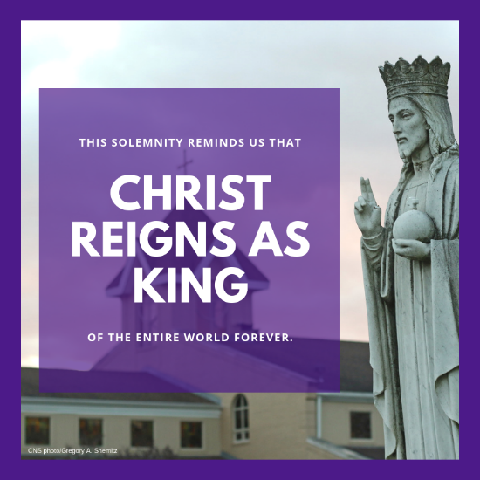
- Download Image

