Word of Life: February 2019
Recommended dates are provided, but you are welcome to use these materials at any time!
Featured this Month…
February 7–14, 2019: National Marriage Week
February 10, 2019: World Marriage Day
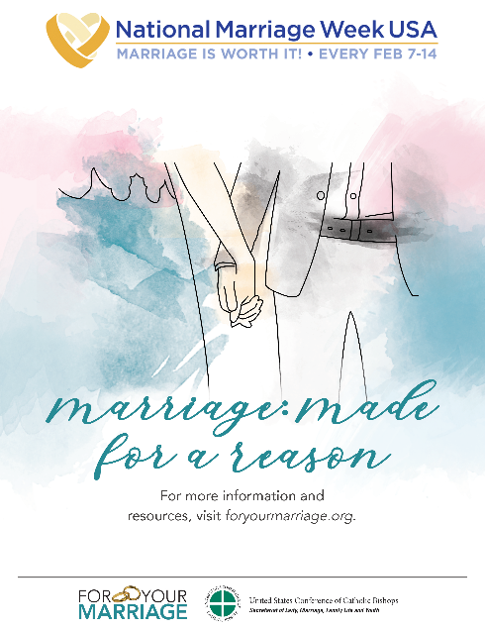
The upcoming observances of National Marriage Week and World Marriage Day are opportunities to focus on building a culture of life and love by supporting and promoting marriage and the family. The USCCB Secretariat of Laity, Marriage, Family Life and Youth offers many resources to assist you in your efforts.
- Flyer
- Prayer for Married Couples
- Preaching Resource: World Marriage Sunday
- Prayer Intentions
- 2019 Virtual Marriage Retreat
Additional resources and online events can be found at www.foryourmarriage.org/celebrate-national-marriage-week and on the USCCB website.

Related Pro-Life Resources
Seven Considerations while Navigating Infertility
Married Love and the Gift of Life
Healing within Marriage from an Abortion

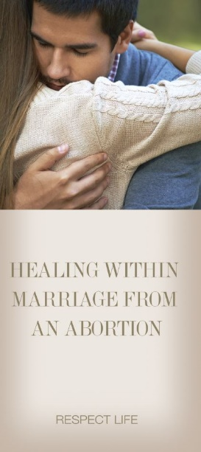
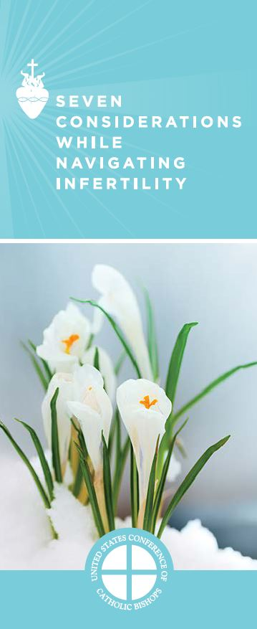

Word of Life – February 2019

Intercessions for Life
February 3rd  For new and expecting mothers and fathers:  May they lovingly accept and welcome  the gift of their new child,  who was formed in the womb by the hand of God;  We pray to the Lord: | Fourth Sunday in Ordinary Time
February 10th  For all who are imprisoned,  especially those sentenced to death:  That they may have the ears to hear  the Lord’s ceaseless call  and know of His endless mercy and love;  We pray to the Lord: | Fifth Sunday in Ordinary Time
February 17th  For our nation and our lawmakers:  That we may continually strive for laws that lead our country towards blessedness and remind us of our necessary reliance on and trust in God;  We pray to the Lord: | Sixth Sunday in Ordinary Time
February 24th  For abortion healing ministries:  That through their service,  our kind and merciful Lord will reach hurting hearts  with healing and peace;  We pray to the Lord: | Seventh Sunday in Ordinary Time

Word of Life – February 2019

Bulletin Quotes
February 3rd  “Before I formed you in the womb I knew you” (Jeremiah 1:5).  NABRE © 2010 CCD. Used with permission. | 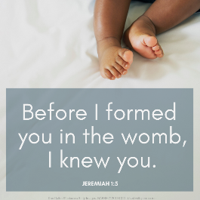  Download
February 10th  “When violent crime impacts a community there is a temptation to respond with anger and vengeance. But the Gospel calls for rehabilitation, reconciliation, and restoration and teaches us to respect the dignity of all human beings, even those guilty of committing horrendous crimes.”  “Pastoral Plan for Pro-Life Activities”  United States Conference of Catholic Bishops | 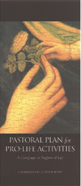  Order | Read Online
February 17th  “Called to serve the people and the common good, [civil leaders] have a duty to make courageous choices in support of life, especially through legislative measures.”  Pope Saint John Paul II, Evangelium vitae, 90.  © 1995 Libreria Editrice Vaticana. Used with permission. | 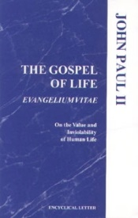  Order | Read Online
February 24th  “Abortion affects countless marriages more than many people recognize. But there is no doubt that God will bring great healing to those who trust in his infinite mercy. If a past abortion can be acknowledged and addressed, a married couple can make great strides in experiencing even more fully God’s design that ‘the two shall become one’ (Mt 19:5).”  “Healing within Marriage from an Abortion”  USCCB Secretariat of Pro-Life Activities  NABRE © 2010 CCD. Used with permission. | 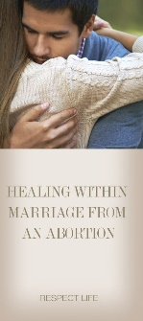  Read Online | Print

Word of Life – February 2019

Bulletin Art
You are welcome to use these and other downloadable images from the online Respect Life image gallery, provided they are not altered in any way, other than the size. Thank you!
Sunday, February 3rd, 2019
- Download Image

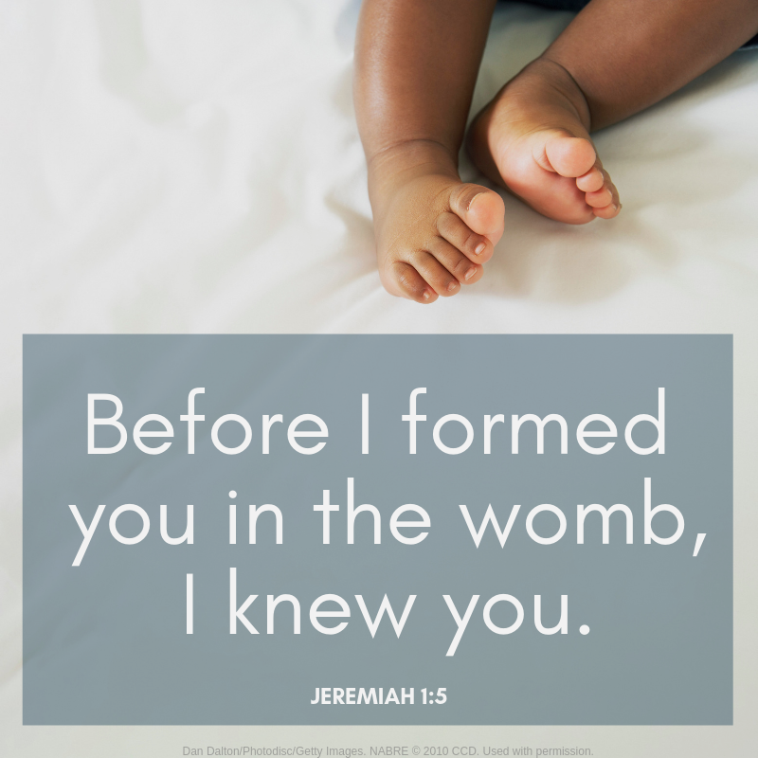
Sunday, February 24th, 2019
- Download Image
