Word of Life: August 2020
Recommended dates are provided, but you are welcome to use these materials at any time!
Featured this Month…
Pray for Life: August
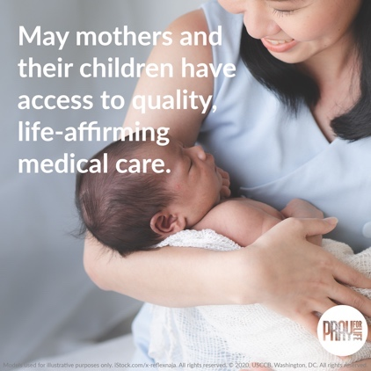
Here are graphics and a sample announcement to use in bulletins and newsletters. (Please note: Each month’s issue is posted the first day of that month on the website below.)
Sample Announcement:
Join this month’s prayer and action at walkingwithmoms.com/pray-for-moms!
Graphic: English | Spanish
Prayer Guide (print version): English | Spanish
Reflection on the Solemnity of the Assumption of the Blessed Virgin Mary
August 15, 2020
The Solemnity of the Assumption celebrates the Blessed Mother’s entrance into heavenly glory. The Catechism explains that Mary “was taken up body and soul into the glory of heaven, where she already shares in the glory of her Son’s Resurrection, anticipating the resurrection of all members of his Body” (CCC, 974).
Need a photo to go with this reflection?
Many works of art are believed to be in the common domain and are available to download from museum websites.

The Assumption of the Virgin, Bergognone
Credit: Bergognone, “The Assumption of the Virgin,” Oil and Gold on Wood, ca. 1453-1523, Fletcher Fund, 1926, courtesy of The Metropolitan Museum of Art, New York, NY.
The Assumption, Laurent de La Hyre
Credit: De La Hyre, Laurent, “The Assumption,” oil on canvas, ca. 1653, The Ciechanowiecki Collection, Gift of The Ahmanson Foundation, courtesy of the Los Angeles County Museum of Art.

Mary’s Assumption into heaven reminds us that life on earth is a pilgrimage to our ultimate destination. We prepare in hope for our own passage into eternal life by the choices we make today. When we choose to love and follow God in our daily lives, we strengthen our relationship with Him, and this relationship is the true meaning of heaven: “To live in heaven is ‘to be with Christ’” (CCC, 1025 citing St. Ambrose, In Luc.,10,121:PL 15 1834A.).
We can see how, throughout her life, the Blessed Mother continually chose to go deeper into her relationship with God. She modeled how to value and respect His precious gift of human life, from the moment of conception to its natural end. In the Annunciation, through her “yes,” Mary witnessed to the undeniable humanity of unborn children as she conceived and carried the Christ child in her womb. After the Annunciation, having learned that her cousin Elizabeth was with child, she went in haste to her aid.
Our Blessed Mother shows us how the way we live today can prepare us, in hope, to also enter into heavenly glory at the end of our lives. Are we open to God’s precious gift of new life? How do we support expectant mothers and parents of young children? Do we prioritize showing our love and care for loved ones who are ill or aging?
Holy Mary, Mother of God, pray for us sinners, now and at the hour of our death. Amen.
Catechism of the Catholic Church, second edition © 2000 LEV-USCCB. Used with permission. All rights reserved.
Word of Life – August 2020

Intercessions for Life

August 2nd  May the Lord generously provide  for the needs of all mothers  as they dedicate themselves  to caring for their children;  We pray to the Lord: | Eighteenth Sunday in Ordinary Time
August 9th  For those grieving after a miscarriage:  May they be comforted by Christ’s everlasting love  and His presence amidst their sorrow;  We pray to the Lord: | Nineteenth Sunday in Ordinary Time
August 16th  For those suffering after abortion:  May they know that the Lord desires to bring healing,  to replace their pain with His mercy and peace;  We pray to the Lord: | Twentieth Sunday in Ordinary Time
August 23rd  For the Church:  That She may steadfastly proclaim and uphold  the dignity of all human life,  in all stages and circumstances;  We pray to the Lord: | Twenty-first Sunday in Ordinary Time
August 30th  For those who are imprisoned,  especially those condemned to death:  May they be treated with the respect due  to every human person;  We pray to the Lord: | Twenty-second Sunday in Ordinary Time

Word of Life – August 2020
Bulletin Quotes
August 2nd  “We thank you, heroic mothers, for your invincible love! We thank you for your intrepid trust in God and in his love. We thank you for the sacrifice of your life” (EV 86).  Pope Saint John Paul II, Evangelium vitae © 1995, Libreria Editrice Vaticana.  Used with permission. All rights reserved. | 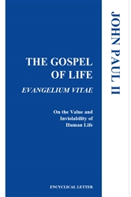  Order | Read Online
August 9th  “Although we may feel unsure how best to comfort those who mourn, we must stand with them in their time of suffering. Miscarriage touches the lives of many people, yet all too often this tragedy remains unaddressed. This lack of response not only often leads to unresolved grief, but also fails to clearly manifest our belief that each person, from conception onward, is precious and unique.”  USCCB Secretariat of Pro-Life Activities  “Solace and Strength in the Sorrow of Miscarriage” | 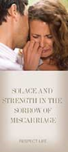  Order | Download
August 16th  “Abortion affects countless marriages more than many people recognize. But there is no doubt that God will bring great healing to those who trust in his infinite mercy. If a past abortion can be acknowledged and addressed, a married couple can make great strides in experiencing even more fully God’s design that ‘the two shall become one’ (Mt 19:5).”  USCCB Secretariat of Pro-Life Activities  “Healing within Marriage from an Abortion” (NABRE © 2010 CCD. Used with permission.) | Order | Download
August 23rd  “God’s love—individual, real, unchanging—is the true source of our worth, identity, and dignity. It really is not a question of who we are, but rather whose we are. Because his love will never change, nothing can reduce our God-given dignity, and nothing can diminish the immeasurable worth of our lives.”  USCCB Secretariat of Pro-Life Activities  “How to Build a Culture of Life” | 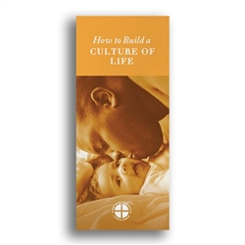  Order | Download
August 30th  “No sin or crime is greater than God’s mercy. The sacrifice of the Cross reveals that Christ’s greatest desire is to forgive those with a repentant heart.”  USCCB Secretariat of Pro-Life Activities  “Death Penalty: Catholic Q&A” | 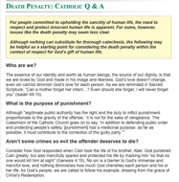  Read Online

Word of Life – August 2020

Bulletin Art
You are welcome to use these and other downloadable images from the online Respect Life image gallery, provided they are not altered in any way, other than the size. Thank you!

Sunday, August 2, 2020
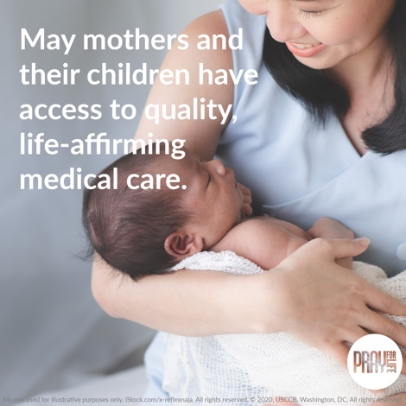
Pray for Life: August 2020

- Download Image: English | Spanish
- Prayer Guide: English | Spanish

Sunday, August 16, 2020
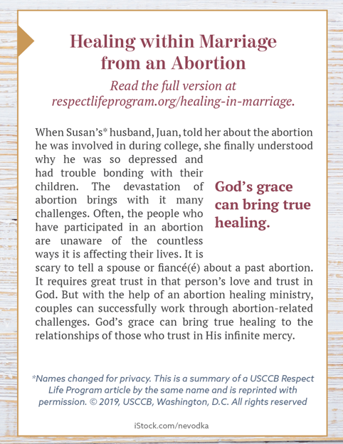
Healing within Marriage from an Abortion

- Online: English | Spanish
- ¼ Page “Bulletin Box” Image: English | Spanish
- Full-Length Bulletin Insert (print format): English | Spanish

