Social Media Tool Kit

Post 1: Before the Collection
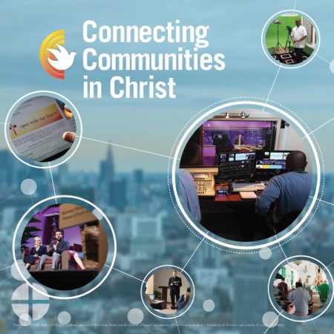
Facebook/Instagram/Twitter:
Help people connect with Christ by supporting the Catholic Communication Campaign at Mass! #1church1mission

Learn more: www.usccb.org/ccc

Post 2: Week of the Collection
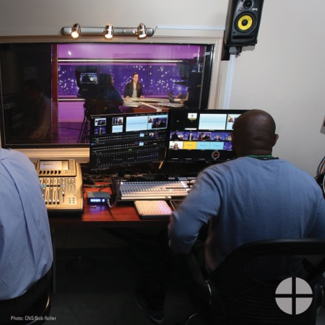
Facebook/Instagram/Twitter:
Support the Catholic Communication Campaign at Mass and help our local communications projects! Fifty percent of funds raised stay here in the diocese. The other fifty percent support projects across the US and in developing countries. #1church1mission www.usccb.org/ccc

Post 3: Week of the Collection
Facebook/Instagram/Twitter:
When you support the Catholic Communication Campaign, you help people around the world connect with Christ. Please be generous to the collection this weekend! #1church1mission www.usccb.org/ccc

Post 4: Week of the Collection
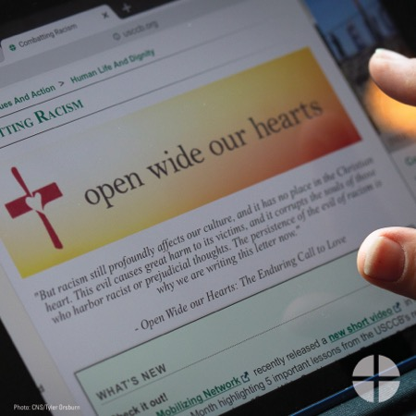
Facebook/Instagram/Twitter:
Want to help spread the Good News, but don’t know how? Support the Catholic Communication Campaign at Mass, and help people in the U.S. and around the world connect with Christ! #1church1mission www.usccb.org/ccc

Post 5: Week of the Collection
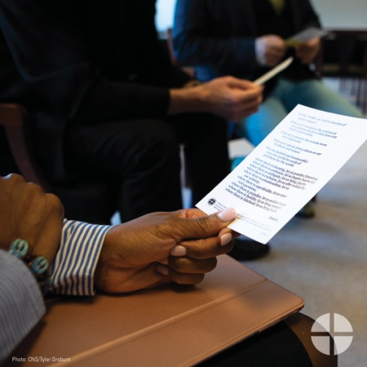
Facebook/Instagram/Twitter:
This weekend is the collection for the Catholic Communication Campaign! Please prayerfully consider how much you can give to help spread the Gospel in the U.S. and around the world. #1church1mission www.usccb.org/ccc

Post 6: Day of the Collection
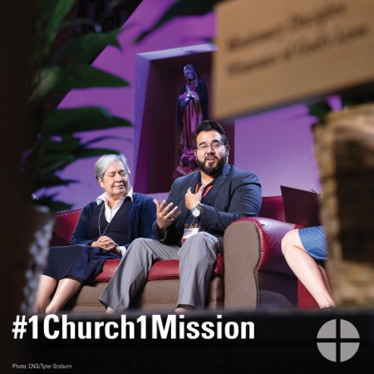
Facebook/Instagram/Twitter:
Today is the collection for the Catholic Communication Campaign. Please be generous at Mass! Fifty percent of funds will stay to support projects in your diocese, and the other fifty percent support projects in developing countries #1church1mission www.usccb.org/ccc

