**Social Media Tool Kit**

The links in these posts lead to videos. Be sure to copy the whole link for each post. The video will automatically be linked on Facebook and Twitter!

**Post 1: Before the Collection**

The link in the post leads to a video. Be sure to copy the whole link and the video will automatically be linked on Facebook and Twitter!

**Facebook/Twitter:**

Check out how you helped translate the Catechism into the Mayan language Q’eqchi’ for the first time through the Collection for the Church in Latin America! #ShareYourFaith #1church1mission <https://goo.gl/ZTq2zZ>

**Post 2: Before the Collection**

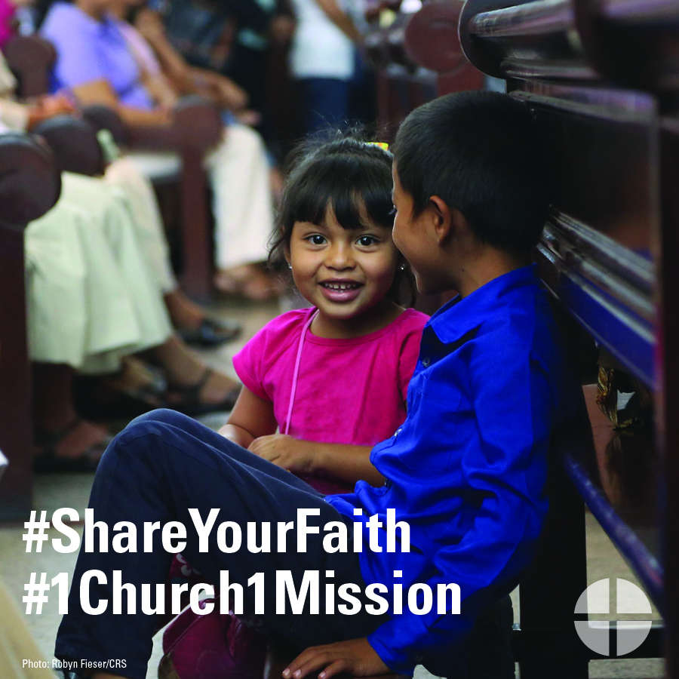

**Facebook/Twitter/Instagram:**

For over 50 years, the Collection for the Church in Latin America has been a way for us to join in solidarity with our brothers and sisters in Latin America and the Caribbean. #ShareYourFaith #1church1mission [www.usccb.org/latin-america](http://www.usccb.org/latin-america)

**Post 3: Before the Collection**

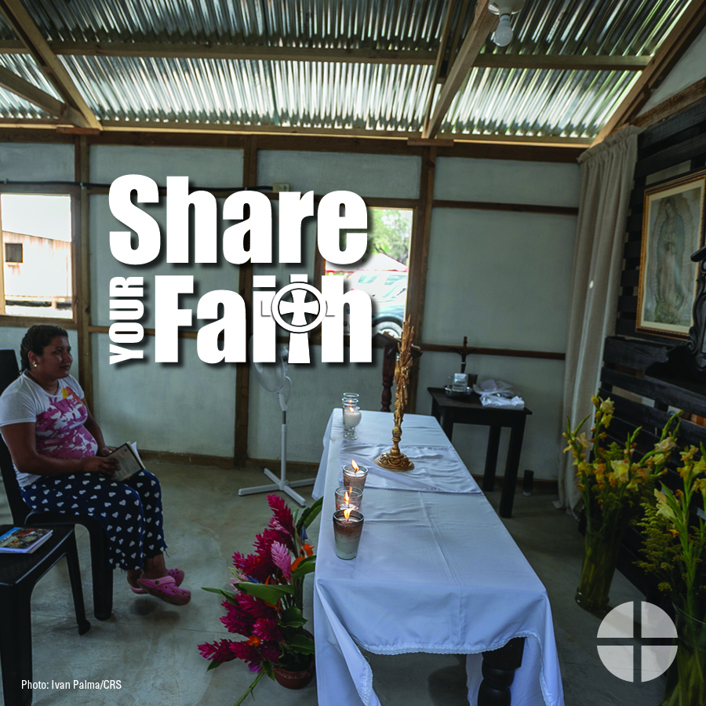

**Facebook/Twitter/Instagram:**

The Collection for the Church in Latin America is an opportunity to #ShareYourFaith with our brothers and sisters in Latin America and the Caribbean. Please be generous to the collection! #1church1mission [www.usccb.org/latin-america](http://www.usccb.org/latin-america)

**Post 4: Week of the Collection**

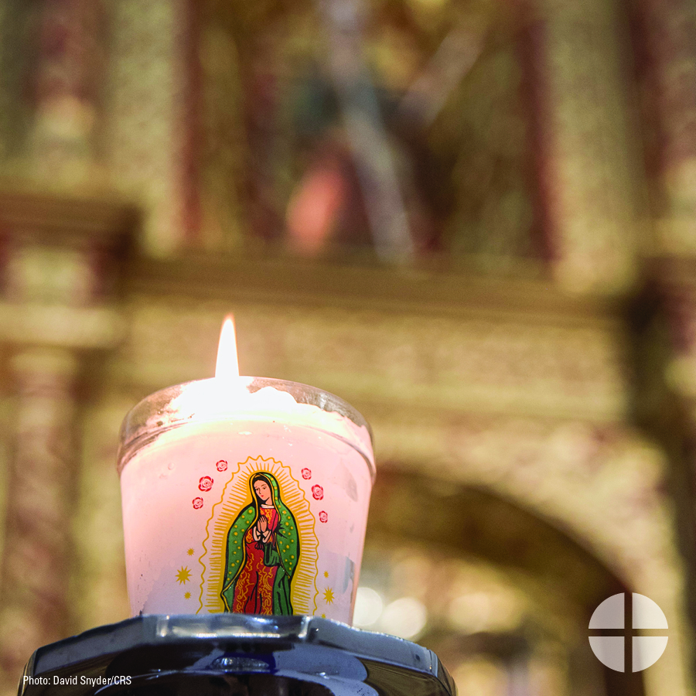

**Facebook/Instagram/Twitter:**

#ShareYourFaith and support the Collection for the Church in Latin America this weekend at Mass! #1church1mission [www.usccb.org/latin-america](http://www.usccb.org/latin-america)

**Post 5: Week of the Collection**

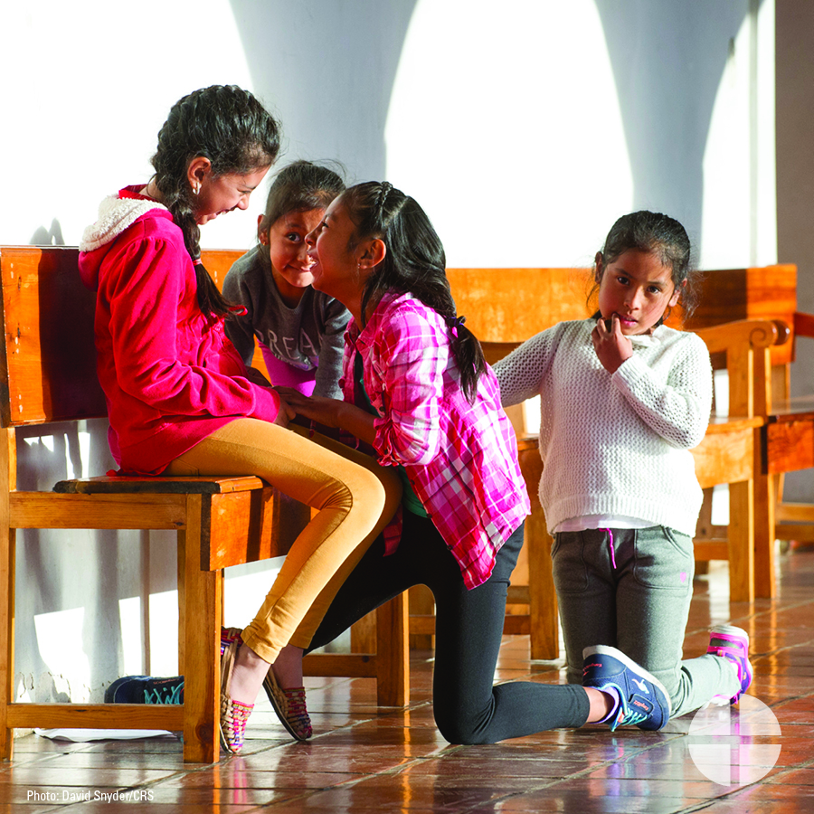

**Facebook/Twitter/Instagram:**

This weekend, our second collection is for the Church in Latin America. Your generosity makes a difference for our brothers and sisters in Latin America and the Caribbean. #ShareYourFaith #1church1mission www.usccb.org/latin-america

**Post 6: Week of the Collection**

*The link in the post leads to a video. Be sure to copy the whole link and the video will automatically be linked on Facebook and Twitter!*

**Facebook/Twitter/Instagram:**

See how funds from the Collection for the Church in Latin America supports the educational programs of the bishops in Venezuela and strengthens the faith of Venezuelan youth in the face of government persecution #ShareYourFaith #1church1mission  
<https://youtu.be/6lQwjVLa_PU>

**Post 7: Weekend of the Collection**

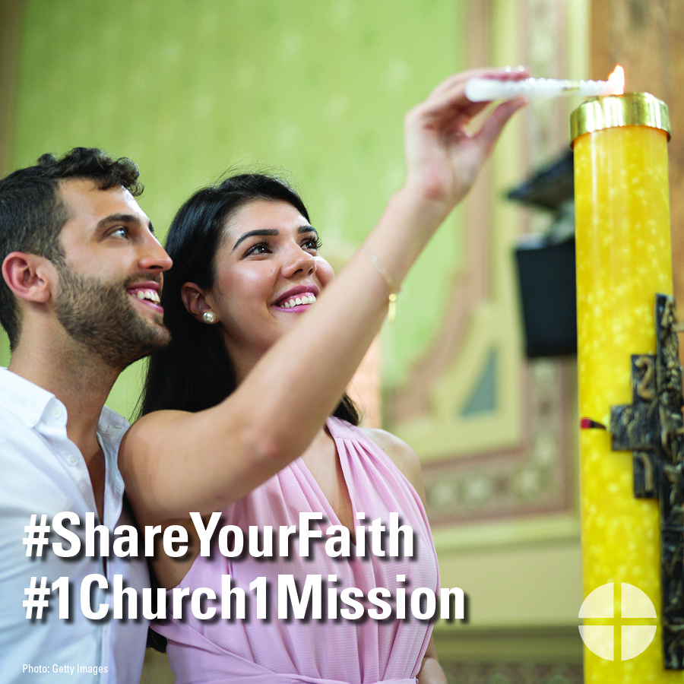

**Facebook/Twitter/Instagram:**

Today is the Collection for the Church in Latin America! Your generosity helps people throughout Latin America and the Caribbean grow closer to Christ! #ShareYourFaith #1church1mission [www.uscccb.org/latin-america](http://www.uscccb.org/latin-america)