Sample Bishop’s Letter
May be read from the pulpit or inserted into the parish bulletins.

Dear Brothers and Sisters in Christ,

The Sahel region separates the Sahara Desert of north Africa from the humid regions to the south. It stretches west to east across Africa, from Mauritania on the Atlantic Ocean to Sudan on the Red Sea. Desertification, shortage of resources, and armed conflicts between governments and Islamist affiliates of al-Qaida and the Islamic State group—these and other factors have affected millions throughout the region, particularly in the west African country of Mali.

Malian young people—especially those personally exposed to the violence of war and the anxiety of political and personal insecurity—urgently need to experience Christ’s love as found in the Bible and in the Catholic Church’s teachings on human dignity so that they can grow into future leaders working toward peace. With support received from the Solidarity Fund for the Church in Africa, the Episcopal Conference of Mali brought together young people for such an encounter. The conference gathered nearly 200 young Catholic men and women, ages 18 to 35, from across Mali’s five dioceses to attend a special Bible camp. There, the young participants learned about the Catholic principles of religious freedom, interreligious dialogue, and peace found in Scripture and in the Second Vatican Council’s teachings.

Your support for the Solidarity Fund for the Church in Africa helps young people encounter the teachings of the Church and grow as disciples who are eager to share Christ’s peace where so many have experienced conflict and war.

Please be generous to this appeal for the Solidarity Fund through the offertory collection or your parish’s e-offertory platform. To learn more about the collection and whom it supports, visit www.usccb.org/africa.

To support the Solidarity Fund with an online donation, please use this QR code or visit #iGiveCatholic at igivecatholic.org/story/USCCB-CA.

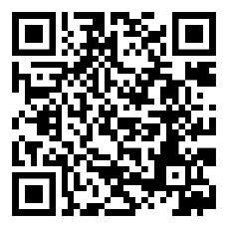

Thank you and God bless.

Sincerely yours in Christ,

[Bishop’s name, signature, title, diocese]
For more information, please visit www.usccb.org/africa.

