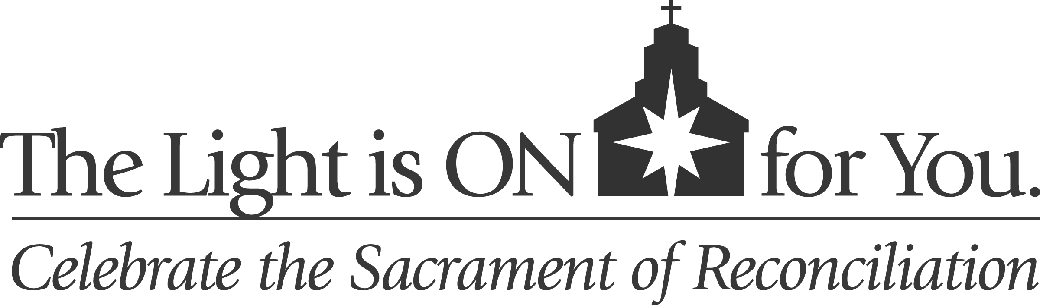

Parish Toolkit Contents

The following materials are provided as part of The Light is On for You initiative. Most resources are available in English and Spanish.

Liturgical and General Resources
- Homily hints
- General Intercessions
- Bulletin and pulpit announcements
- Logos
- Suggestions for implementation
- Sources for catechetical material on Reconciliation

Adoration and Reconciliation Resources
- Pastoral Letter: God’s Mercy and Loving Presence
- Reconciliation: A Short Guide
- Guide for praying before the Blessed Sacrament and Benediction

The Light Is On For You © 2012 Archdiocese of Washington and Diocese of Arlington.

These and other materials are online at www.adw.org.

