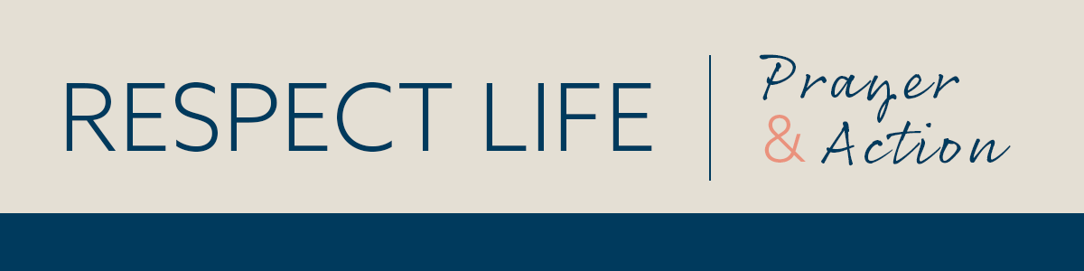

­­

*Prayer Guide* | *SEPTEMBER 2021*

–­

INTERCEDE



PRAY

*Our Father, 3 Hail Marys, Glory Be*

REFLECT

Our faith teaches us that each moment of our lives is a gift from God. Even in the face of suffering or limited ability, life is always meaningful. Our human dignity and value *never* diminish. The practice of assisted suicide tragically rejects the truth that *every* life is worth living.

Asking to die is a cry for help. People considering suicide want to escape what they perceive to be an intolerable situation, inaccurately believing that death is their only way out. A person requesting assisted suicide is often asking, “Does anyone want me to be alive, or care enough to talk me out of this and support me through this difficult time?”

While the practice of assisted suicide is often the result of misguided mercy, laws permitting assisted suicide erroneously communicate the idea that, under difficult circumstances, some lives are not worth living. Sadly, this tragically false message will be heard not only by those with a terminal illness, but by any person struggling with the temptation to end his or her life.

The dying process is a sacred time—a final season to seek closure in this life and prepare for the next in the hope of sharing in Christ's Resurrection. We are called to accompany those entering this season of life, surrounding them with life-affirming love, support, and compassion.

ACT *(choose one)*

* Offer the prayer “Every Life is Worth Living” for this month’s intention ([usccb.org/every-life-worth-living](https://www.usccb.org/every-life-worth-living)).
* Learn about the concrete ways you can help accompany a loved one who is nearing the end of life: [usccb.org/end-of-life-care](https://www.usccb.org/end-of-life-care).
* Offer some other sacrifice or prayer that you feel called to do for this month’s intention.

ONE STEP FURTHER

Learn more about the negative impacts of assisted suicide on society in “Every Suicide is Tragic” ([usccb.org/every-suicide-tragic](https://www.usccb.org/every-suicide-tragic)).

DID YOU KNOW?

September is National Suicide Prevention Month. In this short [video](https://youtu.be/iiK3B0Cofc0) Luke recounts his personal experience with suicide and helps us better understand its intimate connection to assisted suicide.