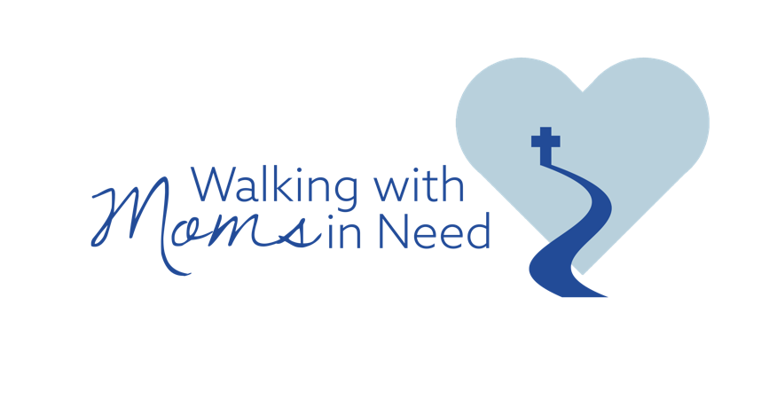

MEDIA BACKGROUNDER

INTRODUCTION

Walking with Moms in Need is a nationwide initiative to increase support for pregnant and parenting mothers facing difficulties.

As part of Walking with Moms in Need, parishes—with the support of their bishop and pastor—are invited to take part in a yearlong process to evaluate local resources and support for mothers in need. Each participating parish is asked to complete a simple inventory of the resources currently available in their local area, assess the results and identify gaps, and plan and implement a parish response based on their findings.

Walking with Moms in Need was initially launched by the United States Conference of Catholic Bishops on March 25, 2020, in honor of the 25th anniversary Pope St. John Paul II’s encyclical Evangelium vitae (The Gospel of Life). When the U.S. bishops planned and launched this ground-breaking pastoral effort, no one could have foreseen the deep and lasting impacts of the COVID-19 pandemic. While the pandemic sadly overshadowed much of the initial momentum of Walking with Moms in Need, it has also provided new and exciting opportunities to adapt and expand this important initiative to meet the challenges of our unique times.

The USCCB Secretariat of Pro-Life Activities is providing resources on how to implement Walking with Moms in Need and ongoing support to help dioceses and parishes. These resources include a guide on how to get started, sample timelines, announcements, prayers, activities, and more. While each parish will participate in its own unique way, a basic framework and structure are provided which can be adapted to each local Church’s needs.

Dioceses and parishes that have yet to begin Walking with Moms may still join. Many dioceses have had to re-launch the initiative, and others were delayed indefinitely. Now is a great time for parishes and dioceses to begin implementing Walking with Moms in Need in their local area.

Walking with Moms in Need is already having a profound, positive impact on our parishes and the Church at large.

BACKGROUND
While many pregnancy-help resources are appropriately coordinated at the diocesan or regional level, moms in need are often best reached at the local level. With well over 17,000 parishes in the United States, the Church is uniquely positioned to encourage a collaboration of resources at the local level and to increase awareness of help available to mothers and families in need.

INSPIRATION

On March 25, 2020, the Solemnity of the Annunciation of the Lord, the Church celebrated the 25th anniversary of the papal encyclical Evangelium vitae (The Gospel of Life). This prophetic document reaffirmed the Church’s constant teaching on the value and inviolability of every human life. In that landmark encyclical, Pope St. John Paul II challenged the Church:
“With great openness and courage, we need to question how widespread is the culture of life today among individual Christians, families, groups and communities in our Dioceses. With equal clarity and determination we must identify the steps we are called to take in order to serve life in all its truth.” (EV 95)

Pope Francis has similarly challenged the Church to go to the margins and bring hope and help to those in need. He has repeatedly reminded us that our parishes are called to be “islands of mercy in the midst of a sea of indifference.”

Walking with Moms in Need is a response to both of these challenges.

Women facing challenging pregnancies, or who are parenting young children in difficult circumstances, should see the Church as a place where they can find help—especially with its extensive social services dedicated to meeting the needs of people in crisis. But the Church must also honestly assess the pastoral and practical assistance that it currently provides to pregnant moms and families in need and how effective it is in communicating such help to those who need it most.

Everyone in a given parish community should know where to refer a pregnant woman in need. Walking with Moms in Need hopes to help parishes do just that.

VISION
Walking with Moms in Need is not intended to be a prescriptive program. Every parish community and diocese are unique. Parishes are the experts on their community and are best able to understand and respond to the needs and challenges in their local area. It is for this reason that Walking with Moms is a parish-based initiative. All provided materials are meant to be resources to help equip and empower parishes to reach out to mothers in need in their communities, and parishes are encouraged to adjust and adapt the provided materials as needed. All materials are provided in both English and Spanish, and are available for free download from our website.

Walking with Moms in Need will look very different from parish to parish and from diocese to diocese based on the resources and capacity of each local Church community. Bishops, pastors, and diocesan and parish leaders are encouraged to prayerfully discern the implementation of Walking with Moms in Need and truly allow the Holy Spirit to guide their efforts.

Mothers and children that we cannot protect by law, we can surround and rescue with love. We want no mother, no child left behind because there was no one to encourage and assist them.

MORE INFORMATION

For more information on Walking with Moms in Need, please see our FAQ for answers to our most frequently ask questions.

Additional information can also be found online in our Press Kit.

Please direct all media inquiries to Chieko Noguchi, Director of Public Affairs for the United States Conference of Catholic Bishops.
Email: media-relations@usccb.org | Phone: (202) 541-3200

Evangelium vitae (The Gospel of Life), no. 95 © 1995, Libreria Editrice Vaticana. Pope Francis, Lenten Message © 2015, Libreria Editrice Vaticana. Used with permission. All rights reserved. Copyright © 2021, United States Conference of Catholic Bishops, Washington, DC. All rights reserved.

