Word of Life: March 2021
Recommended dates are provided, but you are welcome to use these materials at any time!
Featured this Month…
Solemnity of the Annunciation: March 25, 2021
In March, the Church celebrates the Solemnity of the Annunciation of the Lord. This feast day helps us to recognize the gift of new life from its very beginning and calls us to reflect on how we are to care for, protect, and welcome new life—as the Blessed Mother did for the Christ child.
Our March Action Guide features sample timelines, homily helps, announcements, activities, and more to assist in celebrating this solemnity within your parish community.
A reflection exploring the connection between the Annunciation and the Gospel of Life is available as a bulletin insert in English and Spanish.
Additional resources, such as an Annunciation novena and parish webinar recording, are also available at www.respectlife.org/action-guides.
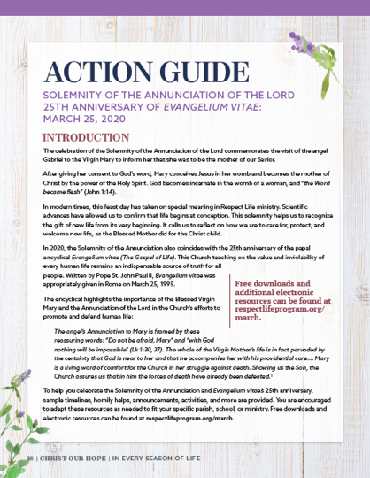
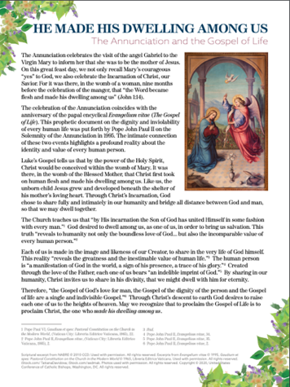

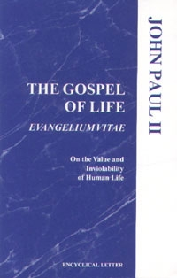
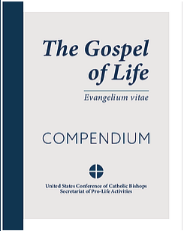
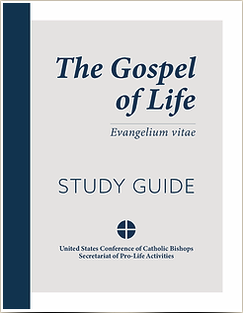
Anniversary of Evangelium vitae: March 25
March 25th also marks the anniversary of the papal encyclical Evangelium vitae (The Gospel of Life). This Church teaching on the value and inviolability of every human life remains an indispensable source of truth for all people.
Several resources are available to help you observe this anniversary in your parish, including the Gospel of Life: Compendium and Study Guide.
Additional resources including bulletin inserts and graphics are available at respectlife.org/gospel-of-life.

Word of Life – March 2021
Intercessions for Life
March 7th  For each expectant mother considering abortion:  May the Lord protect her  and give her the grace and resolve  to choose life for her child;  We pray to the Lord: | Third Sunday of Lent
March 14th  For those nearing the end of life:  May they be given the grace to persevere in faith  and place their trust in God,  as they prepare for eternity with Christ;  We pray to the Lord: | Fourth Sunday of Lent
March 21st  May all who suffer from the wounds of abortion  be filled with the hope that does not disappoint,  and be healed by Christ;  We pray to the Lord: | Fifth Sunday of Lent
March 25th  Inspired by the example of the Blessed Mother,  may we, like Mary, have the courage  to say “yes” to life from conception to natural death;  We pray to the Lord: | Solemnity of the Annunciation  of the Lord
March 28th  May all mothers facing difficult pregnancies  be lovingly accompanied as they prepare  to encounter Christ anew  through the gift of their children;  We pray to the Lord: | Palm Sunday of the Passion of Our Lord

Word of Life – March 2021
Bulletin Quotes
In honor of the anniversary of Evangelium vitae, the bulletin quotes for this month all come from this historic document. Additional artwork is provided for each bulletin quote this month. Please include the following credit:
Pope Saint John Paul II, Evangelium vitae. © 1995 Libreria Editrice Vaticana. Used with permission.
March 7th  “[The Gospel of Life] is therefore meant to be a precise and vigorous reaffirmation of the value of human life and its inviolability, and at the same time a pressing appeal addressed to each and every person, in the name of God: respect, protect, love and serve life, every human life! Only in this direction will you find justice, development, true freedom, peace and happiness!” (The Gospel of Life 5) | 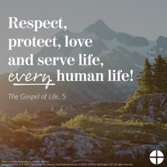  English | Spanish
March 14th  “We are facing an enormous and dramatic clash between good and evil, death and life, the ‘culture of death’ and the ‘culture of life’. We find ourselves not only ‘faced with’ but necessarily ‘in the midst of’ this conflict: we are all involved and we all share in it, with the inescapable responsibility of choosing to be unconditionally pro-life” (The Gospel of Life 28). | 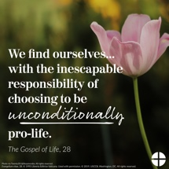  English | Spanish
March 21st  “To celebrate the Gospel of life means to celebrate the God of life, the God who gives life… In every child which is born and in every person who lives or dies we see the image of God’s glory. We celebrate this glory in every human being, a sign of the living God, an icon of Jesus Christ” (The Gospel of Life 84). | 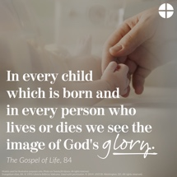  English | Spanish
March 28th  “There is an everyday heroism, made up of gestures of sharing, big or small, which build up an authentic culture of life… Part of this daily heroism is also the silent but effective and eloquent witness of all those ‘brave mothers who devote themselves to their own family without reserve, who suffer in giving birth to their children and who are ready to make any effort, to face any sacrifice, in order to pass on to them the best of themselves’… We thank you, heroic mothers, for your invincible love! We thank you for your intrepid trust in God and in his love. We thank you for the sacrifice of your life” (The Gospel of Life 86). | 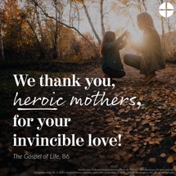  English | Spanish

Word of Life – March 2021

Bulletin Art
You are welcome to use these and other downloadable images from the online Respect Life image gallery, provided they are not altered in any way, other than the size. Thank you!
Sunday, March 7, 2021
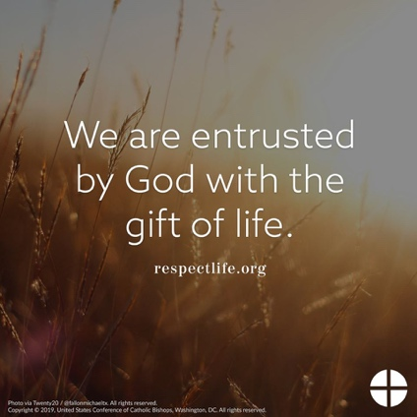
Download: English | Spanish

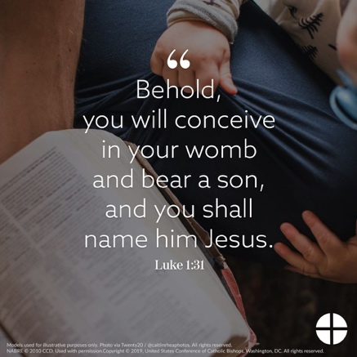
Sunday, March 21, 2021

Download: English | Spanish

Sunday, March 28, 2021
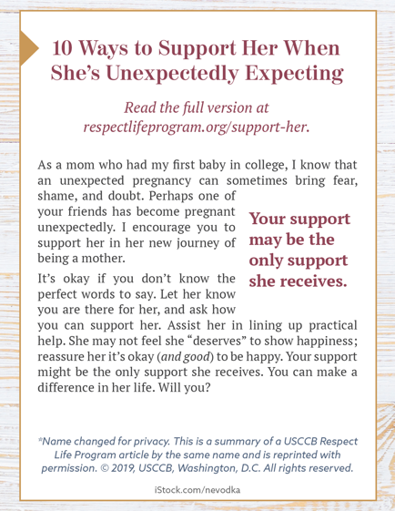
Bulletin Box: English | Spanish

