Word of Life: April 2021
Recommended dates are provided, but you are welcome to use these materials at any time!
Featured this Month…
April 11, 2021: Sunday of Divine Mercy
On the Second Sunday of Easter, the Church celebrates the Sunday of Divine Mercy. It provides an important opportunity to share Christ’s message of mercy, especially with those who have been wounded by participation in abortion. By the age of 45, as many as 1 in 3 women have had an abortion, and a similar number of men and family members have been involved. Many inaccurately feel that abortion is “the unforgivable sin.” They need to hear that God forgives every sin of a repentant heart, even the sin of abortion. In fact, Jesus’ message to St. Faustina is the greater the sinner, the greater the right to His mercy.
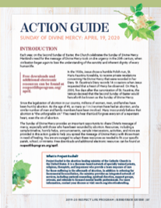
The Action Guide for the Sunday of Divine Mercy includes a sample timeline, simple steps, sample announcements, and an activity to help you bring Christ’s message of mercy to your parish community.
Prayer | Order
Check out respectlife.org/action-guides for supplemental resources.
Weekend(s) of April 11, 18 and/or 25, 2021: No Taxpayer Abortion
The website listed below is in the process of being built and will be ready by April 9.

Background: There’s a new push in Congress to force Americans to pay for abortion. The Hyde Amendment and other similar laws have protected taxpayers from funding elective abortion. Now, Congress wants to take away these laws, which have had broad public support for nearly 50 years. Without the Hyde Amendment, billions of dollars in healthcare funding could go to abortion.

Bulletin Announcement
Stop your tax dollars from going to abortion! www.NoTaxpayerAbortion.com

Graphics: https://www.usccb.org/resources/respect-life-graphics-no-taxpayer-abortion

Word of Life – April 2021
Intercessions for Life
April 4th  May the glory of the Resurrection  inspire lasting hope in all who work  to protect the dignity of human life;  We pray to the Lord: | Easter Sunday  The Resurrection of the Lord
April 11th  May the infinite mercy  of our divine Savior reach all who are  suffering from participation in abortion, and transform them  by His forgiveness, healing, and peace;  We pray to the Lord: | Second Sunday of Easter  (or Sunday of Divine Mercy)
April 18th  For all those in hospice:  May the loving accompaniment  of family and friends  bear witness to the gift of their lives;  We pray to the Lord: | Third Sunday of Easter
April 25th  For elected officials:  May they work to protect human life  from conception to natural death;  We pray to the Lord: | Fourth Sunday of Easter

Word of Life – April 2021
Bulletin Quotes

April 4th  “Like us, Christ entered the world through the womb of a woman. He willingly experienced the fullness of human suffering. He breathed his last on the Cross at Calvary in order that He might save us. Therefore, ‘God is the foundation of hope: not any god, but the God who has a human face and who has loved us to the end’ (Spe salvi 31).”  USCCB Secretariat of Pro-Life Activities  “Respect Life Reflection: Christ Our Hope in Every Season of Life” (Citing Pope Benedict XVI, Spe salvi © 2007, Libreria Editrice Vaticana. Used with permission. All rights reserved.) | 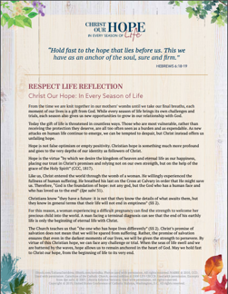  Download
April 11th  If you or someone you know has had an abortion, “be assured that it is never too late to seek God’s forgiveness in the Sacrament of Reconciliation.”* Additionally, other confidential, compassionate help is available. Select “Find Help” from the menu on www.hopeafterabortion.org to find the diocesan Project Rachel Ministry near you.  USCCB Secretariat of Pro-Life Activities  *“Bridges of Mercy for Healing after Abortion”  www.usccb.org/bridges-of-mercy | 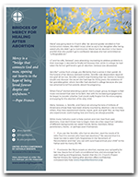  Order | Download
April 18th  “Christ invites us to trust in his invisible grace that prompts us to the generosity of supernatural charity, as we identify with everyone who is ill: ‘Amen, I say to you, whatever you did for one of these least brothers of mine, you did for me’ (Mt 25:40).”  Congregation for the Doctrine of the Faith  “Samaritanus bonus: On the Care of Persons in the Critical and Terminal Phases of Life”. (© 2020, Libreria Editrice Vaticana. Used with permission. All rights reserved.) | 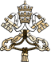  Read Online
April 25th  “Current laws in our country fail to protect the lives of unborn children. … People of good will must boldly stand up against this intrinsic evil [of abortion], especially when it is occurring on a massive scale, implemented in law and funded, in some instances, by the government.”  Most Reverend Joseph F. Naumann, Chair of the USCCB Committee on Pro-Life Activities, “Priorities at the Polls” | 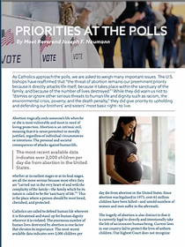  Download | Read Online

Word of Life – April 2021

Bulletin Art
You are welcome to use these, provided they are not altered in any way, other than the size. Thank you!

Sunday, April 11th, 2021
Download Images: https://www.usccb.org/resources/divine-mercy-images
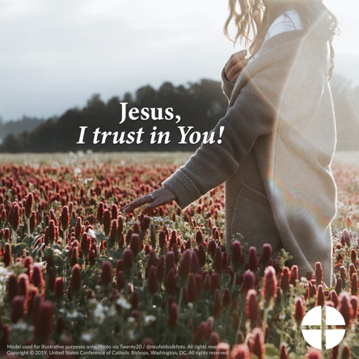

Sunday, April 18th / 25th, 2021

Download Images: https://www.usccb.org/resources/respect-life-graphics-no-taxpayer-abortion

