Word of Life: June 2021
Recommended dates are provided, but you are welcome to use these materials at any time!
Featured this Month…

No Taxpayer Abortion
First 2 Weeks of June

Please use the following sample announcement in parish bulletins, newsletters, pulpit announcements, ministry updates, and any other permissible way you can during the first two weeks of June:

"Stop your tax dollars from going to abortion. www.notaxpayerabortion.com"

Other materials are also available to assist your efforts at respectlife.org/no-taxpayer-abortion.

Father’s Day Action Guide
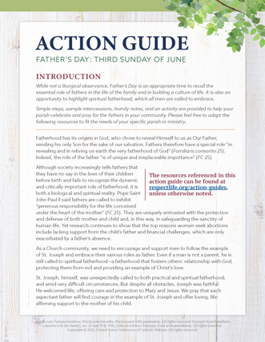
June 20, 2021
Religious Freedom Week: Solidarity in Freedom
June 22-29, 2021
Simple steps, sample intercessions, homily considerations, and an activity are provided in the Father’s Day Action Guide to help your parish honor fathers and highlight their importance in building a culture of life.

A previously recorded webinar explains the resources available. Please feel free to adapt the resources to fit the needs of your specific parish or ministry.
- Webinar Recording
- Action Guide (English | Spanish)
- Supplemental Resources (listed under Father’s Day section on this page)
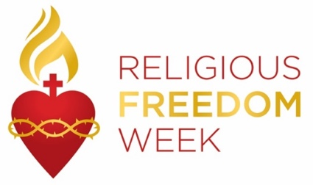
Religious Freedom Week 2021: Solidarity in Freedom takes place June 22 – 29. The Week begins with the Feast of Sts. John Fisher and Thomas More, ends with the Solemnity of Sts. Peter and Paul, and includes the Feast of the Nativity of St. John the Baptist. Many resources are available to help the faithful pray, reflect, and take action on religious liberty, both here in this country and abroad. Resources, including graphics, lectionary notes, bulletin inserts, and daily prayers and reflections are available at usccb.org/ReligiousFreedomWeek.
Word of Life – June 2021
Intercessions for Life
June 6th  May increased devotion to Jesus,  hidden, yet really present in the Eucharist,  deepen our care for unborn children,  hidden beneath the hearts of their mothers;  We pray to the Lord: | Solemnity of the Most Holy Body and Blood of Christ (Corpus Christi)
June 13th  For all children in need of adoption  and those families hoping to adopt:  May the Lord bless them  and provide for their every need;  We pray to the Lord: | Eleventh Sunday in Ordinary Time
June 20th  May expectant fathers lovingly support  the mothers of their children  in welcoming new life;  We pray to the Lord: | Twelfth Sunday in Ordinary Time
June 27th  For the preservation of religious freedom in our country:  That the right to freely worship God  and live our lives according to His commands  may be protected and upheld;  We pray to the Lord: | Thirteenth Sunday in Ordinary Time

Word of Life – June 2021

Bulletin Quotes

June 6th  “Our relationship with Christ—strengthened by receiving him worthily in Holy Communion—helps us understand our relationships with one another and with creation.”  USCCB Secretariat of Pro-Life Activites  “Serene Attentiveness to God’s Creation” |   Order | Read Online
June 13th  “It is so hard to express in words what a unique experience adoption has been for us. It has been quite a journey facing infertility, as well as so many unknowns and acts of kindness and sacrifice—all with so many emotions—which led to the growth of our family. There were times when our faith was shaken and we weren't sure if we could handle our cross. But adopting Andrew has made us more aware of God's power and of his love for us. We realize that he always has a perfect plan for our lives.”  USCCB Secretariat of Pro-Life Activites  “An Adoption Love Story” |   Order | Read Online
June 20th  “Through our prayers and through the intercession of St. Joseph, patron of fathers, may fathers come to know the irreplaceable role they hold in the lives of their children, and the responsibility they share in welcoming God’s gift of new life!  Most Reverend Shelton J. Fabre, Bishop of Houma-Thibodaux  “Fathers’ Irreplaceable Role in Welcoming Life” | 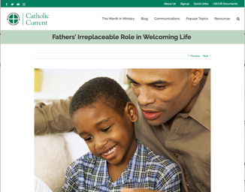  Read Online
June 27th  “We ask you to bless us in our vigilance for the gift of religious liberty. Give us the strength of mind and heart to readily defend our freedoms when they are threatened; give us courage in making our voices heard on behalf of the rights of your Church and the freedom of conscience of all people of faith.”  USCCB  “Prayer for the Protection of Religious Liberty” | 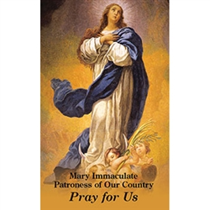  Download

Word of Life – June 2021

Bulletin Art
You are welcome to use these, provided they are not altered in any way, other than the size. Thank you!


Sunday, June 6th, 2021

Download Image (Other graphics are available on the same webpages.): English | Spanish

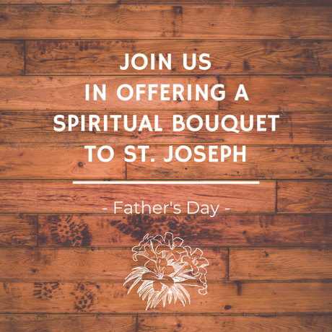
Sunday, June 13th, 2021

Download Image (Other graphics are available on the same webpages.): English | Spanish

Sunday, June 27th, 2021
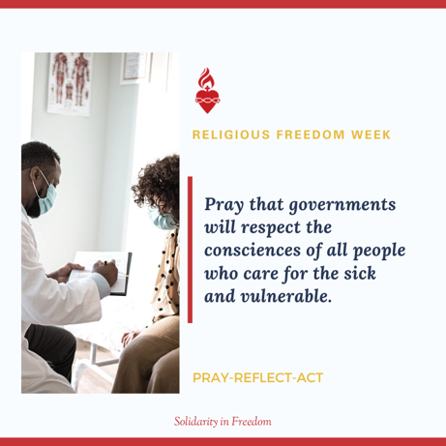

Download Image: English | Spanish
(Other graphics are available here.)

