**Word of Life: September 2024**

*Recommended dates are provided, but you are welcome to use these materials at any time!*

**Featured this Month…**

**September 9, 2024**

**Memorial of Saint Peter Claver, Priest  
National Day of Prayer for Peace in Our Communities**

St. Peter Claver was a Jesuit missionary from Spain who, in the 1600s, served and ministered to captured and enslaved Africans as they were taken off the slave ships landing in South America. St. Peter Claver desired to offer his life as “a slave of the slaves.”1

The U.S. Catholic bishops suggest that parishes “could use the National Day of Prayer for Peace in Our Communities, which falls on the feast of St. Peter Claver (September 9), to organize activities that foster community, dialogue, and reconciliation. These encounters will help open our minds and hearts more fully and continue the healing needed in our communities and our nation.”2

The following resources are available:

* [Prayer Service for the Feast Day of St. Peter Claver](http://www.usccb.org/issues-and-action/human-life-and-dignity/racism/upload/peter-claver-prayer-service-color.pdf)
* [Prayer for Peace in Our Communities](https://www.usccb.org/sites/default/files/2020-09/16-056-prayer-for-peace-prayer-card.pdf)
* [Prayer of the Faithful for the Day of Prayer for Peace in Our Communities](http://www.usccb.org/issues-and-action/human-life-and-dignity/racism/prayer-of-the-faithful-day-of-prayer-for-peace-in-our-communities.cfm)

Additional resources for the Day of Prayer are [available here](https://www.usccb.org/committees/ad-hoc-committee-against-racism/combatting-racism-parish-resources). Additional resources from the Ad Hoc Committee against Racism can be found at [www.usccb.org/racism](http://www.usccb.org/racism).

1 Collect from the Mass of Saint Peter Claver, *Roman Missal, Third Edition*.

2 USCCB, *Open Wide Our Hearts: The Enduring Call to Love*, 25.

Excerpt from *Roman Missal, Third Edition*, © 2010 International Commission on English in the Liturgy Corporation. All rights reserved.

**Racism and Life Issues**

In their November 2018 Pastoral Letter Against Racism, *[Open Wide Our Hearts: The Enduring Call to Love](http://www.usccb.org/issues-and-action/human-life-and-dignity/racism/upload/open-wide-our-hearts.pdf)*,the U.S. Catholic bishops wrote, “racism occurs because a person ignores the fundamental truth that … all [humans are] equally made in the image of God.”1 Racism fails to acknowledge the dignity with which God creates each person, and it contributes to a culture of death. The Church in the United States has spoken out consistently against abortion, assisted suicide, euthanasia, the death penalty, and other threats to human life; it is not a secret that these attacks have severely affected people of color. These brothers and sisters are targeted for **abortion,** disproportionally affected by **poverty**, have the greatest numbers on **death row**, and are most likely to feel pressure to end their lives through **assisted suicide** when facing serious illness.2

The feast of St. Peter Claver is an opportunity to highlight the connection between racism and various attacks against human life. As St. John Paul II reminded us, “*Where life is involved, the service of charity must be profoundly consistent.* It cannot tolerate bias and discrimination, for human life is sacred and inviolable at every stage and in every situation; it is an indivisible good”3 (emphasis added.) Additional [parish resources for combatting racism](http://www.usccb.org/issues-and-action/human-life-and-dignity/racism/parish-resources-on-racism.cfm) are available online.

1 USCCB, *Open Wide Our Hearts: The Enduring Call to Love*, 4.

2 *Ibid*, 30.

3 Pope Saint John Paul II, *Evangelium vitae* (Vatican City: Libreria Editrice Vaticana, 1995), no. 87.

Excerpt from *Evangelium vitae*, © 1995, Libreria Editrice Vaticana. Used with permission. All rights reserved.

**Word of Life – September 2024**

**Intercessions for Life**

|  |  |
| --- | --- |
| **September 1st**  For those who struggle to find meaning in their lives:  May they find reassurance in Christ  through the loving support of friends and family;  *We pray to the Lord:* | **Twenty-second Sunday**  **in Ordinary Time** |
| **September 8th**  For all people:  That we always recognize  each member of this human family as being loved by God and made in his image;  *We pray to the Lord:* | **Twenty-third Sunday**  **in Ordinary Time** |
| **September 15th**  For all whose hearts ache  from participating in abortion: may they be strengthened to seek  the Lord’s compassion, mercy, and healing  in the Sacrament of Reconciliation;  *We pray to the Lord:* | **Twenty-fourth Sunday**  **in Ordinary Time** |
| **September 22nd**  For all who are forgotten or cast off,  especially the unborn, the poor, the sick, and the aged:  may they be treated according to the dignity with which God created them;  *We pray to the Lord:* | **Twenty-fifth Sunday**  **in Ordinary Time** |
| **September 29th** May the life of every human person, from conception to natural death, be protected in our laws and cherished in our hearts; *We pray to the Lord*: | **Twenty-sixth Sunday**  **in Ordinary Time** |
|  |  |

**Word of Life – September 2024**

**Bulletin Quotes**

|  |  |
| --- | --- |
| **September 1st**  “Suicidal individuals—with or without a terminal illness—typically do not want to die… The patient requesting assisted suicide is often asking, ‘Does anyone want me to be alive, or care enough to talk me out of this request and support me through this difficult time?’”  USCCB Secretariat of Pro-Life Activities, “Every Suicide is Tragic”  [usccb.org/every-suicide-tragic](https://www.usccb.org/every-suicide-tragic) | [Order](https://store.respectlife.org/collections/pamphlets/products/every-suicide-is-tragic) | [Download](http://www.usccb.org/about/pro-life-activities/respect-life-program/2016/upload/rlp-16-flyer-every-suicide-is-tragic.pdf) |
| **September 8th**  “We pray to you, O Lord, that we always recognize each member of this human family as being made in your image and beloved by you, with worth and dignity.”  USCCB, “Prayer to Heal Racial Division” | [Read Online](https://www.usccb.org/prayers/prayer-heal-racial-division) |
| **September 15th**  “Throughout salvation history, God has welcomed repentant sinners with special joy. Jesus concludes the parable of the lost sheep with these words: ‘there will be more joy in heaven over one sinner who repents than over ninety-nine righteous people who have no need of repentance’ (Lk 15:7)*.”  *\*NABRE © 2010 CCD. Used with permission.*  USCCB Secretariat of Pro-Life Activities  “Life Matters: Forgiveness and Healing After Abortion” | [Order](https://store.respectlife.org/collections/pamphlets/products/life-matters-forgiveness-and-healing-after-abortion) | [Read Online](https://www.usccb.org/prolife/life-matters-forgiveness-and-healing-after-abortion) |
| **September 22nd**  “The truth of the Gospel of life is at the foundation of who we are as followers of Christ. In his earthly life, Jesus provided the perfect model for how we are to love our neighbor and live out the Gospel call: “Truly, I say to you, as you did it to one of the least of these my brethren, you did it to me” (Mt. 25:40).”*  *\*NABRE © 2010 CCD. Used with permission.*  USCCB Secretariat of Pro-Life Activities, “Live the Gospel of Life”  [respectlife.org/live-the-gospel-of-life](https://www.respectlife.org/live-the-gospel-of-life) | [Read Online](https://www.respectlife.org/live-the-gospel-of-life) | [Download](https://www.usccb.org/resources/respect-life-reflection-live-gospel-life) |
| **September 29th**  “Over the years, the FDA has bent the law and shown disregard for women’s health when it comes to chemical abortion. In 2000, mifepristone was first approved using an ‘accelerated’ review process that is supposed to be only for new drugs that treat serious illnesses and are better than existing treatments. But pregnancy is not an illness, and abortion drugs are riskier than surgical abortion.”  USCCB Secretariat of Pro-Life Activities, “Abortion Pills: The Basics” | [Download](https://www.usccb.org/sites/default/files/2024-03/abortionpills_basics_3.2024.pdf) |

**Word of Life - September 2024**

**Bulletin Art**

*You are welcome to use these, provided they are not altered in any way, other than the size. Thank you!*

**Sunday, September 1, 2024**

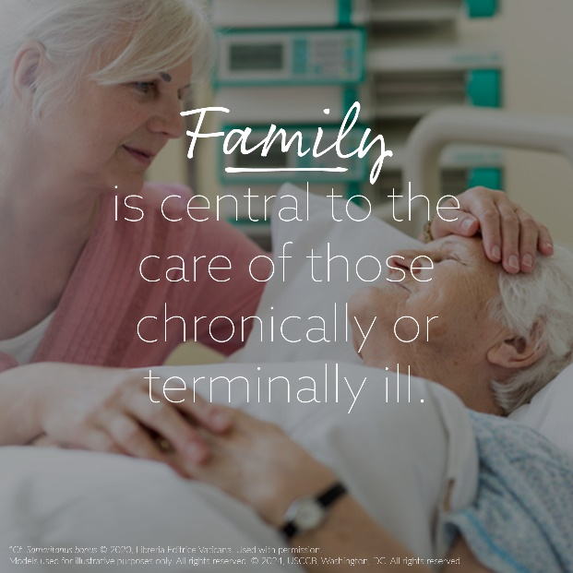Download Image: [English](https://www.usccb.org/resources/sb-graphics-4.png)

**Sunday, September 22, 2024**

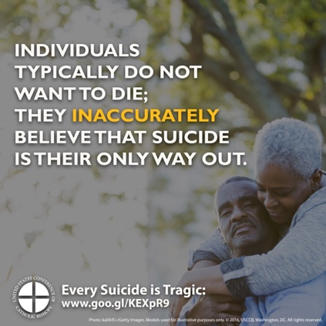Image: [English](https://www.usccb.org/resources/pray_for_life_04-2019-rev.png)