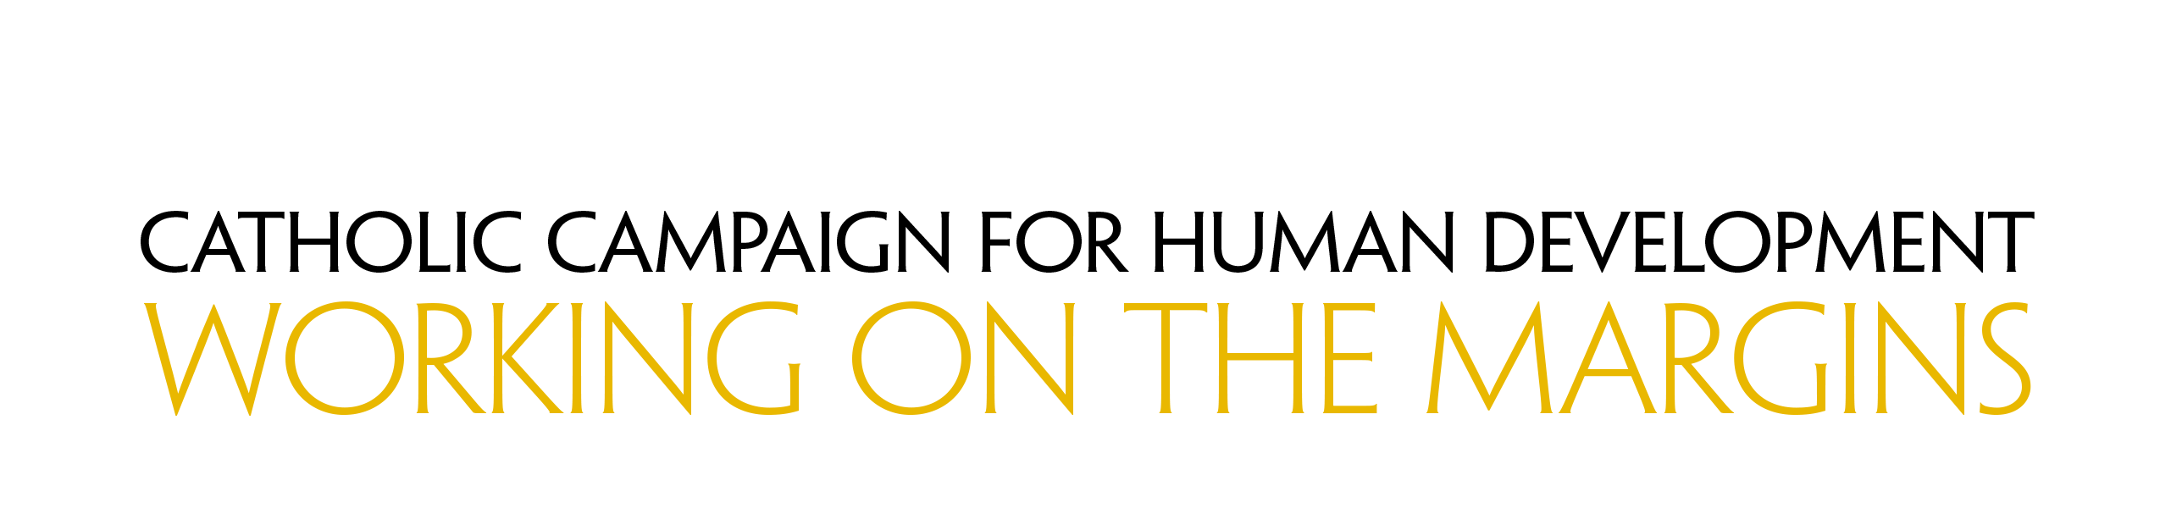

Bulletin Announcements

Week Before the Collection

Next week our special collection will support the Catholic Campaign for Human Development. More than thirty-eight million people in the United States live in poverty. This collection supports programs that empower people to identify and address the obstacles they face as they work to bring permanent and positive change to their communities. Learn more about the Catholic Campaign for Human Development at www.usccb.org/cchd.

Week of the Collection

Please be generous in this week’s special collection for the Catholic Campaign for Human Development. In the United States, one in eight people lives in poverty. With this collection, you support programs that address the root causes of poverty and provide a sustainable future for those struggling across the country. In addition, 25% of the funds we collect remain in our diocese to fund local anti-poverty projects. Please prayerfully consider how you can support this collection and those working on the margins. More information about the Catholic Campaign for Human Development can be found at www.usccb.org/cchd.

Week After the Collection

Thank you for your generous support last week for the collection for the Catholic Campaign for Human Development! As a parish, we raised $[amount] to support those on the margins who live in poverty in the United States. If you missed the collection, it’s not too late to give! Visit www.usccb.org/nationalcollections and click “How to Give” under “Resources.”

