Social Media Tool Kit

Facebook Profile Image
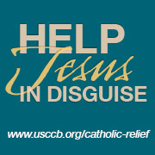
Facebook Banner Image
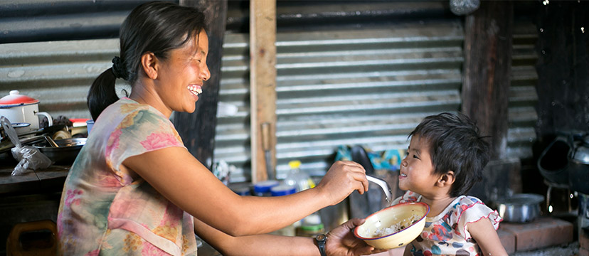

Post 1: Before the Collection


Facebook/Twitter/Instagram:
The Catholic Relief Services Collection supports six Catholic agencies that serve the vulnerable and marginalized at home and abroad. Support the collection at Mass! #JesusInDisguise #1church1mission www.usccb.org/catholic-relief

Post 2: Before the Collection
Facebook/Twitter/Instagram:
Join us in praying for all who benefit from The Catholic Relief Services Collection. #JesusInDisguise #1church1mission



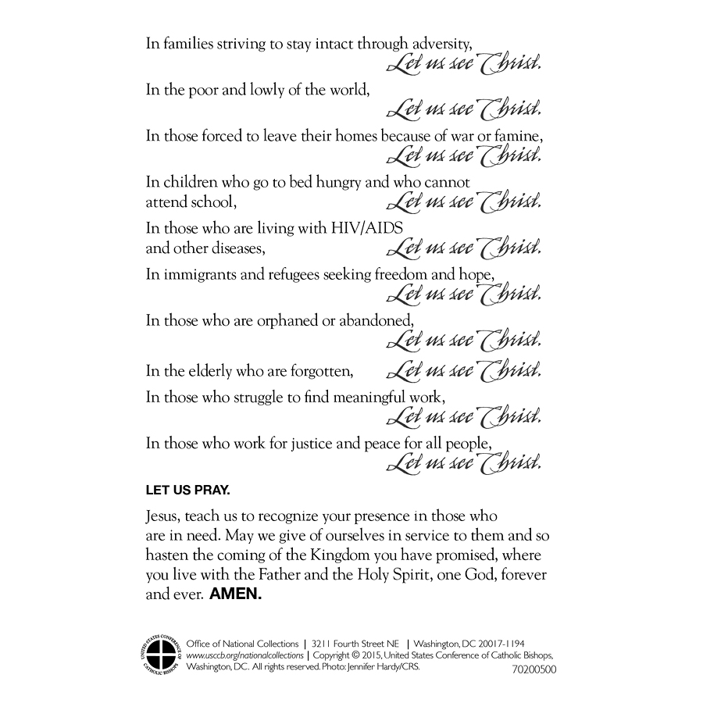

Post 3: Before the Collection

Facebook/Twitter/Instagram:
In families trying to stay intact through adversity, let us see Christ. Support The Catholic Relief Services Collection at Mass! #JesusInDisguise #1church1mission www.usccb.org/catholic-relief

Post 4: Before the Collection
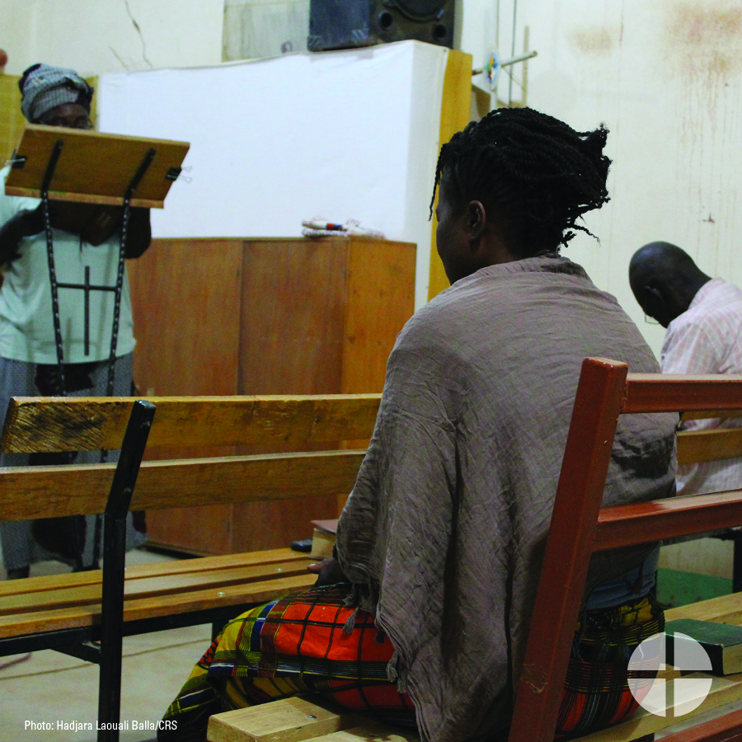
Facebook/Twitter/Instagram:
In the poor and lowly of the world, let us see Christ. Support The Catholic Relief Services Collection at Mass, and help #JesusInDisguise #1church1mission www.usccb.org/catholic-relief

Post 5: Before the Collection
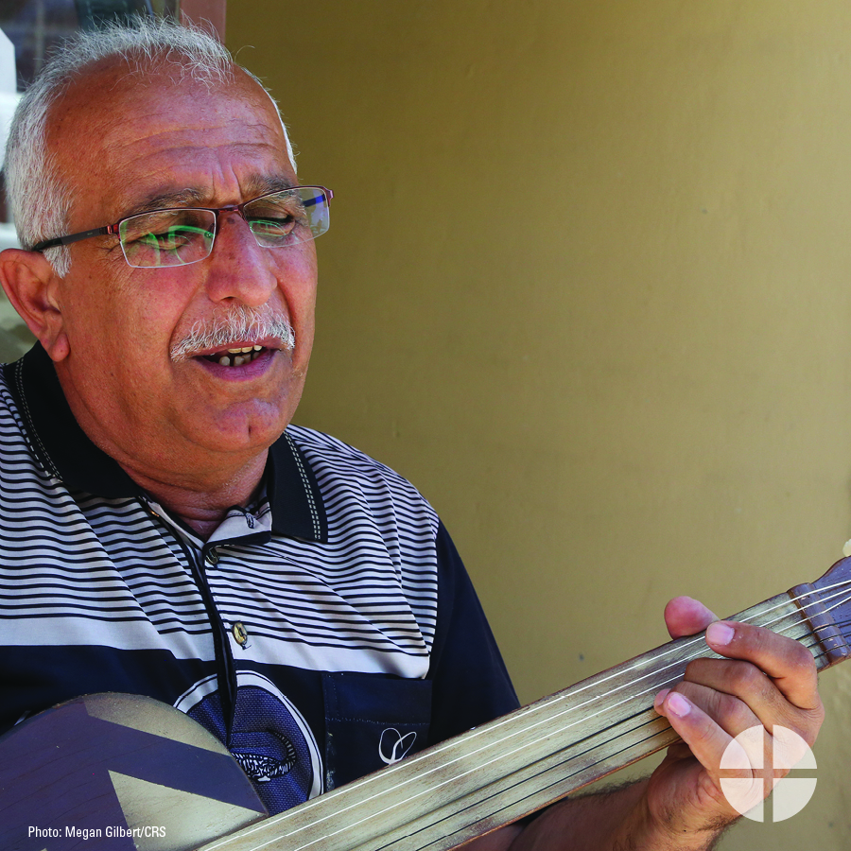

Facebook/Twitter/Instagram:
In those forced to leave their homes because of war or famine, let us see Christ. Support The Catholic Relief Services Collection at Mass! #JesusInDisguise #1church1mission www.usccb.org/catholic-relief

Post 6: Before the Collection


Facebook/Twitter/Instagram:
In children who go to bed hungry and who cannot attend school, let us see Christ. Help #JesusInDiguise, and support The Catholic Relief Services Collection at Mass! #1church1mission www.usccb.org/catholic-relief

Post 7: Before the Collection

Facebook/Twitter/Instagram:
In immigrants and refugees seeking freedom and hope, let us see Christ. Help #JesusInDisguise and support The Catholic Relief Services Collection at Mass! #1church1mission www.usccb.org/catholic-relief

Post 8: Before the Collection

Facebook/Twitter/Instagram:
In those who are orphaned or abandoned, let us see Christ. Support The Catholic Relief Services Collection at Mass! #JesusInDisguise #1church1mission www.usccb.org/catholic-relief

Post 9: Before the Collection


Facebook/Twitter/Instagram:
In the elderly who are forgotten, let us see Christ. Support The Catholic Relief Services Collection at Mass, and help #JesusInDisguise #1church1mission www.usccb.org/catholic-relief

Post 10: Week of the Collection

Facebook/Twitter/Instagram:
In those who struggle to find meaningful work, let us see Christ. Support The Catholic Relief Services Collection at Mass this weekend! #JesusInDisguise #1church1mission www.usccb.org/catholic-relief

Post 11: Week of the Collection

Facebook/Instagram:
In those who work for justice and peace for all people, let us see Christ. Please be generous to The Catholic Relief Services Collection at Mass! #JesusInDisguise #1church1mission www.usccb.org/catholic-relief

Post 12: Week of the Collection


Facebook/Instagram:
This weekend, we will take up The Catholic Relief Services Collection. Please prayerfully consider supporting this collection at Mass! #JesusInDisguise #1church1mission www.usccb.org/catholic-relief
Post 13: Week of the Collection

Facebook/Twitter/Instagram:
We are taking up The Catholic Relief Services Collection this weekend. Learn more, and help #JesusInDiguise #1church1mission www.usccb.org/catholic-relief

Post 14: Week of the Collection
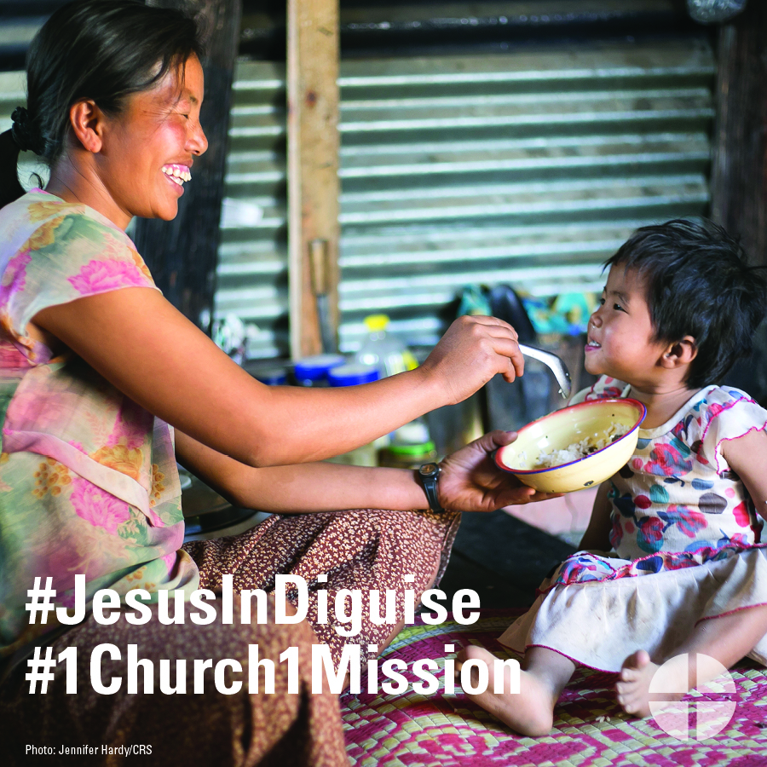

Facebook/Twitter/Instagram:
The Catholic Relief Services Collection is this weekend! Support this collection, and help #JesusInDisguise #1church1mission www.usccb.org/catholic-relief

Post 15: Day of the Collection
Facebook/Twitter/Instagram:
Today is The Catholic Relief Services Collection! Thank you for helping #JesusInDisguise #1church1mission www.usccb.org/catholic-relief

