Social Media Tool Kit
Kit de herramientas para los medios sociales

Post 1: Before the Collection
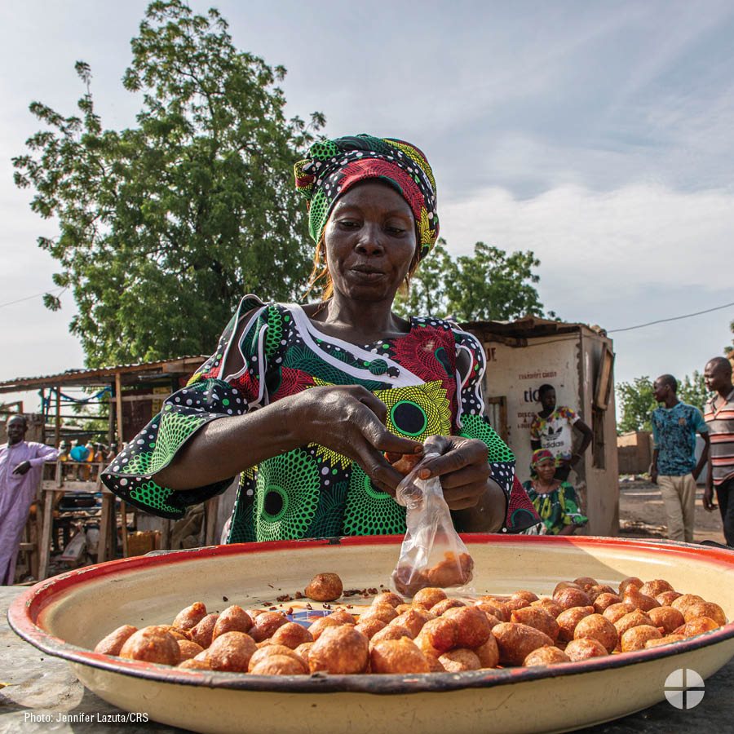
Facebook/X/Instagram
The Catholic Relief Services Collection supports six Catholic agencies that serve the vulnerable and marginalized at home and abroad. Support the collection at Mass. #RevealChristsLove #1church1mission www.usccb.org/catholic-relief

Aporte 1: Antes de la colecta
Facebook/X/Instagram
The Catholic Relief Services Collection apoya a seis agencias católicas que sirven a personas vulnerables y marginadas en nuestro país y en el extranjero. Apoya a la colecta en la Misa. #RevelaElAmorDeCristo #1iglesia1misión www.usccb.org/catholic-relief

Post 2: Before the Collection
Facebook/X/Instagram
To those forced to leave their homes because of war or famine, let us reveal Christ’s love. Support The Catholic Relief Services Collection at Mass. #RevealChristsLove #1church1mission www.usccb.org/catholic-relief

Aporte 2: Antes de la colecta
Facebook/X/Instagram
A los que están forzados a dejar sus hogares debido a la guerra o la hambruna, revélales el amor de Cristo. Apoya a The Catholic Relief Services Collection en la Misa. #RevelaElAmorDeCristo #1iglesia1misión www.usccb.org/catholic-relief

Post 3: Before the Collection

Facebook/X/Instagram
To immigrants and refugees seeking freedom and hope, let us reveal Christ’s love. Support The Catholic Relief Services Collection at Mass. #RevealChristsLove #1church1mission www.usccb.org/catholic-relief

Aporte 3: Antes de la colecta
Facebook/X/Instagram
A los inmigrantes y refugiados que buscan libertad y esperanza, revélales el amor de Cristo. Apoya a The Catholic Relief Services Collection en la Misa. #RevelaElAmorDeCristo #1iglesia1misión www.usccb.org/catholic-relief

Post 4: Week of the Collection
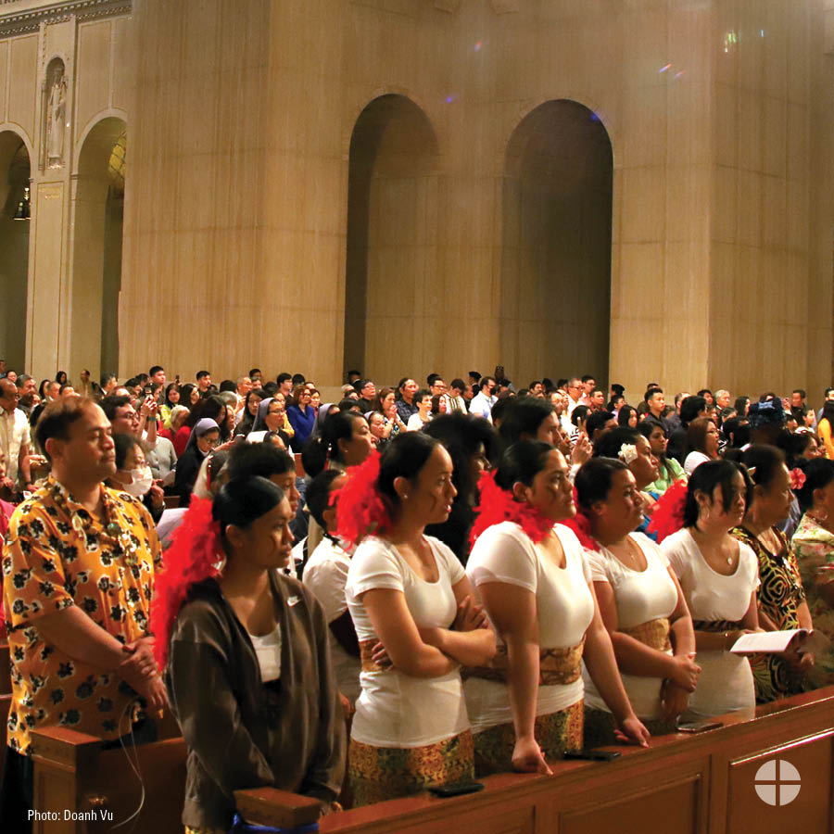
Facebook/X/Instagram
This week we will take up The Catholic Relief Services Collection. Please prayerfully consider supporting this collection at Mass. #iGiveCatholicTogether also accepts online donations for this collection at usccb.igivecatholictogether.org/organizations/usccb-the-catholic-relief-services-program #RevealChristsLove #1church1mission www.usccb.org/catholic-relief

Aporte 4: Antes de la colecta
Facebook/X/Instagram
Esta semana, llevaremos a cabo The Catholic Relief Services Collection. Por favor, en oración, considera dar tu apoyo a esta colecta en la Misa. #iGiveCatholicTogether tambien acepta donativos en línea para esta colecta usccb.igivecatholictogether.org/organizations/usccb-the-catholic-relief-services-program #RevelaElAmorDeCristo #1iglesia1misión www.usccb.org/catholic-relief

Post 5: Day of the Collection

Facebook/X/Instagram
Today is The Catholic Relief Services Collection! Thank you for revealing Christ’s love. #RevealChristsLove #1church1mission www.usccb.org/catholic-relief

Foto 5: Día de la colecta
Facebook/X/Instagram
¡Hoy es The Catholic Relief Services Collection! Gracias por revelar el amor de Cristo. #RevelaElAmorDeCtristo #1iglesia1misión www.usccb.org/catholic-relief

