Sample Bishop’s Letter
May be read from the pulpit or inserted into the parish bulletins.

Dear Brothers and Sisters in Christ,

Soon our diocese will take up The Catholic Relief Services Collection. Your support for this collection provides aid to vulnerable people affected by war, natural disasters, and exploitation.

Human trafficking is the exploitation of a person through forced labor, domestic servitude, or commercial sex. It affects women, children, and men of all ages everywhere in the world, including in the United States. Although some victims of human trafficking are also smuggled across national borders, human trafficking involves anyone who is compelled by force, fraud, or coercion to provide work or service, regardless of nationality or citizenship or geographic location.
Poverty, isolation from the support of family and friends, and cultural or language barriers are among the factors that place people at risk of trafficking. Native Americans are particularly vulnerable to trafficking and violence, as many live in poverty away from reservations or tribal lands. Meanwhile, many reservations cover vast rural territories and have few law enforcement resources to aid victims of trafficking and bring perpetrators to justice.
In light of these challenges, successful antitrafficking efforts must involve communities that can recognize the signs of trafficking and provide direct assistance to victims. School teachers, parish staff and clergy, and health care providers at community clinics—with training to recognize the signs of human trafficking in their own communities—can be effective in combatting the exploitation of those they serve.

With funds received through The Catholic Relief Services Collection, the office of Migration and Refugee Services (MRS) of the United States Conference of Catholic Bishops launched a pilot program to combat human trafficking among indigenous Hawaiians in the Diocese of Honolulu and on the St. Regis Mohawk Reservation in the Diocese of Ogdensburg, New York. Working with local partners, MRS staff assessed the challenges facing those communities, trained local leaders to recognize the signs of human trafficking, and helped leaders establish networks to respond to the needs of victims.

Your support of The Catholic Relief Services Collection empowers and brings healing to communities affected by poverty and injustice. Your participation helps MRS and five other Catholic ministries to reveal Christ’s love to victims of trafficking, war, and natural disaster, both around the world and here in the United States. Please prayerfully consider how you can support the collection this year. To support the collection with an online donation, please use this QR code or visit iGiveCatholic at igivecatholic.org/story/USCCB-CRS

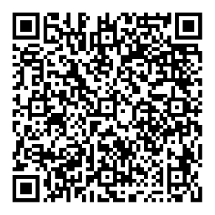

To learn more about the collection and the people who benefit, please visit www.usccb.org/catholic-relief.

Thank you for your generous support for The Catholic Relief Services Collection.

Sincerely yours in Christ,

(Bishop name, title, and signature)

