Word of Life: Special Edition
Dobbs Parish Leader Kit
Featured Resources…
Advocate Locally
Connect with your local state Catholic conference for information and resources to advocate for life in your local government.
- National Association of State Catholic Conference Directors
Find your state Catholic conference in this directory and share the website and their resources in parish bulletins, newsletters, websites, and social media.
Stay in the Loop
Sign up to stay updated with news, updates, prayer efforts, and action opportunities.
- Respect Life Prayer and Action
Sign up to receive prayers, action alerts to contact Congress, and ways to strengthen a culture of life in your community.
- USCCB Pro-Life Action Alerts
Sign up for pro-life action alerts so that you can contact your elected representatives to express your concerns and opinions on upcoming legislation. (Make sure to select "Pro-Life" under Areas of Interest.)
- Word of Life
Word of Life is a monthly resource for dioceses and parishes, available in English and Spanish. Each month you’ll be provided with special feature resources, intercessions, and bulletin quotes and graphics. (Subscribe here.)
Online Resources
Websites you should know.
- walkingwithmoms.com
Learn more about the Church’s nationwide, parish-based effort to prayerfully support pregnant and parenting mothers in need. Take the pledge and download materials to bring Walking with Moms in Need to your parish.
- hopeafterabortion.org | esperanzaposaborto.org
This website is for anyone seeking information, help, and healing after participation in an abortion. Dioceses with a confidential, designated helpline are listed on the Find Help map.
- respectlife.org
Find ready-to-use resources, prayers, graphics, and information on various Respect Life topics. Check out our parish action guides, leader toolkits, monthly prayer guides, and more!
- prayfordobbs.com
Join Catholic, Orthodox, and Protestant Christians uniting in prayer and action for the Supreme Court case, Dobbs v. Jackson Women’s Health Organization.

Word of Life – Special Edition
Intercessions for Life
These intentions are appropriate for inclusion in the Prayer of the Faithful at Sunday Mass. They can also be printed in the weekly bulletin, included in parish Holy Hours or Rosaries, featured in email newsletters, shared on social media platforms, or prayed during personal or family prayer.

For the legal protection of unborn children
and for loving support for their mothers
before and after their births;
We pray to the Lord:

For expectant mothers considering abortion:
May the Lord give them the grace to choose life
for their children and send them caring people to help them meet their needs;
We pray to the Lord:

For expectant mothers:
May they be lovingly supported
by the fathers of their children
in welcoming new life;
We pray to the Lord:

May friends and families of women
with difficult pregnancies
provide loving, life-affirming support
for both mother and child;
We pray to the Lord:

May Catholics recognize the needs
of pregnant and parenting women
present in their communities
and help them to obtain the necessities of life;
We pray to the Lord:

May Catholic parish communities strive
to provide compassionate, tangible support
to pregnant and parenting mothers
in need of assistance;
We pray to the Lord:

For the Church:
May we faithfully witness in word and in deed
to the dignity of every human life
through comprehensive care
of mothers and their children;
We pray to the Lord:

May the Church redouble its efforts
to accompany mothers in need,
offering them compassionate care and support;
We pray to the Lord:

May the Church better understand
the challenges facing mothers in need
and respond with increased care and support;
We pray to the Lord:

May Catholic parishes become islands of mercy for women, children, and families
in need of assistance;
We pray to the Lord:

For our nation:
May we create a society in which
the legal protection of human life
is accompanied by profound care
for mothers and their children;
We pray to the Lord:

For those who have participated in an abortion
and feel they have committed an unforgiveable sin: May they come to know the Lord’s limitless mercy, and turn to Him for forgiveness and healing;
We pray to the Lord:

For those who suffer after participating in an abortion:
May they find peace through the Sacrament of Reconciliation and be consoled through the Church’s abortion healing ministry;
We pray to the Lord:

Word of Life – Special Edition

Bulletin Quotes & Educational Tools
These short quotes can be printed in weekly bulletins, featured in email newsletters, and shared on websites and social media platforms. Each quote comes from a full-length educational resource that can also be shared digitally or through printed materials.
Standing with Moms in Need  “The Catholic Church has a long history of service to those who are most vulnerable and remains the largest private provider of social services in the United States. Through the sacrificial efforts of faithful Catholics, the Church serves millions through diocesan ministries and agencies, Catholic hospitals and healthcare systems, immigration clinics, shelters, and Catholic schools and parishes. From religious communities to pregnancy care centers, from refugee resettlement services to foster care and adoption agencies, and from maternity homes to parish-based ministries, the Church consistently bears witness in word and deed to the beauty and dignity of every human life—including both mother and child.”  USCCB Committee Chairmen  “Standing with Moms in Need” | 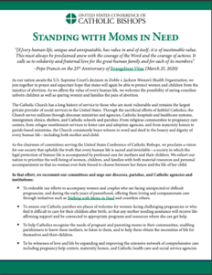  Read Online | Download
Pregnancy Support  “Perhaps one of your friends has become pregnant unexpectedly. As someone who has been there, I encourage you to support your friend in her new journey of being a mother… Your support might be the only support she receives. Even if we never know how, the smallest things we do can change someone’s life. You can make a difference in her life. Will you?” Learn ten tips at respectlife.org/support-her.  USCCB Secretariat of Pro-Life Activities  “10 Ways to Support Her When She’s Unexpectedly Expecting” | 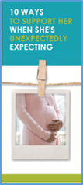  Order | Download
Serving Moms in Need  “By reaching out to lovingly support and care for pregnant women and their children, we witness to the sanctity of every human person, in every stage and every circumstance.”  *Excerpt from Evangelium vitae, © 1995, Libreria Editrice Vaticana. Used with permission. All rights reserved.  USCCB Secretariat of Pro-Life Activities  “Serving Moms in Need: Living the Gospel of Life” | Download
Abortion Healing  “Many people know someone personally who is suffering because of an abortion. If a friend confided in you tomorrow that she had an abortion, would you be able to respond in a way that brings her closer to healing?  USCCB Secretariat of Pro-Life Activities  “How to Talk to a Friend Who’s Had an Abortion” | Order | Read Online
Expectant Mothers Considering Adoption  “Maya discovered she was pregnant six months into her freshman year of college. When her son was born, she placed him with a very kind adoptive family; she ‘just knew they were the right choice.’ Now, years later, Maya emphasizes the importance of offering ongoing support to expectant mothers considering adoption.” Learn how at respectlife.org/mothers-considering-adoption.  USCCB Secretariat of Pro-Life Activities  “Accompanying Expectant Mothers Considering Adoption” | 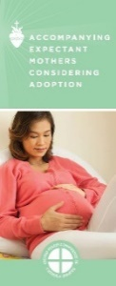  Order | Download
Abortion Healing  “While many Catholics want to help women and men heal from past abortions, most don't know how to begin. Here are a few ways that Catholics of different backgrounds can assist friends, family members, fellow parishioners, clients—or perhaps even themselves.” Learn how you can become an instrument of God’s mercy at usccb.org/bridges-of-mercy.  USCCB Secretariat of Pro-Life Activities,  “Bridges of Mercy for Healing after Abortion”, usccb.org/bridges-of-mercy | 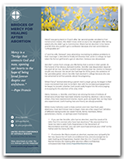  Download
Friend Considering Abortion  “We are created to walk with and support one another; we don't need to fear reaching out in love. Help your friend experience the strength of God's message that resounds throughout time: ‘Do not fear: I am with you’ (Isaiah 41:10).”  USCCB Secretariat of Pro-Life Activities  “What to Do When a Friend Is Considering Abortion”, respectlife.org/l-o-v-e  NABRE © 2010 CCD. Used with permission. | Order Download
The Gospel of Life  “Having received the gift of the Gospel of Life, we are the people of life and a people for life. It is our duty to proclaim the Gospel of Life to the world. To proclaim Jesus is to proclaim life itself. Gratitude and joy at the incomparable dignity of the human person impel us to bring the Gospel of life to the hearts of all people and make it penetrate every part of society.”  USCCB Secretariat of Pro-Life Activities  “The Gospel of Life: A Brief Summary”  respectlife.org/gospel-of-life-summary | Download | Read Online  Online

Word of Life – Special Edition

Bulletin Art
You are welcome to download and use these images in bulletins, newsletters, parish websites, and social media. (Images may not be altered in any way, other than the size.)

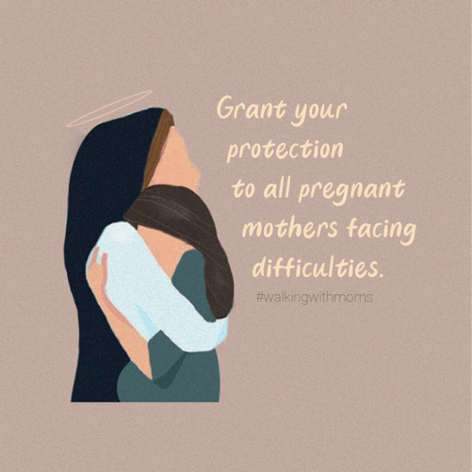
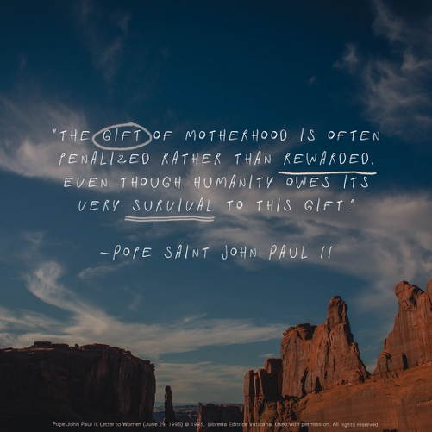
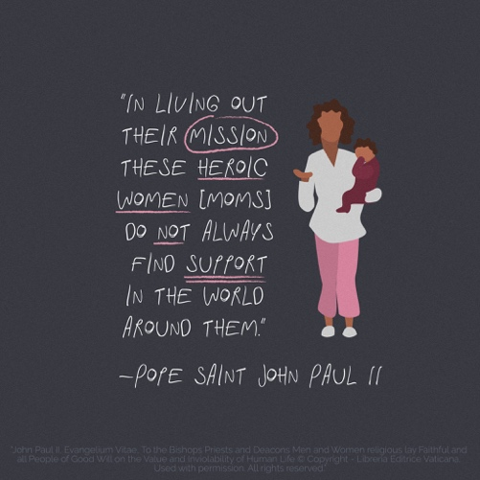
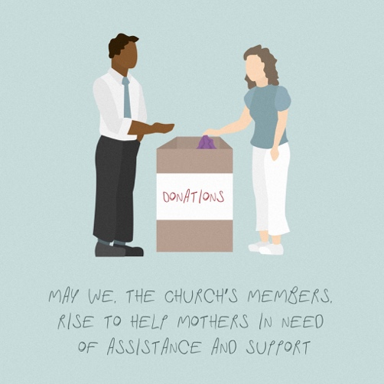
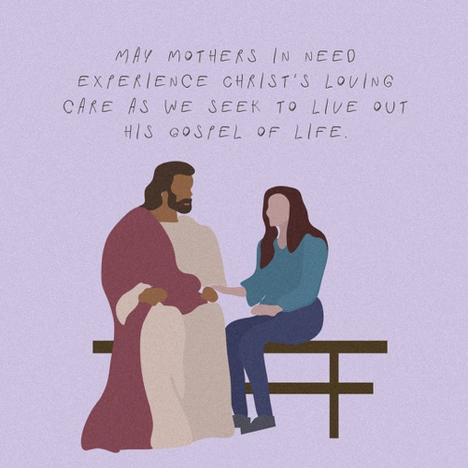
Download: https://www.usccb.org/resources/walking-moms-need-graphics
