Option 1
[Hyperlink graphic to https://www.votervoice.net/USCCB/Campaigns/83763/Respond.]

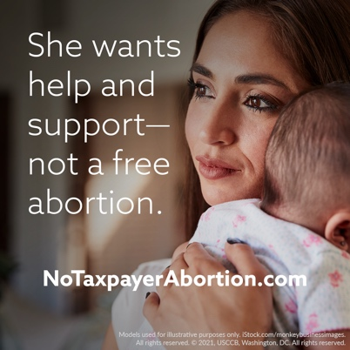

Option 2 (with or without a graphic)
The Hyde amendment is SUPPORTED by low-income women, with 55% of low-income people saying they specifically support the Hyde amendment. Tell Congress not to take it away: https://bit.ly/no-taxpayer-abortion-action.

Option 3 (with or without a graphic)
Some powerful Members of Congress want taxpayer dollars to pay for abortion for poor women.
To offer a woman a government-funded abortion, but not the resources she needs to care for her child, is not “choice” but coercion.
Government money would be better spent supporting women in crisis pregnancies and struggling new mothers than paying to end the lives of their children.
Tell Congress to save the Hyde amendment: https://bit.ly/no-taxpayer-abortion-action.

Graphics: https://www.usccb.org/resources/graphics-no-taxpayer-abortion
