**Social Media Tool Kit**

**Post 1: Before the Collection**

**Facebook/Instagram/Twitter:**   
Do you follow #PopeFrancis as he works to spread the Gospel and help those who are suffering? Support the Peter’s Pence Collection to help his message of mercy travel even further. #WitnessCharity #1church1mission   
<http://www.peterspence.va/en.html>

**Post 2: Before the Collection**

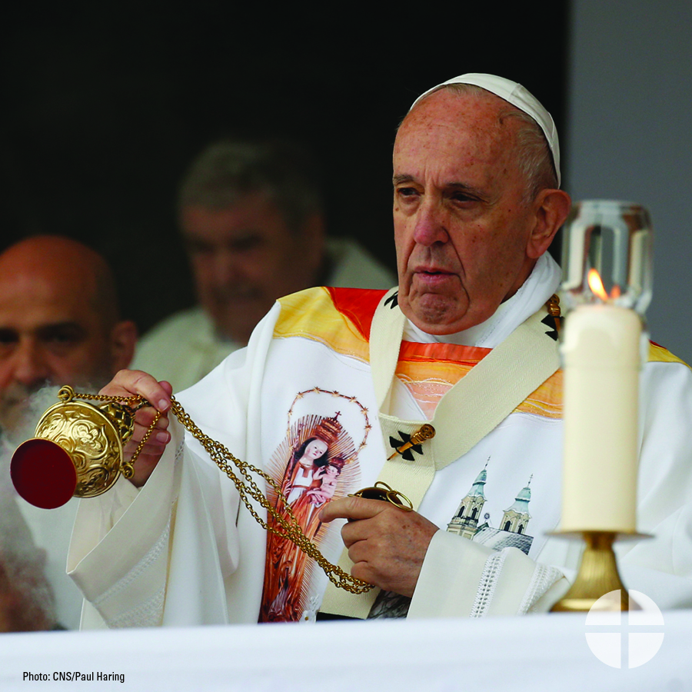

**Facebook/Twitter:**   
Learn more about the Peter’s Pence Collection and support #PopeFrancis and his works! #WitnessCharity #1church1mission <http://www.peterspence.va/en.html>

**Post 3: Week of the Collection**

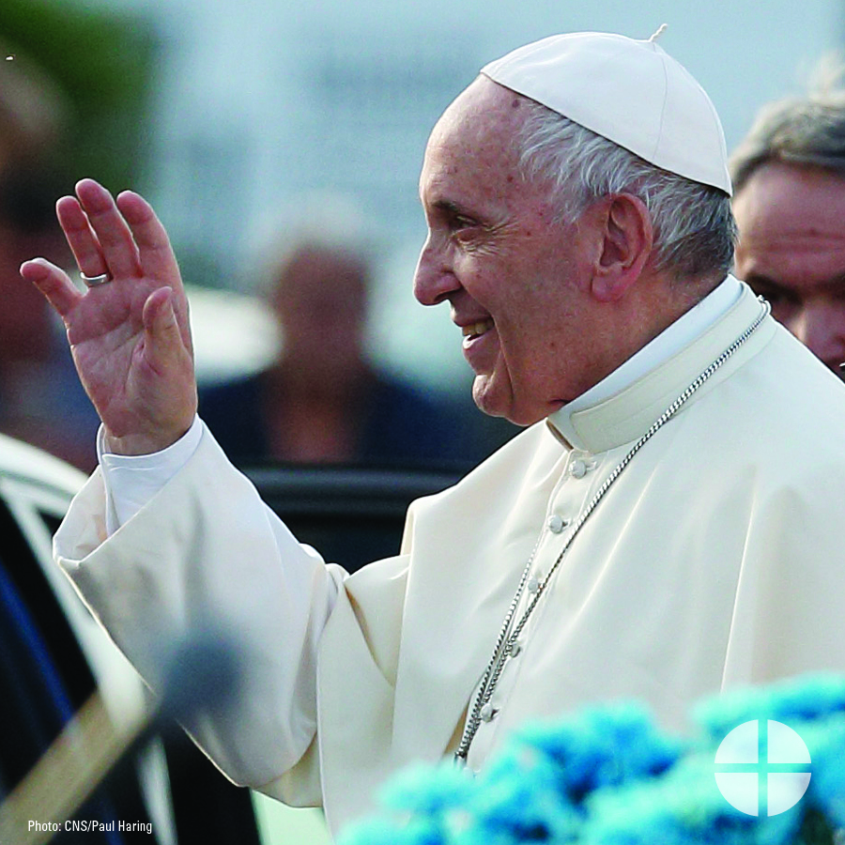

**Facebook/Twitter:**   
Did you know the Peter’s Pence Collection is rooted in ancient Christianity? Learn more about this collection and #WitnessCharity by supporting it this weekend at Mass! #1church1mission <http://www.peterspence.va/en.html>

**Post 4: Day of the Collection**

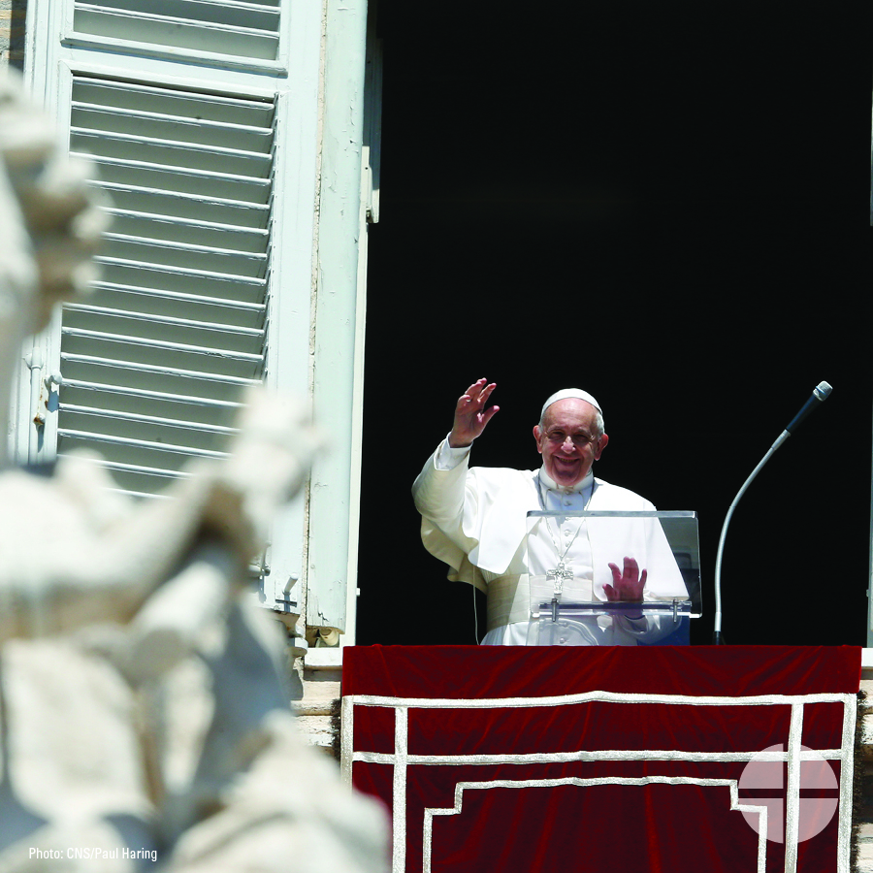

**Facebook/Instagram/Twitter:**   
Today is the Peter’s Pence Collection! Your generosity will support the activities of the Holy See and the charitable works of #PopeFrancis. Please prayerfully consider how you can support the collection this year. #WitnessCharity #1church1mission <http://www.peterspence.va/en.html>