

­­

*Prayer Guide* | *MAY 2022*

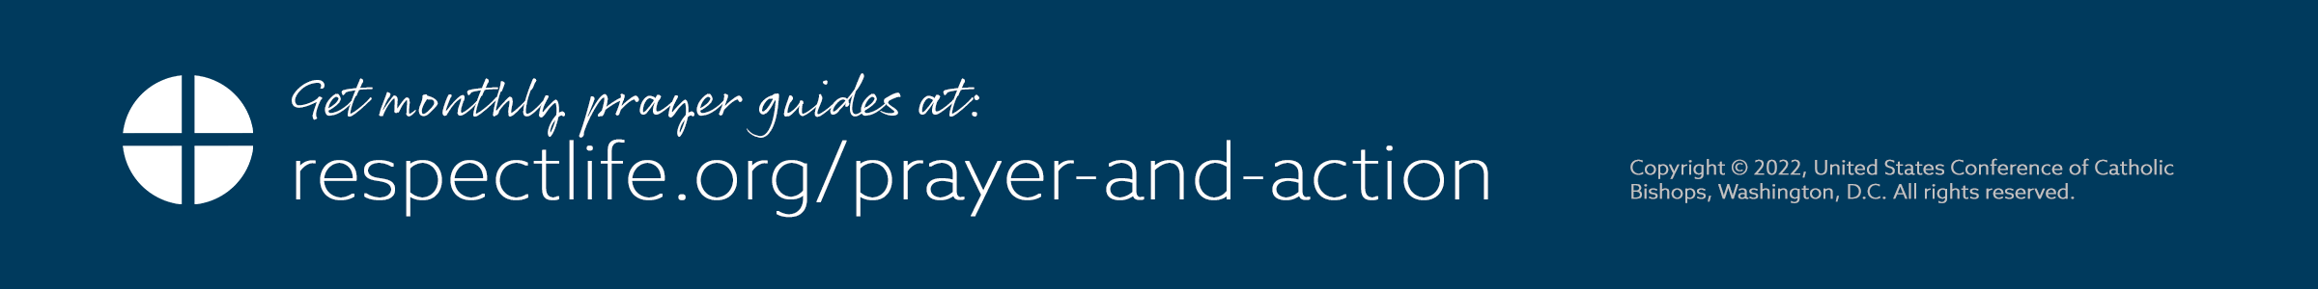–­

INTERCEDE

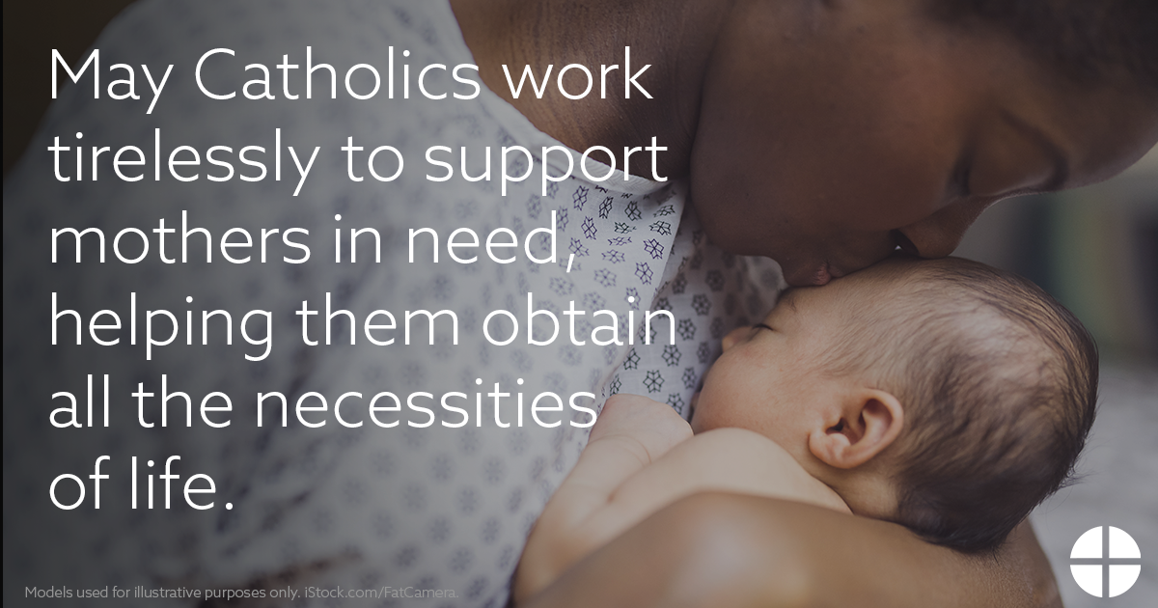

PRAY

*Our Father, 3 Hail Marys, Glory Be*

REFLECT

The month of May is truly a celebration of motherhood. Traditionally, May has been dedicated to the Blessed Virgin Mary. It is also the time in which we honor and thank our earthly mothers for their sacrificial love. And the Feast of the Visitation on May 31 celebrates the meeting of two mothers—Mary and Elizabeth—both with a child hidden within their wombs.

Scripture tells us that, following the Annunciation, Mary set out *in haste* to visit her cousin Elizabeth who is pregnant (*Lk* 1:39). Despite being pregnant herself, Mary undertakes the long and likely difficult journey to be at Elizabeth’s side. The Blessed Mother’s example demonstrates supporting and accompanying mothers, especially those who may be experiencing challenging or difficult circumstances. Yet in a culture that disproportionately values independence and self-reliance, mothers in need can too often be left isolated and alone, not knowing where to turn for support or assistance. Mary provides a model of how we, as Catholics, are called to come alongside such mothers.

In addition to “walking with” mothers in love, support, and friendship, we can also help answer their needs for practical and material assistance. Inspired by our Blessed Mother, we can help connect mothers with the Church’s extensive network of social services to ensure mothers and their children obtain all the necessities of life. Through generous stewardship of the gifts God has entrusted to us of prayer, time, talent, and treasure, we can help meet the needs of mothers as they welcome and care for God’s precious gift of life.

ACT *(choose one)*

* In preparation for the Feast of the Visitation, join Catholics nationwide in praying *A Novena for Life* from May 22-30. (Sign up to receive the daily prayers at [respectlife.org/visitation](https://www.respectlife.org/visitation).)
* Read and meditate on the Gospel account of the Visitation ([Lk 1:39-56](https://bible.usccb.org/bible/luke/1?39)). Ask the Blessed Mother’s intercession for God to reveal how your gifts can help serve vulnerable mothers in your community.
* Offer some other sacrifice or prayer that you feel called to do for this month’s intention.

ONE STEP FURTHER

Invite friends and family to join in praying the novena in honor of the Visitation by sharing this signup link: [respectlife.org/visitation](https://www.respectlife.org/visitation).

DID YOU KNOW?

The Church has a nationwide initiative called *Walking with Moms in Need* that helps Catholics form parish teams to identify resources in their local area and connect pregnant and parenting mothers with support and services. Learn more: [WalkingWithMoms.com](https://www.walkingwithmoms.com/).