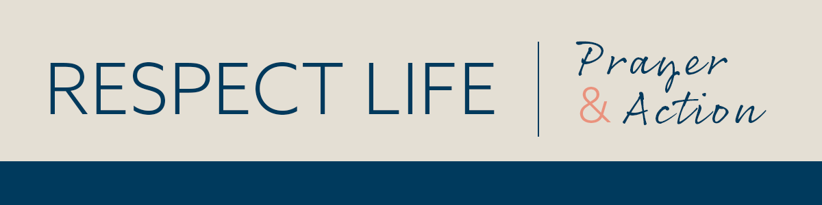

­­

*Prayer Guide* | *AUGUST 2022*

–­

INTERCEDE

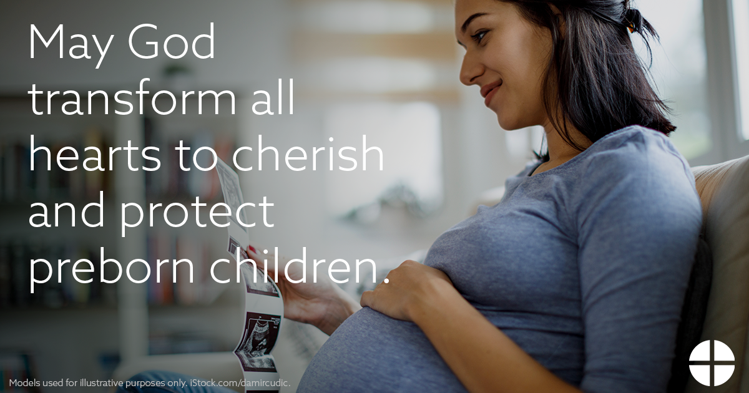

PRAY

*Our Father, 3 Hail Marys, Glory Be*

REFLECT

As we praise God for the Supreme Court’s overturn of *Roe v. Wade*, we also pray for the many souls who don’t recognize the full humanity of children in the womb and their right to be protected. As the Church has long taught, “All human beings, from their mothers’ womb, belong to God who searches them and knows them, who forms them and knits them together with his own hands, who gazes on them when they are tiny shapeless embryos and already sees in them the adults of tomorrow” (*EV*, 61). In the face of challenging or unexpected pregnancies in difficult circumstances, authentic love and charity tell us that we must protect and care both for women and their children ([Standing with Moms in Need](https://www.usccb.org/resources/statement-standing-with-moms-031522.pdf)).

In the Gospel account of the Transfiguration, Peter, James, and John witness Jesus in His glorified appearance. During a time of prayer, Jesus’s face is transformed, and His clothes become dazzling white. He had just told them that it was necessary for him to suffer. In this vision, the chosen disciples are given a preview of His future glory, a glory that had been

hidden, but that would be fully revealed on the other side of the Passion. Darkness will not have the last word, but rather the light of His glory.

We pray that all who support abortion will see the full value and dignity of preborn children, hidden within the mystery of the womb. May Christ also grant us the courage to shine His light throughout our lives, bearing loving, courageous, and steadfast witness to the dignity of every human life. The darkness of abortion will not have the last word.

ACT *(choose one)*

* Meditate on the Gospel account of the Transfiguration ([bit.ly/luke-9-28](https://bit.ly/luke-9-28)). Ask Jesus to transform hearts to recognize the equal value and dignity of preborn children.
* Choose one day this week and fast from caffeine, sweets, or snacks.
* Offer some other sacrifice or prayer that you feel called to do for this month’s intention.

ONE STEP FURTHER

This year’s new Respect Life materials highlight the call to serve moms in need and are available at [www.respectlife.org/called-to-serve](http://www.respectlife.org/called-to-serve). Check back in the coming weeks to see additional resources that you can suggest to your parish to use during Respect Life Month in October!