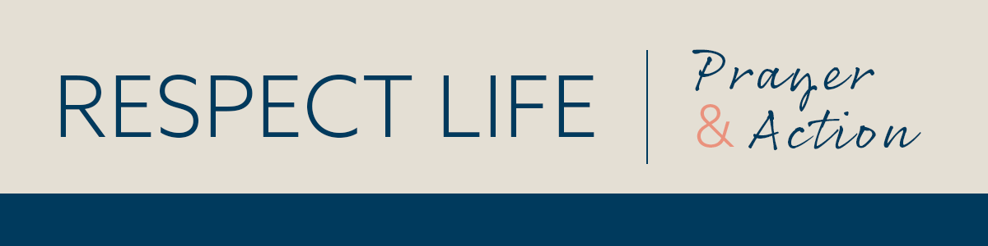

­­

*Prayer Guide* | *NOVEMBER 2022*

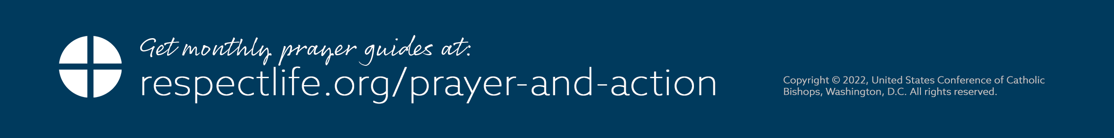–­

The Good Samaritan shows us that our relationship with our suffering neighbor should embrace the qualities of attention, listening, understanding, compassion, and accompaniment. We need to learn how to look upon our own existence and that of others and to recognize that every human existence is a unique and unrepeatable wonder, one to be received and welcomed as a gift. We are invited to “remain” at the side of a suffering person, as the Blessed Mother and the beloved disciple remained at the foot of the Cross. Their example provides a way to understand that, even when it seems that there is nothing more to do, there is much to do—because “remaining” by the side of the sick is a sign of love and of the hope that it contains. Healed by Jesus, we become men and women called to proclaim his healing power and provide care for our neighbors, until the very end.

*Reflection adapted from “*[*The Witness of the Good Samaritan: Palliative Care and Hospice*](https://www.usccb.org/resources/witness-good-samaritan-palliative-care-and-hospice)*.” Scriptural excerpts from NABRE © 2010 CCD. Used with permission. All rights reserved.*

ACT *(choose one)*

* Offer the Prayer of the Elderly written by Pope St. John Paul II ([bit.ly/prayer-elderly](https://bit.ly/prayer-elderly)).
* Read the Parable of the Good Samaritan (Lk 10:29-37). Meditate on how you can help accompany those who are sick or dying.
* Offer some other sacrifice or prayer that you feel called to do for this month’s intention.

ONE STEP FURTHER

November is National Hospice and Palliative Care Month. Learn more about hospice and palliative care from a Catholic perspective: [bit.ly/witness-good-samaritan](https://bit.ly/witness-good-samaritan).

INTERCEDE

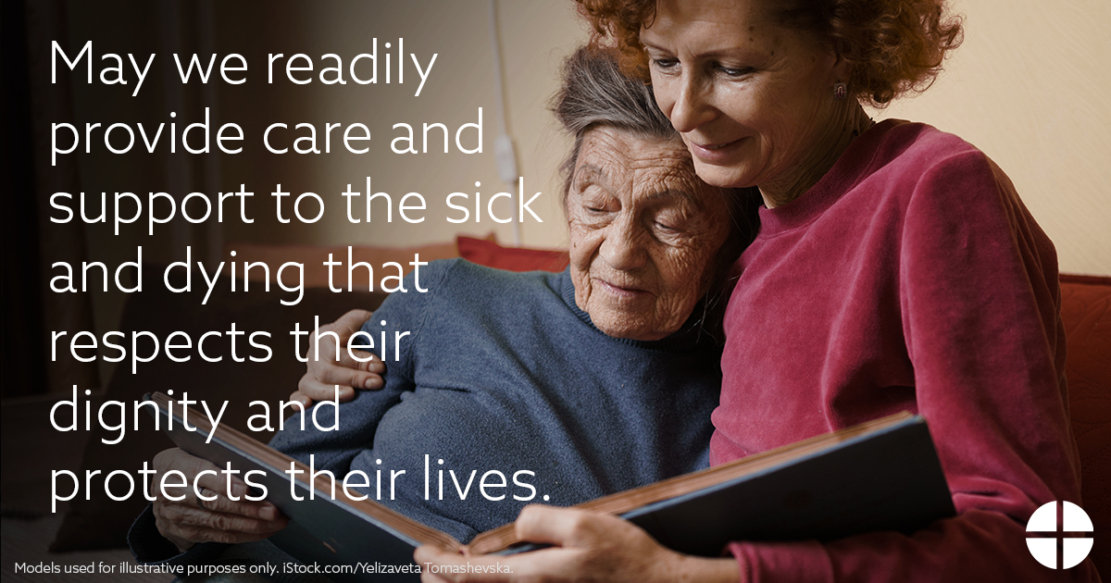

PRAY

*Our Father, 3 Hail Marys, Glory Be*

REFLECT

The source of human dignity lies in the reality that God became man to save us and calls us into communion with him. The Good Samaritan, who goes out of his way to aid an injured man, shows us what it really means to fulfill the commandment to love our neighbors. Despite our best efforts, it can sometimes be difficult to recognize the profound value of human life when we see its full weakness and fragility. Yet, the faithful care of human life until its natural end is entrusted to every person.

Death is a decisive moment in our encounter with God the Savior. Helping our neighbor to prepare for this moment is a supreme act of charity, encompassing the patient with the solid support of human relationships to accompany them and help them be open to hope. The Church learns from the example of the Good Samaritan how to care for those who are sick or dying, respecting and defending every human life. Each of us is invited to imitate the Samaritan’s example, to “*Go and do likewise*” (Lk 10:37).