

­­

*Prayer Guide* | *DECEMBER 2022*



INTERCEDE

­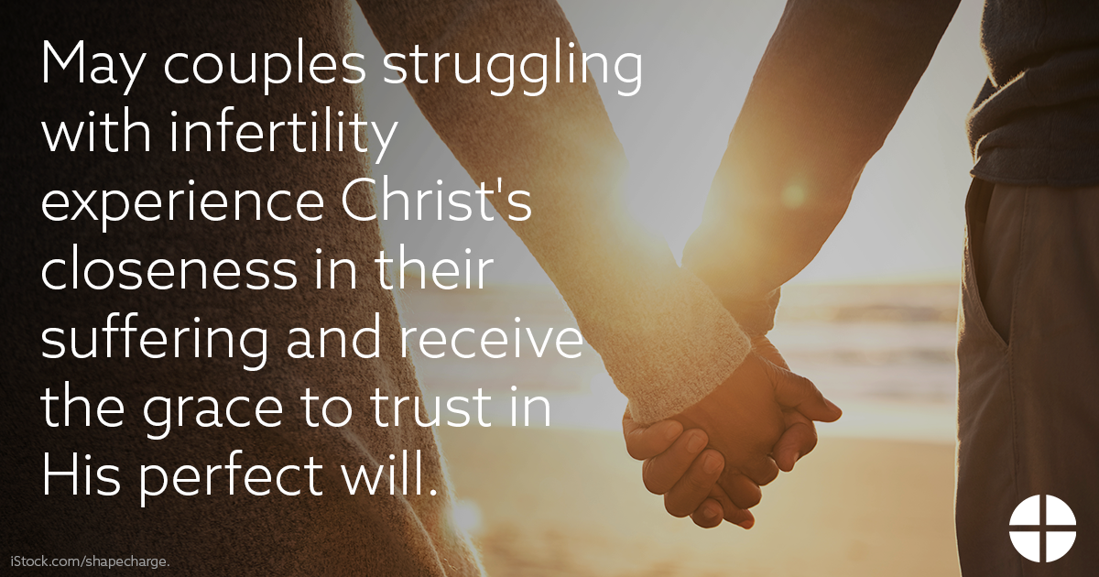

PRAY

*Our Father, 3 Hail Marys, Glory Be*

REFLECT

We can often assume that parenthood comes easily after “I do,” but for many married couples, it does not. For some, the joy of conception never happens. Others suffer repeated miscarriages. Still others experience secondary infertility: after giving birth to one or more children, they are unable to have another. Infertility can be a profound Cross for couples desiring a child, and their suffering can become overwhelming. Social media posts of pregnancies, baby announcements, or attending baby showers may intensify the sense of being alone in their ache for a child. The pursuit of ethical medical treatments in hopes of conceiving can be physically and emotionally taxing and increase feelings of isolation. However, it is estimated that as many as 1 in 6 couples will struggle with infertility, meaning that you or someone you know is likely bearing this cross, often silently or without support.

We can all find hope in the truth that God does not abandon us in our suffering, even when we don’t understand His will. The Church desires to walk with all those who bear the burden of infertility. Pope St. John Paul II clearly affirmed that couples who are

unable to have children are “no less loved by God; your love for each other is complete and fruitful when it is open to others.” It is important that all couples who experience infertility—and those who desire to offer them support—know that their love is still *fruitful* and their married life remains filled with meaning. We pray that couples struggling with infertility would know Christ’s closeness in a special way and be confident in His perfect will for their marriage and family. May we strive to be channels of mercy to all who carry the cross of infertility through our own awareness, sensitivity, and support.  *Reflection adapted from “Seven Considerations While Navigating Infertility” (*[*respectlife.org/navigating-infertility*](https://www.respectlife.org/navigating-infertility)*).*

ACT *(choose one)*

* Pray the Divine Mercy Chaplet ([usccb.org/divine-mercy-chaplet](https://www.usccb.org/divine-mercy-chaplet)) for all couples who carry the Cross of infertility.
* Choose one day this week to abstain from sweets or your favorite snack as a reminder to draw close to Christ in times of suffering and trust in His plan for our lives.
* Offer some other sacrifice or prayer that you feel called to do for this month’s intention.

ONE STEP FURTHER

Learn more about the struggle of infertility through the experiences of four Catholic couples and how the Church can respond with sensitivity and compassion in this podcast: [bit.ly/fruitful-in-infertility](https://bit.ly/fruitful-in-infertility).