Word of Life: August 2021
Recommended dates are provided, but you are welcome to use these materials at any time!
Featured this Month…
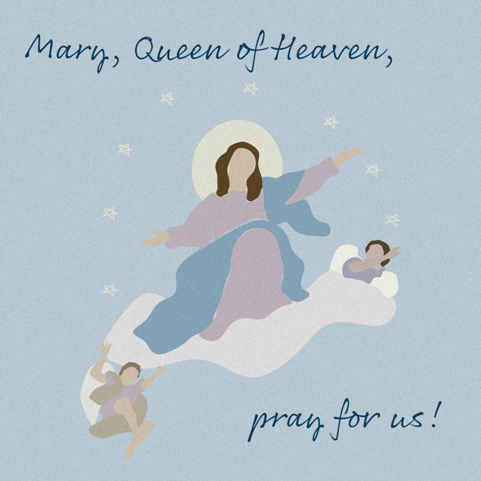
Reflection on the Solemnity of the Assumption of the Blessed Virgin Mary
August 15, 2021
The Solemnity of the Assumption celebrates the Blessed Mother’s entrance into heavenly glory. The Catechism explains that Mary “was taken up body and soul into the glory of heaven, where she already shares in the glory of her Son’s Resurrection, anticipating the resurrection of all members of his Body” (CCC, 974).
Mary’s Assumption into heaven reminds us that life on earth is a pilgrimage to our ultimate destination. We prepare in hope for our own passage into eternal life by the choices we make today. When we choose to love and follow God in our daily lives, we strengthen our relationship with Him, and this relationship is the true meaning of heaven: “To live in heaven is ‘to be with Christ’” (CCC, 1025 citing St. Ambrose, In Luc.,10,121:PL 15 1834A.).
Download
We can see how, throughout her life, the Blessed Mother continually chose to go deeper into her relationship with God. She modeled how to value and respect His precious gift of human life, from the moment of conception to its natural end. In the Annunciation, through her “yes,” Mary witnessed to the undeniable humanity of unborn children as she conceived and carried the Christ child in her womb. After the Annunciation, having learned that her cousin Elizabeth was with child, she went in haste to her aid.
Need a photo to go with this reflection?
Many works of art are believed to be in the common domain and are available to download from museum websites.

The Assumption of the Virgin, Bergognone
Credit: Bergognone, “The Assumption of the Virgin,” Oil and Gold on Wood, ca. 1453-1523, Fletcher Fund, 1926, courtesy of The Metropolitan Museum of Art, New York, NY.
The Assumption, Laurent de La Hyre
Credit: De La Hyre, Laurent, “The Assumption,” oil on canvas, ca. 1653, The Ciechanowiecki Collection, Gift of The Ahmanson Foundation, courtesy of the Los Angeles County Museum of Art.

Our Blessed Mother shows us how the way we live today can prepare us, in hope, to also enter into heavenly glory at the end of our lives. Are we open to God’s precious gift of new life? How do we support expectant mothers and parents of young children? Do we prioritize showing our love and care for loved ones who are ill or aging?
Holy Mary, Mother of God, pray for us sinners, now and at the hour of our death. Amen.

Catechism of the Catholic Church, second edition © 2000 LEV-USCCB. Used with permission. All rights reserved.

Word of Life – August 2021

Intercessions for Life

August 1st  May the Lord generously provide  for the needs of all mothers  as they dedicate themselves  to caring for their children;  We pray to the Lord: | Eighteenth Sunday in Ordinary Time
August 8th  For those grieving after a miscarriage:  May they be comforted by God’s everlasting love  and His presence amidst their sorrow;  We pray to the Lord: | Nineteenth Sunday in Ordinary Time
August 15th  For those who are gravely ill or dying:  May our Blessed Mother ease their pain and fears,  and by her glorious Assumption,  console them with the hope of eternal life;  We pray to the Lord: | Solemnity of the Assumption of the Blessed Virgin Mary
August 22nd  For all Catholics:  That we may steadfastly proclaim and uphold  the dignity of all human life,  in all stages and circumstances;  We pray to the Lord: | Twenty-first Sunday in Ordinary Time
August 29th  For those who are imprisoned:  May they be treated with the respect due  to every human person;  We pray to the Lord: | Twenty-second Sunday in Ordinary Time

Word of Life – August 2021
Bulletin Quotes
August 1st  “We thank you, heroic mothers, for your invincible love! We thank you for your intrepid trust in God and in his love. We thank you for the sacrifice of your life” (EV 86).  Pope Saint John Paul II, Evangelium vitae © 1995, Libreria Editrice Vaticana.  Used with permission. All rights reserved. | 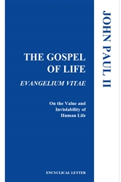  Order | Read Online
August 8th  “Although we may feel unsure how best to comfort those who mourn, we must stand with them in their time of suffering. Miscarriage touches the lives of many people, yet all too often this tragedy remains unaddressed. This lack of response not only often leads to unresolved grief, but also fails to clearly manifest our belief that each person, from conception onward, is precious and unique.”  USCCB Secretariat of Pro-Life Activities  “Solace and Strength in the Sorrow of Miscarriage” | 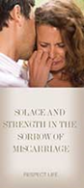  Order | Download
August 15th  “In times of suffering, the human person should be able to experience a solidarity and a love that takes on the suffering, offering a sense of life that extends beyond death… In the family a person can count on strong relationships, valued in themselves apart from their helpfulness or the joy they bring. It is essential that the sick under care do not feel themselves to be a burden, but can sense the intimacy and support of their loved ones” (SB 4-5).  Congregation for the Doctrine of the Faith, Samaritanus bonus: On the Care of Persons in the Critical and Terminal Phases of Life © 2020, Libreria Editrice Vaticana. Used with permission. All rights reserved. | 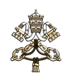  Read Online
August 22nd  “God’s love—individual, real, unchanging—is the true source of our worth, identity, and dignity. It really is not a question of who we are, but rather whose we are. Because his love will never change, nothing can reduce our God-given dignity, and nothing can diminish the immeasurable worth of our lives.”  USCCB Secretariat of Pro-Life Activities  “How to Build a Culture of Life” | 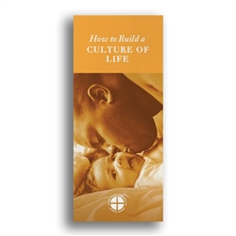  Order | Download
August 29th  “No sin or crime is greater than God’s mercy. The sacrifice of the Cross reveals that Christ’s greatest desire is to forgive those with a repentant heart.”  USCCB Secretariat of Pro-Life Activities  “Death Penalty: Catholic Q&A” | 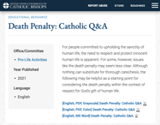  Download

Word of Life – August 2021

Bulletin Art
You are welcome to use these, provided they are not altered in any way, other than the size. Thank you!

Sunday, August 1, 2021
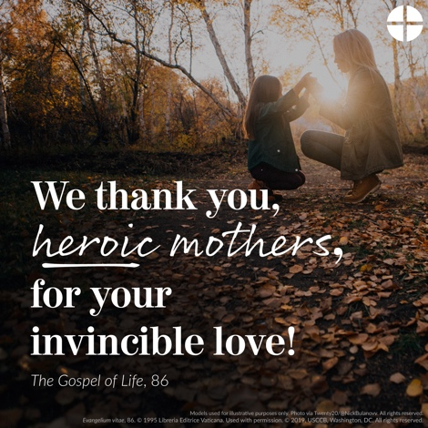
- Download Image: English | Spanish

Sunday, August 15, 2021
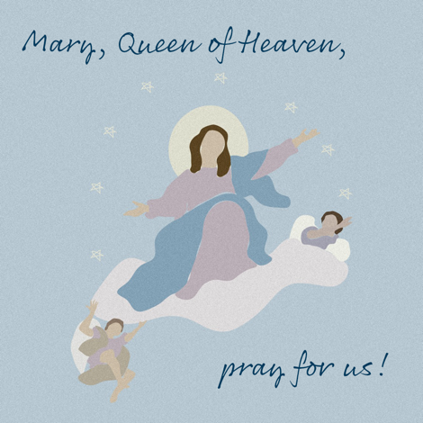
- Download Image: English | Spanish

Sunday, August 22, 2021
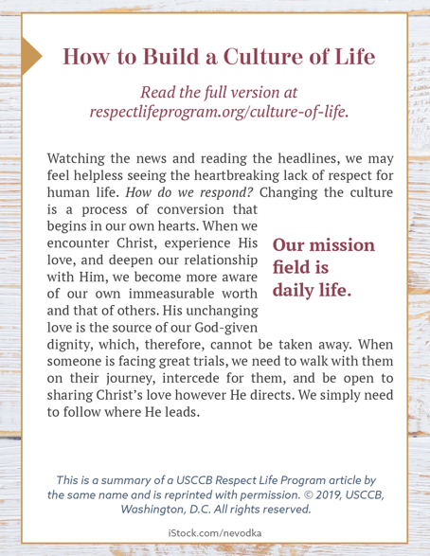
How to Build a Culture of Life

- Online: English | Spanish
- ¼ Page “Bulletin Box” Image: English | Spanish
- Full-Length Bulletin Insert (print format): English | Spanish

