**Word of Life: October 2021**

*Recommended dates are provided, but you are welcome to use these materials at any time!*

[**Respect Life Month 2021**](https://www.respectlife.org/respect-life-month)**: *St. Joseph, defender of life***

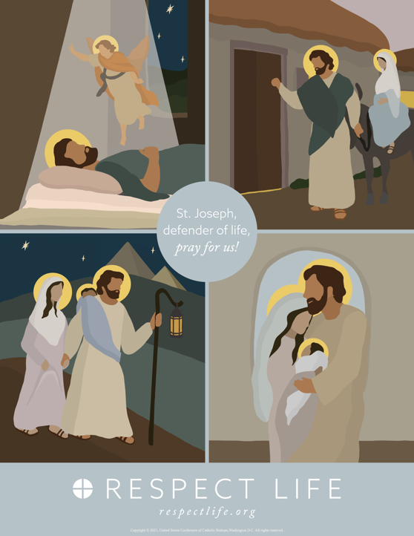The 2021 Respect Life Month resources are to assist you in helping Catholics understand, value, and become engaged with building a culture that cherishes every human life.

A variety of materials are available to order in print or to download online. Visit [respectlife.org/respect-life-month](http://www.respectlife.org/respect-life-month)!

**Featured Resources**

* [Respect Life Month Action Guide](https://www.usccb.org/resources/respect-life-month-action-guide)   
  *(a sample timeline, action ideas, & more!)*
* [Respect Life Reflection](https://www.usccb.org/resources/respect-life-reflection-st-joseph-defender-life)
* [Graphics](https://www.respectlife.org/respect-life-image-gallery)
* [Homily Helps](https://www.usccb.org/resources/respect-life-month-homily-helps)
* Poster ([Download](https://www.usccb.org/resources/respect-life-poster-st-joseph-defender-life) / [Order](https://store.usccb.org/collections/respect-life/products/a-prayer-to-st-joseph-defender-of-life-english))
* Prayer Card ([Download](https://www.usccb.org/resources/prayer-st-joseph-defender-life) / [Order](https://store.usccb.org/collections/respect-life/products/a-prayer-to-st-joseph-defender-of-life-english-1))

**Sample Pulpit Announcements**

**Option 1: Respect Life Sunday (October 3)**

Today is Respect Life Sunday, which kicks off Respect Life Month. We consider more deeply why *every* human life is valuable and reflect on how to build a culture that protects it. See the bulletin for more information.

**Option 2: Respect Life Month   
(any weekend in October)**

Every October, we celebrate Respect Life Month. We consider more deeply why *every* human life is valuable and reflect on how to build a culture that protects life from conception to natural death. See the bulletin for more information.

**Sample Bulletin Announcement**

**Option 1: Respect Life Sunday (October 3)**

**Today is Respect Life Sunday!**   
Join Catholics nationwide in celebrating Respect Life Month! **respectlife.org/celebrate**

**Word of Life – October 2021**

**Intercessions for Life**

|  |  |
| --- | --- |
| **October 3rd**  For all Catholics: On this Respect Life Sunday, may we resolve anew  to protect the gift of every human life; *We pray to the Lord:* | **Twenty-seventh Sunday**  **in Ordinary Time**  ***(Also observed in the U.S. as***  ***Respect Life Sunday)*** |
| **October 10th**  May God grant us the wisdom and courage to lovingly protect His gift of human life at every stage, in sickness and in health; *We pray to the Lord:* | **Twenty-eighth Sunday**  **in Ordinary Time** |
| **October 17th**  That the life of every person, from conception to natural death, will be protected in our laws and cherished in our hearts; *We pray to the Lord:* | **Twenty-ninth Sunday**  **in Ordinary Time** |
| **October 24th**  For women and men suffering after abortion: May the Church’s abortion healing ministry,  Project Rachel, help them find forgiveness and peace through Christ’s endless mercy; *We pray to the Lord:* | **Thirtieth Sunday**  **in Ordinary Time** |
| **October 31st**  For those nearing the end of life: May they receive care that respects their dignity and protects their lives as they place their hope in the promise of eternal life; *We pray to the Lord:* | **Thirtieth Sunday**  **in Ordinary Time** |

**Word of Life – October 2021**

**Bulletin Quotes**

|  |  |
| --- | --- |
| **October 3rd**  “St. Joseph’s ‘yes’ to the Lord meant that regardless of the hardship and personal sacrifice to himself, he consistently chose to put the needs of Mary and Jesus before his own. Joseph’s devotion helps reveal to us our own call to show special care for the lives of those whom God has entrusted to us.”  USCCB Secretariat of Pro-Life Activities  Respect Life Reflection: St. Joseph, Defender of Life, [respectlife.org/reflection-joseph](http://www.respectlife.org/reflection-joseph) | [Download](https://www.usccb.org/resources/respect-life-reflection-st-joseph-defender-life) |
| **October 10th**  “An old Irish proverb says, ‘It is in the shelter of each other that the people live.’ Indeed, we are created to depend upon one another and walk together in suffering. But when family members or friends approach life's end, we may not know how best to ‘shelter’ them. Here are some concrete ways we can compassionately care for them: [usccb.org/end-of-life-care](https://www.usccb.org/end-of-life-care).”  USCCB Secretariat of Pro-Life Activities  Caring for Loved Ones at Life’s End | [Download](https://www.usccb.org/resources/caring-loved-ones-lifes-end) |
| **October 17th**  “Dearest St. Joseph, at the word of an angel, you lovingly took Mary into your home. As God’s humble servant, you guided the Holy Family on the road to Bethlehem, welcomed Jesus as your own son in the shelter of a manger, and fled far from your homeland for the safety of both Mother and Child… Help us to faithfully commit ourselves to the service and defense of human life —especially where it is vulnerable or threatened. Obtain for us the grace to do the will of God in all things. Amen.”  USCCB Secretariat of Pro-Life Activities  “A Prayer to St. Joseph, Defender of Life", [respectlife.org/prayer-to-st-joseph](https://www.respectlife.org/prayer-to-st-joseph) | [Order](https://store.usccb.org/collections/respect-life/products/a-prayer-to-st-joseph-defender-of-life-english-1) | [Download](https://www.usccb.org/resources/prayer-st-joseph-defender-life) |
| **October 24th**  “I would now like to say a special word to women who have had an abortion. The Church is aware of the many factors which may have influenced your decision, and she does not doubt that in many cases it was a painful and even shattering decision. The wound in your heart may not yet have healed. …But do not give in to discouragement and do not lose hope. …The Father of mercies is ready to give you his forgiveness and his peace in the Sacrament of Reconciliation.”  Pope Saint John Paul II, *Evangelium vitae,* no. 99. © 1995, Libreria Editrice Vaticana.  Used with permission. All rights reserved. | A screenshot of a cell phone  Description automatically generated  [Order](https://store.usccb.org/products/the-gospel-of-life-evangelium-vitae-on-the-value-and-inviolability-of-human-life) | [Read Online](http://w2.vatican.va/content/john-paul-ii/en/encyclicals/documents/hf_jp-ii_enc_25031995_evangelium-vitae.html) |
| **October 31st**  “We know earthly death is not the end, but rather the door through which we must pass to gain eternal life. Because of our belief and hope in the Resurrection, we can face death not with fear, but with preparation... We prepare for eternal life by choosing to love and follow God now, in our daily lives and decisions.”  USCCB Secretariat of Pro-Life Activities  “Catholic Considerations for Our Earthly Passing”  [respectlife.org/end-of-life-considerations](http://www.respectlife.org/end-of-life-considerations) | page3image781473824  [Order](https://store.usccb.org/products/catholic-considerations-for-our-earthly-passing) | [Download](https://www.usccb.org/about/pro-life-activities/respect-life-program/2017/upload/rlp-17-end-of-life-flyer-color-secure.pdf) |

**Word of Life – October 2021**

**Bulletin Art**

*You are welcome to use these and other downloadable images from the* [***online Respect Life image gallery***](https://www.respectlife.org/respect-life-image-gallery)*, provided they are not altered in any way, other than the size. Thank you!*

**Sunday, October 3rd, 2021**

**Featuring Reflection: “St. Joseph: Faithful Protector of Mother and Child”**

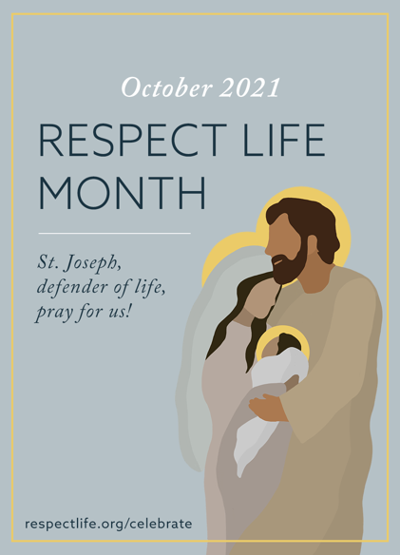

* [Respect Life Reflection](https://www.usccb.org/resources/respect-life-reflection-st-joseph-defender-life)
* [Image](https://www.usccb.org/resources/rlp-21-rlm-bulletin-980x1360.png)

*View our full image gallery* [*online*](https://www.respectlife.org/respect-life-image-gallery) *for additional sizes and formats of artwork for Respect Life Month.*

**Sunday, October 24th, 2021**

**Featuring “Healing within Marriage from an Abortion”**

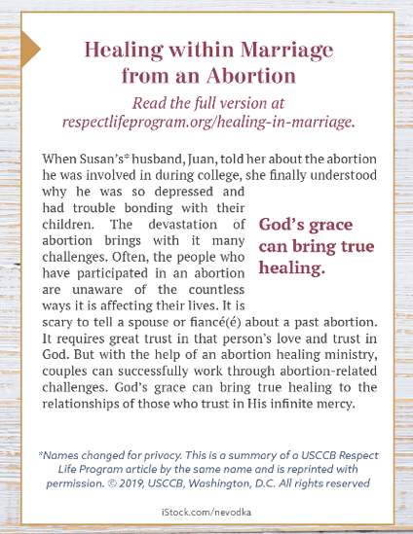

* Bulletin Box (color): [English](https://static.wixstatic.com/media/c138fd_53d854b7962b4beba6fba89714b6657d~mv2_d_1275_1650_s_2.png/v1/fill/w_1275,h_1650/rlp-19-bulletinboxes-healing-in-marriage.png) | [Spanish](https://static.wixstatic.com/media/c138fd_845993ef8d1544d388fd1376e5f87fc3~mv2_d_1275_1650_s_2.png/v1/fill/w_1275,h_1650/rlp-19-bulletinboxes-healing-in-marriage-spn.png)
* Bulletin Box (grayscale): [English](https://static.wixstatic.com/media/c138fd_090bf52748f74e6fb4be79d8c94d6e10~mv2_d_1275_1650_s_2.png/v1/fill/w_1275,h_1650/rlp-19-bulletinboxes-healing-in-marriage-bw.png) | [Spanish](https://static.wixstatic.com/media/c138fd_50bf550496ef4d958ee863d941747f81~mv2_d_1275_1650_s_2.png/v1/fill/w_1275,h_1650/rlp-19-bulletinboxes-healing-in-marriage-spn-BW.png)
* Bulletin Box (text-only): [Download](https://www.usccb.org/resources/respect-life-bulletin-boxes-compilation)