Word of Life: April 2022
Recommended dates are provided, but you are welcome to use these materials at any time!
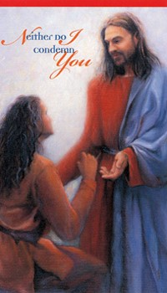
Featured this Month…
April 24, 2022: Sunday of Divine Mercy
On the Second Sunday of Easter, the Church celebrates the Sunday of Divine Mercy. It provides an important opportunity to share Christ’s message of mercy, especially with those who suffer because of their participation in an abortion. By the age of 45, as many as 1 in 3 women have had an abortion, and a similar number of men and family members have been involved. Many feel that abortion is “the unforgivable sin.” They need to hear that, through the Sacrament of Reconciliation, God forgives every sin of a repentant heart, even the sin of abortion. In fact, Jesus’ message to St. Faustina is that the greater the sinner, the greater the right to His mercy.
Prayer | Order
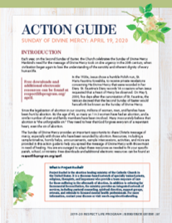
The Action Guide for the Sunday of Divine Mercy includes a sample timeline, simple steps, sample announcements, homily helps, and an activity to help you bring Christ’s message of mercy to your parish community.
Priests and deacons may find these considerations especially helpful when preparing their homilies.
Visit respectlife.org/action-guides and usccb.org/prolife/divine-mercy-sunday for additional resources.

Resources on Abortion Healing
Prayer Guide: Divine Mercy

Bridges of Mercy for Healing After Abortion

Divine Mercy in my Soul

Healing within Marriage from an Abortion

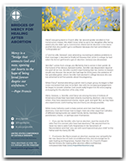
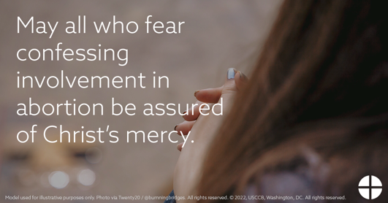

Word of Life – April 2022
Intercessions for Life
April 3rd  For elected officials:  May they work to protect human life  from conception to natural death;  We pray to the Lord: | Fifth Sunday of Lent
April 10th  For all those receiving hospice care:  May the way they are attended to  bear witness to the gift of their lives;  We pray to the Lord: | Palm Sunday of the Passion of the Lord
April 17th  May the glory of the Resurrection  inspire lasting hope in all who work  to protect human life;  We pray to the Lord: | Easter Sunday  of the Resurrection of the Lord
April 24th  For those who have participated in an abortion  and feel they have committed an unforgiveable sin:  May they come to know the Lord’s limitless mercy,  and turn to Him for forgiveness and healing;  We pray to the Lord: | Second Sunday of Easter  (or Sunday of Divine Mercy)

Word of Life – April 2022
Bulletin Quotes

April 3rd  “Virgin of Guadalupe, Patroness of unborn children, we implore your intercession for every child at risk of abortion. … Guide our public officials  to defend each and every human life through just laws. Inspire us all to bring our faith into public life, to speak for those who have no voice. We ask this in the name of your Son, Jesus Christ, who is Love and Mercy itself. Amen.”  A Prayer to Our Lady of Guadalupe  USCCB Secretariat of Pro-Life Activities | 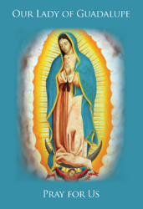  Full Prayer
April 10th  “Despite our best efforts, it can sometimes be difficult to recognize the profound value of human life when we see its full weakness and fragility. Yet, the faithful care of human life until its natural end is entrusted to every person.”  USCCB Secretariat of Pro-Life Activities  “The Witness of the Good Samaritan: Palliative Care and Hospice” | 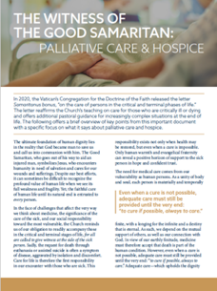  Download
April 17th  “Like us, Christ entered the world through the womb of a woman. He willingly experienced the fullness of human suffering. He breathed his last on the Cross at Calvary in order that He might save us. Therefore, ‘God is the foundation of hope: not any god, but the God who has a human face and who has loved us to the end’ (Spe salvi 31).”  USCCB Secretariat of Pro-Life Activities  “Respect Life Reflection: Christ Our Hope in Every Season of Life” (Citing Pope Benedict XVI, Spe salvi © 2007, Libreria Editrice Vaticana. Used with permission. All rights reserved.) | 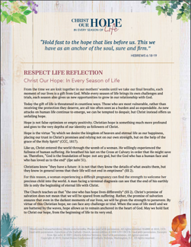  Download
April 24th  If you or someone you know has had an abortion, be assured that it is never too late to seek God’s forgiveness in the Sacrament of Reconciliation. Additionally, other confidential, compassionate help is available. Select “Find Help” from the menu on www.hopeafterabortion.org to find the diocesan Project Rachel Ministry near you.  USCCB Secretariat of Pro-Life Activities  “Bridges of Mercy for Healing after Abortion”  www.usccb.org/bridges-of-mercy | Download

Word of Life – April 2022

Bulletin Art
You are welcome to use these, provided they are not altered in any way, other than the size. Thank you!

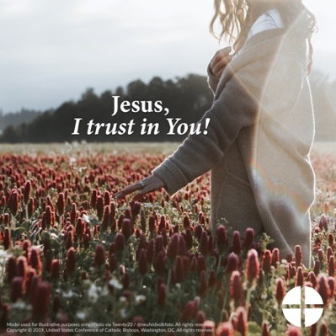

- Download Image: English | Spanish

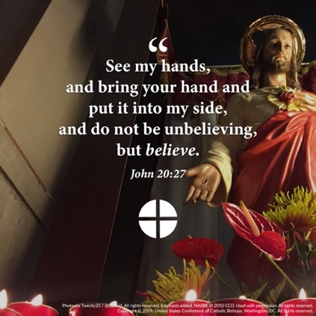
- Download Image: English | Spanish

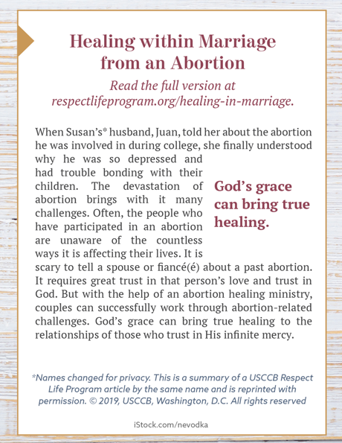
- Download Bulletin Box: English | Spanish

