**Word of Life: June 2022**

*Recommended dates are provided, but you are welcome to use these materials at any time!*

**Featured this Month…**

[**Special Edition: *Dobbs* Parish Leader Kit**](https://www.usccb.org/resources/word-life-special-edition)



This *Dobbs* parish leader kit is a special edition of the *Word of Life.*It is not month-specific and is dedicated to providing resources to use leading up to and after the *Dobbs*decision (which is expected by the end of June).

Other materials are also available to assist your efforts at [prayfordobbs.com](https://www.prayfordobbs.com/).

[**Father’s Day Action Guide**](https://www.respectlife.org/fathers-day)

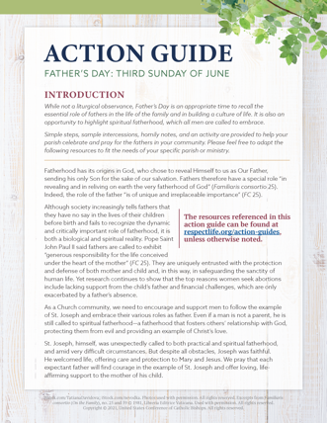**June 19, 2022**  
[**Religious Freedom Week: Life and Dignity for All**](http://www.usccb.org/issues-and-action/religious-liberty/religious-freedom-week/index.cfm) **June 22-29, 2022**

Simple steps, sample intercessions, homily considerations, and an activity are provided in the Father’s Day Action Guide to help your parish honor fathers and highlight their importance in building a culture of life.

A previously recorded webinar explains the resources available. Please feel free to adapt the resources to fit the needs of your specific parish or ministry.

* [Webinar Recording](https://youtu.be/Y6hNocCRW0c)
* Action Guide ([English](https://www.usccb.org/fathers-day-action-guide) | [Spanish](https://www.usccb.org/es/fathers-day-action-guide))
* Supplemental Resources (listed under Father’s Day section [on this page](https://www.respectlife.org/action-guides))

**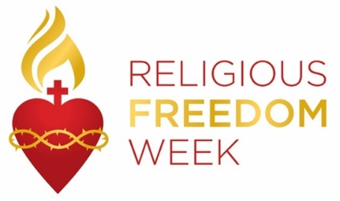***Religious Freedom Week 2022: Life and Dignity for All* takes place June 22–29. The Week begins with the Feast of Sts. John Fisher and Thomas More, ends with the Solemnity of Sts. Peter and Paul, and includes the Feast of the Nativity of St. John the Baptist. Many resources are available to help the faithful **pray**, **reflect**, and **take action** on religious liberty, both here in this country and abroad. Resources, including graphics, lectionary notes, bulletin inserts, and daily prayers and reflections are available at [usccb.org/ReligiousFreedomWeek](http://www.usccb.org/issues-and-action/religious-liberty/religious-freedom-week/index.cfm).

**Word of Life – June 2022**

**Intercessions for Life**

|  |  |
| --- | --- |
| **June 5th**  May the Holy Spirit strengthen God’s people  to embrace and protect  the precious gift of human life;  *We pray to the Lord:* | **Pentecost Sunday** |
| **June 12th**  May society more deeply  respect the human person,  who is created, redeemed, and made holy  by the gracious action of the Trinity,  Father, Son, and Holy Spirit;  *We pray to the Lord:* | **The Solemnity of the Most Holy Trinity** |
| **June 19th**  May expectant fathers lovingly support  the mothers of their children  in welcoming new life;  *We pray to the Lord*: | **The Solemnity of the Most Holy Body and Blood of Christ (Corpus Christi)** |
| **June 26th**  For the preservation of religious freedom in our country:  That the right to freely worship God  and live according to His commands  may be protected and upheld;  *We pray to the Lord:* | **Thirteenth Sunday in Ordinary Time** |

**Word of Life – June 2022**

**Bulletin Quotes**

|  |  |
| --- | --- |
| **June 5th**  “The Catholic Church has a long history of service to those who are most vulnerable and remains the largest private provider of social services in the United States. Through the sacrificial efforts of faithful Catholics, the Church serves millions through diocesan ministries and agencies, Catholic hospitals and healthcare systems, immigration clinics, shelters, and Catholic schools and parishes. From religious communities to pregnancy care centers, from refugee resettlement services to foster care and adoption agencies, and from maternity homes to parish-based ministries, the Church consistently bears witness in word and deed to the beauty and dignity of every human life—including both mother and child.”  USCCB Committee Chairmen, “Standing with Moms in Need” | [Read Online](https://www.usccb.org/news/2022/statement-usccb-president-and-bishop-chairmen-advance-supreme-courts-ruling-dobbs-v)  | [Download](https://www.usccb.org/resources/standing-moms-need) |
| **June 12th**  “In modern times, children in their mothers’ wombs and those approaching the end of their lives are certainly among the ‘least of these’ in our world’s estimation. Practices such as abortion and assisted suicide tragically reject the truth that human life is always to be cherished and defended with loving concern. … Through the intercession of Our Lady of Guadalupe, may Our Lord grant us the grace to truly and courageously live his Gospel of life.”  USCCB Secretariat of Pro-Life Activities, “Live the Gospel of Life”  NABRE © 2010 CCD. Used with permission. | [Read](https://www.respectlife.org/live-the-gospel-of-life) | [Download](https://www.usccb.org/resources/respect-life-program-reflection-2020-2021) |
| **June 19th**  “Through our prayers and through the intercession of St. Joseph, patron of fathers, may fathers come to know the *irreplaceable* role they hold in the lives of their children, and the responsibility they share in welcoming God’s gift of new life!”  Most Reverend Shelton J. Fabre, Bishop of Houma-Thibodaux  “Fathers’ Irreplaceable Role in Welcoming Life” | [Read Online](https://catholiccurrent.org/ministry-blog/fathers-irreplaceable-role-in-welcoming-life/) |
| **June 26th**  “O God our Creator… we ask you to bless us in our vigilance for the gift of religious liberty. Give us the strength of mind and heart to readily defend our freedoms when they are threatened; give us courage in making our voices heard on behalf of the rights of your Church and the freedom of conscience of all people of faith.”  USCCB  “[Prayer for the Protection of Religious Liberty](https://www.usccb.org/committees/religious-liberty/religious-liberty-prayer-resources)” | [Download](https://www.usccb.org/issues-and-action/religious-liberty/upload/Immaculate-Conception-English.pdf) |

**Word of Life – June 2022**

**Bulletin Art**

*You are welcome to use these, provided they are not altered in any way, other than the size. Thank you!*

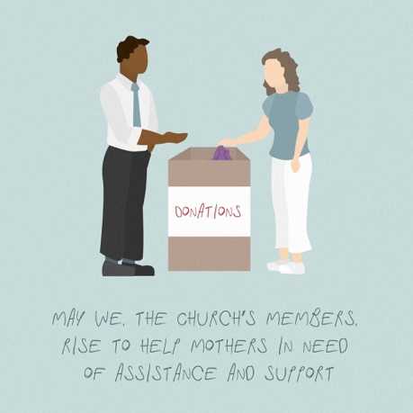**Sunday, June 5th, 2022**

Download Image: [English](https://www.usccb.org/resources/wwmin-graphic-2_0.jpg)

*(Other graphics are available* [*here*](https://www.usccb.org/resources/walking-moms-need-graphics)*.)*

**Sunday, June 12th, 2022**

Download Image *(Other graphics are available on the same webpages.)*: [English](https://www.usccb.org/resources/respect-life-action-guide-fathers-day-activity-graphics) | [Spanish](https://www.usccb.org/es/resources/respect-life-action-guide-fathers-day-activity-graphics-spanish)

**Sunday, June 19th, 2022**

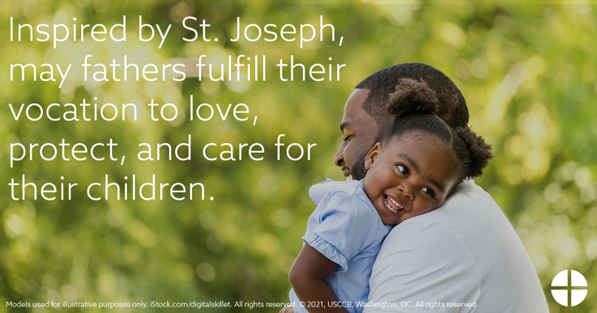

Download Image: [English](https://www.usccb.org/resources/rlpa-21-06-intention.png) | [Spanish](https://www.usccb.org/resources/rlpa-21-06-intention-spa.png)