**Word of Life: October 2022**

*Recommended dates are provided, but you are welcome to use these materials at any time!*

[**Respect Life Month 2022**](https://www.respectlife.org/respect-life-month)**: *Called to Serve Moms in Need***

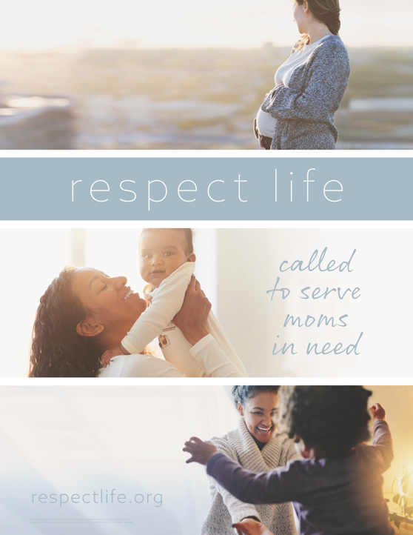The 2022 Respect Life Month resources are to assist you in helping Catholics understand, value, and become engaged with building a culture that cherishes every human life.

A variety of materials are available to order in print or to download online. Visit [respectlife.org/respect-life-month](http://www.respectlife.org/respect-life-month)!

**Featured Resources**

* [Respect Life Month Action Guide](https://www.usccb.org/resources/respect-life-month-action-guide)   
  *(a sample timeline, action ideas, & more!)*
* [Respect Life Reflection](https://www.usccb.org/resources/respect-life-reflection-called-serve-moms-need)
* [Graphics](https://www.respectlife.org/respect-life-image-gallery)
* [Homily Considerations](https://www.usccb.org/resources/respect-life-homily-considerations-churchs-commitment-mothers-need)
* Poster ([Download](https://www.usccb.org/resources/respect-life-poster-called-serve-moms-need) / [Order](https://store.usccb.org/products/respect-life-poster-called-to-serve-moms-in-need-english-spanish?_pos=13&_sid=71e5f32c5&_ss=r))
* Prayer Card ([Download](https://www.walkingwithmoms.com/prayer-for-pregnant-mothers) / [Order](https://store.usccb.org/products/a-prayer-for-pregnant-mothers))

**Sample Pulpit Announcements**

**Option 1: Respect Life Sunday (October 2)**

Today is Respect Life Sunday, which kicks off Respect Life Month. We consider more deeply why *every* human life is valuable and reflect on how to build a culture that protects life from conception to natural death. See the bulletin for more information.

**Option 2: Respect Life Month   
(any weekend in October)**

Every October, we celebrate Respect Life Month. We consider more deeply why *every* human life is valuable and reflect on how to build a culture that protects life from conception to natural death. See the bulletin for more information.

**Sample Bulletin Announcement**

**Option 1: Respect Life Sunday (October 2)**

**Today is Respect Life Sunday!**   
Join Catholics nationwide in celebrating Respect Life Month! **respectlife.org/celebrate**

**Word of Life – October 2022**

**Intercessions for Life**

|  |  |
| --- | --- |
| **October 2nd**  For all Catholics: On this Respect Life Sunday, may we resolve anew  to protect the gift of every human life  and consider how we can serve moms in need; *We pray to the Lord:* | **Twenty-seventh Sunday**  **in Ordinary Time**  ***(Also observed in the U.S. as***  ***Respect Life Sunday)*** |
| **October 9th**  May God grant us the wisdom and courage to lovingly protect His gift of human life at every stage, in sickness and in health; *We pray to the Lord:* | **Twenty-eighth Sunday**  **in Ordinary Time** |
| **October 16th**  That the life of every person, from conception to natural death, will be protected in our laws and cherished in our hearts; *We pray to the Lord:* | **Twenty-ninth Sunday**  **in Ordinary Time** |
| **October 23rd**  For women and men suffering after abortion: May the Church’s abortion healing ministry,  Project Rachel, help them find peace and healing through Christ’s endless mercy; *We pray to the Lord:* | **Thirtieth Sunday**  **in Ordinary Time** |
| **October 30th**  For those nearing the end of life: May they receive care that respects their dignity and protects their lives as they place their hope in the promise of eternal life; *We pray to the Lord:* | **Thirty-First Sunday**  **in Ordinary Time** |

**Word of Life – October 2022**

**Bulletin Quotes**

|  |  |
| --- | --- |
| **October 2nd**  “The witness of our Blessed Mother invites us to become more aware of the needs of pregnant and parenting moms in our own parishes and communities… Following Mary’s example, we can ask ourselves how to better know these mothers, listen to them, seek understanding, and help them obtain the necessities of life for themselves and their children. How can we, like the Blessed Mother, lovingly support mothers in welcoming and caring for God’s gift of life?”  USCCB Secretariat of Pro-Life Activities  Respect Life Reflection: “Called to Serve Moms in Need” | [Download](https://www.usccb.org/resources/respect-life-reflection-called-serve-moms-need) | [Read Online](https://www.respectlife.org/called-to-serve-reflection) |
| **October 9th**  “An old Irish proverb says, ‘It is in the shelter of each other that the people live.’ Indeed, we are created to depend upon one another and walk together in suffering. But when family members or friends approach life's end, we may not know how best to ‘shelter’ them. Here are some concrete ways we can compassionately care for them: [usccb.org/end-of-life-care](https://www.usccb.org/end-of-life-care).”  USCCB Secretariat of Pro-Life Activities  Caring for Loved Ones at Life’s End | [Download](https://www.usccb.org/resources/caring-loved-ones-lifes-end) |
| **October 16th**  “Mary, Mother of the Church, graciously help us build a culture of life and a civilization of love, together with all people of good will, to the praise and glory of God, the Creator and lover of life. Amen.”  USCCB Secretariat of Pro-Life Activities  “A Prayer for Pregnant Mothers" | [Order](https://store.usccb.org/products/a-prayer-for-pregnant-mothers) | [Download](https://www.walkingwithmoms.com/prayer-for-pregnant-mothers) |
| **October 23rd**  “I would now like to say a special word to women who have had an abortion. The Church is aware of the many factors which may have influenced your decision, and she does not doubt that in many cases it was a painful and even shattering decision. The wound in your heart may not yet have healed. …But do not give in to discouragement and do not lose hope. …The Father of mercies is ready to give you his forgiveness and his peace in the Sacrament of Reconciliation.”  Pope Saint John Paul II, *Evangelium vitae,* no. 99. © 1995, Libreria Editrice Vaticana.  Used with permission. All rights reserved. | A screenshot of a cell phone  Description automatically generated  [Order](https://store.usccb.org/products/the-gospel-of-life-evangelium-vitae-on-the-value-and-inviolability-of-human-life) | [Read Online](http://w2.vatican.va/content/john-paul-ii/en/encyclicals/documents/hf_jp-ii_enc_25031995_evangelium-vitae.html) |
| **October 30th**  “The mystery of the redemption of the human person is rooted in the loving involvement of God with human suffering. Hope is always possible. To those who care for the sick, the scene of the Cross provides a way of understanding that even when it seems that there is nothing more to do there remains much to do, because ‘remaining’ by the side of the sick is a sign of love and of the hope that it contains. Healed by Jesus, we become men and women called to proclaim his healing power and provide care for our neighbors, until the very end.”  USCCB Secretariat of Pro-Life Activities  “The Witness of the Good Samaritan: Palliative Care and Hospice” | [Download](https://www.usccb.org/resources/witness-good-samaritan-palliative-care-and-hospice) |

**Word of Life – October 2022**

**Bulletin Art**

*You are welcome to use these and other downloadable images from the* [***online Respect Life image gallery***](https://www.respectlife.org/respect-life-image-gallery)*, provided they are not altered in any way, other than the size. Thank you!*

**Sunday, October 2nd, 2022**

**Featuring Reflection: “Called to Serve Moms in Need”**

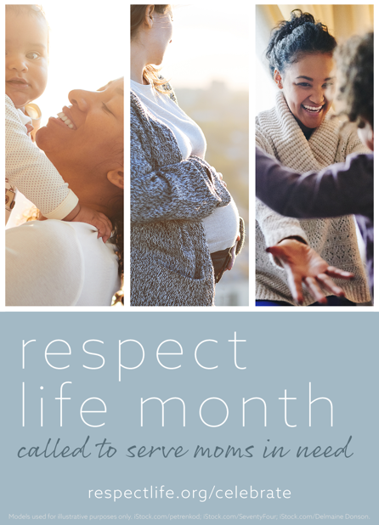

* [Respect Life Reflection](https://www.usccb.org/resources/respect-life-reflection-called-serve-moms-need)
* [Image](https://www.usccb.org/sites/default/files/2022-08/rlp-22-bulletin-980x1360.png)

*View our full image gallery* [*online*](https://www.respectlife.org/respect-life-image-gallery) *for additional sizes and formats of artwork for Respect Life Month.*

**Sunday, October 23rd, 2022**

**Featuring “Healing within Marriage from an Abortion”**

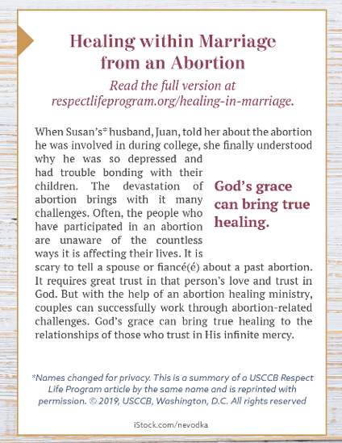

* Bulletin Box (color): [English](https://static.wixstatic.com/media/c138fd_53d854b7962b4beba6fba89714b6657d~mv2_d_1275_1650_s_2.png/v1/fill/w_1275,h_1650/rlp-19-bulletinboxes-healing-in-marriage.png) | [Spanish](https://static.wixstatic.com/media/c138fd_845993ef8d1544d388fd1376e5f87fc3~mv2_d_1275_1650_s_2.png/v1/fill/w_1275,h_1650/rlp-19-bulletinboxes-healing-in-marriage-spn.png)
* Bulletin Box (grayscale): [English](https://static.wixstatic.com/media/c138fd_090bf52748f74e6fb4be79d8c94d6e10~mv2_d_1275_1650_s_2.png/v1/fill/w_1275,h_1650/rlp-19-bulletinboxes-healing-in-marriage-bw.png) | [Spanish](https://static.wixstatic.com/media/c138fd_50bf550496ef4d958ee863d941747f81~mv2_d_1275_1650_s_2.png/v1/fill/w_1275,h_1650/rlp-19-bulletinboxes-healing-in-marriage-spn-BW.png)
* Bulletin Box (text-only): [Download](https://www.usccb.org/resources/respect-life-bulletin-boxes-compilation)