**Word of Life: December 2022**

*Recommended dates are provided, but you are welcome to use these materials at any time!*

**Featured this Month…**

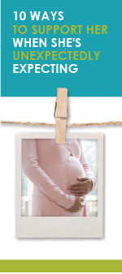**Advent**

The season of Advent is a time of preparation that directs our hearts and minds to preparing for the celebration of the Lord’s birth on Christmas and for Christ’s second coming at the end of time. During this time of preparation and expectant waiting, we also remember expectant mothers who are preparing for the birth of their children. This Advent season, consider highlighting the article “10 Ways to Support Her When She’s Unexpectedly Expecting.” (It is available in a variety of formats at the bottom of [this webpage](https://www.respectlife.org/support-her).)

[**Solemnity of the Immaculate Conception of the Blessed Virgin Mary**](https://bible.usccb.org/bible/readings/120822.cfm)

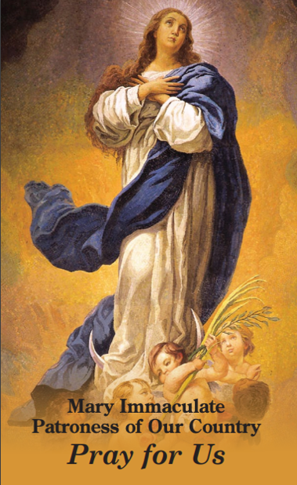***Patronal feast day of the United States of America* (December 8, 2022)**  
On December 8, the Church celebrates the Solemnity of the Immaculate Conception of the Blessed Virgin. (This feast is also a holy day of obligation for dioceses in the United States.) On this feast, we celebrate Mary’s conception free from the stain of Original Sin, and we recognize that Mary’s life began the moment she was conceived in the womb of St. Anne. So, too, does every human life begin at the moment of fertilization, when it is lovingly knit together by God the Father.

The Immaculate Conception is sometimes confused with the Annunciation. This [bulletin insert](http://www.usccb.org/prayer-and-worship/liturgical-year/advent/upload/twim-advent-immaculate-conception.pdf) can be used to help differentiate these two important celebrations. On this solemnity, consider praying Pope Francis’ [Prayer for the Immaculate Conception](http://www.usccb.org/prayer-and-worship/prayers-and-devotions/prayers/pope-francis-prayer-for-the-immaculate-conception.cfm): “We are in need of your immaculate gaze, to rediscover the ability to look upon persons and things with respect and awareness.”

**Word of Life – December 2022**

**Intercessions for Life**

|  |  |
| --- | --- |
| **December 4th**  May God help us prepare the way of the Lord  by acting with tenderness and compassion,  especially toward the most vulnerable among us;  *We pray to the Lord:* | **Second Sunday of Advent** |
| **December 8th**  For women who are unexpectedly pregnant:  May they be filled with trust in God’s providence  and lovingly welcome the gift of their child;  *We pray to the Lord:* | **Solemnity of the Immaculate Conception of the Blessed Virgin Mary** |
| **December 11th**  For all victims of human trafficking: That they may find hope and healing  in the Lord who proclaims liberty to captives  and release to prisoners;  *We pray to the Lord:* | **Third Sunday of Advent** |
| **December 18th**  For all parents awaiting the birth of their child:  May they look to the Blessed Mother and Saint Joseph  and follow their example  of cherishing and protecting human life;  *We pray to the Lord:* | **Fourth Sunday of Advent** |
| **December 25th**  For all Christians:  May the birth of Our Lord Jesus Christ  awaken in our hearts wonder  at the precious gift of every child;  *We pray to the Lord:* | **The Nativity of the Lord (Christmas)** |

**Word of Life – December 2022**

**Bulletin Quotes**

|  |  |
| --- | --- |
| **December 4th**  “Jesus calls each of us to ‘care for the other as a person for whom God has made us responsible’ (EV 87). …The encyclical *The Gospel of Life* recognizes the full range of threats against human life, from poverty and malnutrition to murder and war. Particular emphasis, however, is placed on threats to life at its beginning and end—precisely when it is most in need of protection. In modern times, children in their mothers’ wombs and those approaching the end of their lives are certainly among the ‘least of these’ in our world’s estimation.”  *Excerpt from *Evangelium vitae*, © 1995, Libreria Editrice Vaticana. Used with permission. All rights reserved.  USCCB Secretariat of Pro-Life Activities  [respectlife.org/live-the-gospel-of-life](https://www.respectlife.org/live-the-gospel-of-life) | [Download](https://www.usccb.org/resources/respect-life-program-reflection-2020-2021) |
| **December 11th**  “O St. Bakhita, assist all those who are trapped in a state of slavery;  Intercede with God on their behalf so that they will be released from their chains of captivity.  Those whom man enslaves, let God set free.”  USCCB, “Prayer to St. Josephine Bakhita” | [Download](https://migrants-refugees.va/it/wp-content/uploads/sites/3/2018/11/M7-266-Josephine-Bakhita-Prayer-Card.pdf) |
| **December 18th**  “Perhaps one of your friends has become pregnant unexpectedly. As someone who has been there, I encourage you to support your friend in her new journey of being a mother.” Learn ten tips at [respectlife.org/support-her](https://www.respectlife.org/support-her).  USCCB Secretariat of Pro-Life Activities  “10 Ways to Support Her When She’s Unexpectedly Expecting” | [Download](https://www.respectlife.org/support-her) |
| **December 25th**  “The infant Christ ‘came into our world in a state of great vulnerability. He needed to be defended, protected, cared for and raised by Joseph’ (PC 5). The humble and often hidden carpenter of Nazareth accompanied Mary in her pregnancy, assisted at the birth of the Messiah in a stable, presented Jesus in the Temple, fled with his family far from their homeland to protect them, and lovingly raised Jesus as his own son in the years to come… Joseph’s devotion helps reveal to us our own call to show special care for the lives of those whom God has entrusted to us.”  *Excerpts from *Patris corde*, © 2020, Libreria Editrice Vaticana. Used with permission. All rights reserved.  USCCB Secretariat of Pro-Life Activities  Respect Life Reflection: St. Joseph, Defender of Life | [Read](https://www.respectlife.org/reflection-joseph) | [Download](https://www.usccb.org/resources/respect-life-reflection-st-joseph-defender-life) |

**Word of Life - December 2022**

**Bulletin Art**

*You are welcome to use these and other downloadable images from the online* [**Respect Life image gallery**](https://www.respectlife.org/respect-life-image-gallery)*, provided they are not altered in any way, other than the size. Thank you!*

**Sunday, December 4th, 2022**

**Featuring “**[**Live the Gospel of Life**](https://www.respectlife.org/live-the-gospel-of-life)**”**

* 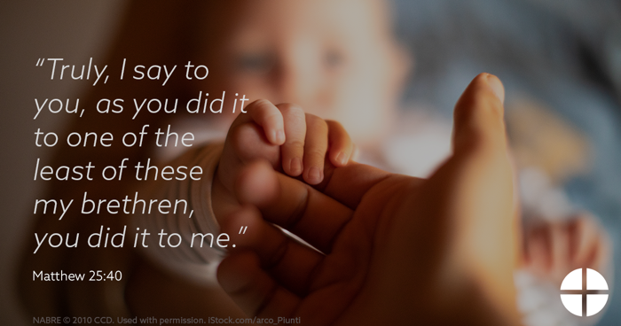[Graphic](https://www.usccb.org/resources/respect-life-graphics-live-gospel-life)
* [Bulletin Insert](https://www.usccb.org/resources/respect-life-program-reflection-2020-2021)

**Sunday, December 18th, 2022**

**Featuring “**[**10 Ways to Support Her When She’s Unexpectedly Expecting**](https://www.respectlife.org/support-her)**”**

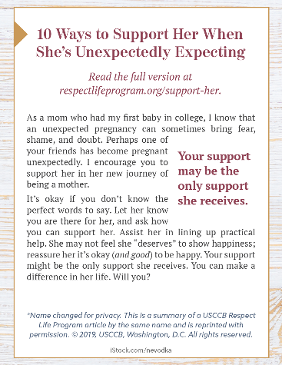

* [Bulletin Box](https://www.usccb.org/resources/10-ways-support-her-when-shes-unexpectedly-expecting)

**Sunday, December 25th, 2022**

**Featuring “**[**St. Joseph: Faithful Protector of Mother and Child**](https://www.respectlife.org/reflection-joseph)**”**

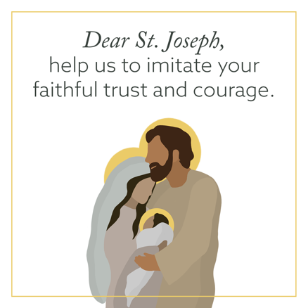

* Graphic: [English](https://www.usccb.org/sites/default/files/2021-11/rlp-21-joseph-5.png) | [Spanish](https://www.usccb.org/resources/rlp-21-joseph-5-spa.png)
* [Reflection](https://www.usccb.org/resources/respect-life-reflection-st-joseph-defender-life)