**Word of Life: April 2023**

*Recommended dates are provided, but you are welcome to use these materials at any time!*

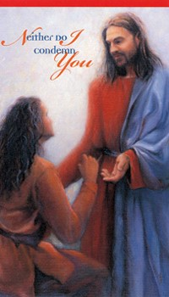**Featured this Month…**

**April 16, 2023: Sunday of Divine Mercy**  
On the Second Sunday of Easter, the Church celebrates the [**Sunday of Divine Mercy**](http://www.usccb.org/about/pro-life-activities/prayers/divine-mercy-sunday.cfm#Origin). It provides an important opportunity to share Christ’s message of mercy, especially with those who suffer because of their participation in one or more abortions. By the age of 45, as many as 1 in 3 women have had an abortion, and a similar number of men and family members have been involved. Many feel that abortion is “the unforgivable sin.” They need to hear that, through the Sacrament of Reconciliation, God forgives *every* sin of a repentant heart, even the sin of abortion. In fact, Jesus’ message to St. Faustina is that the greater the sinner, the greater the right to His mercy.

[Prayer](http://hopeafterabortion.com/?page_id=49) | [Order](https://store.respectlife.org/collections/prayer-cards/products/trust-prayer-card-eng)

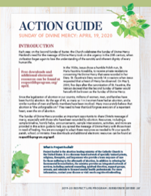

The [**Action Guide for the Sunday of Divine Mercy**](https://www.usccb.org/resources/divine-mercy-action-guide) includes a sample timeline, simple steps, sample announcements, homily helps, and an activity to help you bring Christ’s message of mercy to your parish community.

**Priests and deacons may find** [**these considerations**](https://www.usccb.org/resources/homily-considerations-regarding-healing-after-abortion) **especially helpful** when preparing their homilies.

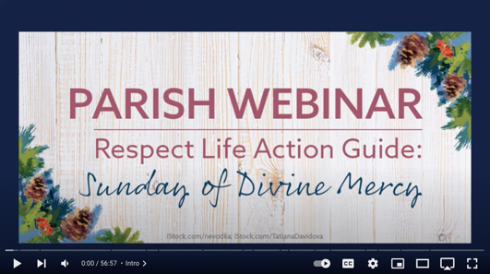Visit [respectlife.org/action-guides](https://www.respectlife.org/action-guides) and [usccb.org/prolife/divine-mercy-sunday](https://www.usccb.org/prolife/divine-mercy-sunday) for additional resources.

[This introductory webinar recording](https://youtu.be/rbq_DuBZChg) is for those who want to help their parish share Christ’s message of mercy, especially with those who suffer from participation in an abortion.

USCCB staff walk through the website and materials available, explaining how the tools above can help parishes spread the message of Divine Mercy with those most in need of healing.

**Additional Resources on Abortion Healing**

* [Bridges of Mercy for Healing after Abortion](https://www.usccb.org/bridges-of-mercy) (Available to order as a [pamphlet](https://store.respectlife.org/collections/pamphlets/products/bridges-of-mercy-for-post-abortion-healing) or [flyer](https://store.respectlife.org/collections/flyers/products/bridges-of-mercy-for-healing-after-abortion))
* [Healing within Marriage from an Abortion](https://www.respectlife.org/healing-in-marriage) ([Order](https://store.respectlife.org/collections/pamphlets/products/healing-within-marriage-from-an-abortion))
* [Prayer Guide: Divine Mercy](https://www.usccb.org/resources/prayer-guide-healing-after-abortion)
* [Divine Mercy in My Soul](https://www.usccb.org/committees/pro-life-activities/divine-mercy-my-soul-theresa-bonopartis-rlp-2000)

**Word of Life – April 2023**

**Intercessions for Life**

|  |  |
| --- | --- |
| **April 2nd**  For all those receiving hospice care:  May the care they receive  bear witness to the gift of their lives;  *We pray to the Lord:* | **Palm Sunday of the Passion of the Lord** |
| **April 9th**  May the glory of the Resurrection  inspire lasting hope in all who work  to protect human life;  *We pray to the Lord:* | **Easter Sunday of the Resurrection of the Lord** |
| **April 16th**  For those who have participated in an abortion  and feel they have committed an unforgiveable sin:  May they come to know the Lord’s limitless mercy,  and turn to Him for forgiveness and healing;  *We pray to the Lord:* | **Second Sunday of Easter (or Sunday of Divine Mercy)** |
| **April 23rd**  For elected officials:  May they work to protect human life  from conception to natural death;  *We pray to the Lord:* | **Third Sunday of Easter** |
| **April 30th**  For persons with disabilities:  May their lives always be recognized  as worth protecting and fighting for  in all circumstances;  *We pray to the Lord:* | **Fourth Sunday of Easter** |

**Word of Life – April 2023  
Bulletin Quotes**

|  |  |
| --- | --- |
| **April 2nd**  “Despite our best efforts, it can sometimes be difficult to recognize the profound value of human life when we see its full weakness and fragility. Yet, the faithful care of human life until its natural end is entrusted to *every* person.”  USCCB Secretariat of Pro-Life Activities  “The Witness of the Good Samaritan: Palliative Care and Hospice” | [Download](https://www.usccb.org/resources/witness-good-samaritan-palliative-care-and-hospice) |
| **April 9th**  “Like us, Christ entered the world through the womb of a woman. He willingly experienced the fullness of human suffering. He breathed his last on the Cross at Calvary in order that He might save us. Therefore, ‘God is the foundation of hope: not any god, but the God who has a human face and who has loved us to the end’ (*Spe salvi*31).”  USCCB Secretariat of Pro-Life Activities  “Respect Life Reflection: Christ Our Hope in Every Season of Life” (Citing Pope Benedict XVI, *Spe salvi* © 2007, Libreria Editrice Vaticana. Used with permission. All rights reserved.) | [Download](https://www.usccb.org/about/pro-life-activities/respect-life-program/upload/rlp-19-reflection-eng-secure.pdf) |
| **April 16th**  If you or someone you know has had an abortion, be assured that it is never too late to seek God’s forgiveness in the Sacrament of Reconciliation. Additionally, other confidential, compassionate help is available. Select “Find Help” from the menu on [www.hopeafterabortion.org](http://www.hopeafterabortion.org) to find the diocesan Project Rachel Ministry near you.  USCCB Secretariat of Pro-Life Activities, “Bridges of Mercy for Healing after Abortion”  [www.usccb.org/bridges-of-mercy](http://www.usccb.org/bridges-of-mercy) | [Order](https://store.respectlife.org/collections/abortion-healing/products/bridges-of-mercy-for-healing-after-abortion) | [Download](https://www.usccb.org/resources/bridges-mercy-healing-after-abortion) |
| **April 23rd**  “Virgin of Guadalupe, Patroness of unborn children, we implore your intercession for every child at risk of abortion. … Guide our public officials to defend each and every human life through just laws. Inspire us all to bring our faith into public life, to speak for those who have no voice. We ask this in the name of your Son, Jesus Christ, who is Love and Mercy itself. Amen.”  USCCB Secretariat of Pro-Life Activities, “A Prayer to Our Lady of Guadalupe” | [Order](https://store.respectlife.org/collections/prayer/products/respect-life-prayer-card-our-lady-of-guadalupe-pray-for-us) | [Read Online](https://www.usccb.org/prayers/prayer-our-lady-guadalupe) |
| **April 30h**  “People often say, “I could never handle a child with a disability.” But the beauty of parenting is that you aren’t given *a* child with a disability. You are given *your*child with a disability. Your child enters the world in a relationship with you, and that changes everything. You are not called to ‘handle’ a disability. You are called to love a particular person, and caring for him or her grows out of that love.”  USCCB Secretariat of Pro-Life Activities, “A Perfect Gift”  [respectlife.org/a-perfect-gift](https://www.respectlife.org/a-perfect-gift) | [Order](https://store.respectlife.org/collections/flyers/products/a-perfect-gift-2018) | [Download](https://www.respectlife.org/a-perfect-gift) |

**Word of Life – April 2023**

**Bulletin Art**

*You are welcome to use these, provided they are not altered in any way, other than the size. Thank you!*

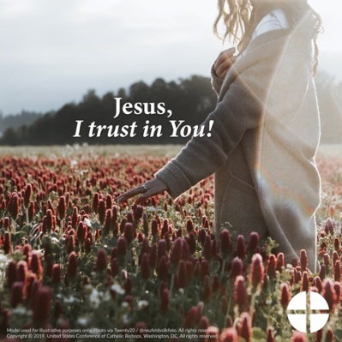

* Download Image: [English](https://www.usccb.org/resources/DivineMercy2.png) | [Spanish](https://www.usccb.org/resources/DivineMercy2-spn.png)

* Download Image: [English](http://cms.usccb.org/about/pro-life-activities/word-of-life/upload/DivineMercy3.png) | [Spanish](http://cms.usccb.org/about/pro-life-activities/word-of-life/upload/DivineMercy3-spn.png)

* Download Bulletin Box: [English](https://static.wixstatic.com/media/c138fd_53d854b7962b4beba6fba89714b6657d~mv2_d_1275_1650_s_2.png/v1/fill/w_1275,h_1650/rlp-19-bulletinboxes-healing-in-marriage.png) | [Spanish](https://static.wixstatic.com/media/c138fd_845993ef8d1544d388fd1376e5f87fc3~mv2_d_1275_1650_s_2.png/v1/fill/w_1275,h_1650/rlp-19-bulletinboxes-healing-in-marriage-spn.png)