**Word of Life: June 2023**

*Recommended dates are provided, but you are welcome to use these materials at any time!*

**Featured this Month…**

****[**National Eucharistic Revival: Beginning of the Year of Parish Revival**](https://www.eucharisticrevival.org/) **June 11, 2023**

June 11, the Solemnity of the Body and Blood of Christ, marks the entrance into the second year of the National Eucharistic Revival—the Year of Parish Revival. The second phase will foster Eucharistic devotion at the parish level, strengthening our liturgical life through faithful celebration of the Mass, Eucharistic Adoration, missions, resources, preaching, and organic movements of the Holy Spirit.

Learn more and find resources at [www.eucharisticrevival.org](http://www.eucharisticrevival.org).

[**Father’s Day Action Guide**](https://www.respectlife.org/action-guides#fathers-day)

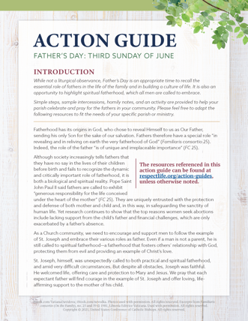**June 18, 2023**

Simple steps, sample intercessions, homily helps, and an activity are provided in the Father’s Day Action Guide to help your parish honor fathers and highlight their importance in building a culture of life.

A previously recorded webinar explains the resources available. Please feel free to adapt the resources to fit the needs of your specific parish or ministry.

* [Webinar Recording](https://youtu.be/Y6hNocCRW0c)
* Action Guide ([English](https://www.usccb.org/fathers-day-action-guide) | [Spanish](https://www.usccb.org/es/fathers-day-action-guide))
* Supplemental Resources (listed under Father’s Day section [on this page](https://www.respectlife.org/action-guides#fathers-day))

[**Religious Freedom Week**](http://www.usccb.org/issues-and-action/religious-liberty/religious-freedom-week/index.cfm) **June 22–29, 2023**

**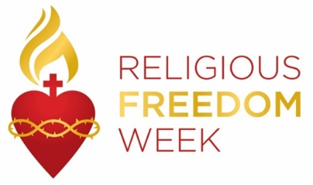***Religious Freedom Week 2023* takes place June 22–29. The Week begins with the Feast of Sts. John Fisher and Thomas More, ends with the Solemnity of Sts. Peter and Paul, and includes the Feast of the Nativity of St. John the Baptist. Many resources will be made available to help the faithful **pray**, **reflect** on, and **take action** for religious liberty, both here in this country and abroad. Resources, including graphics, lectionary notes, bulletin inserts, and daily prayers and reflections will be available at [usccb.org/ReligiousFreedomWeek](http://www.usccb.org/issues-and-action/religious-liberty/religious-freedom-week/index.cfm).

**Word of Life – June 2023**

**Intercessions for Life**

|  |  |
| --- | --- |
| **June 4th**  May we more deeply respect  the gift of each person,  who is created and called to holiness  by the gracious action of the Trinity;  *We pray to the Lord:* | **The Solemnity of the Most Holy Trinity** |
| **June 11th**  May the worthy reception of Christ in the Eucharist  strengthen us in our commitment  to protect and cherish the gift of human life  from conception to natural death;  *We pray to the Lord:* | **The Solemnity of the Body and Blood of Christ (Corpus Christi)** |
| **June 18th**  May expectant fathers lovingly support  the mothers of their children  in welcoming new life;  *We pray to the Lord*: | **Eleventh Sunday in Ordinary Time** *(Father’s Day is not a liturgical feast but is often recognized at Mass.)* |
| **June 25th**  For the preservation of religious freedom:  That the right to freely worship God  and live according to His commands  will be protected and upheld;  *We pray to the Lord:* | **Twelfth Sunday in Ordinary Time** |

**Word of Life – June 2023**

**Bulletin Quotes**

|  |  |
| --- | --- |
| **June 4th**  “The Catholic Church has a long history of service to those who are most vulnerable and remains the largest private provider of social services in the United States. Through the sacrificial efforts of faithful Catholics, the Church serves millions through diocesan ministries and agencies, Catholic hospitals and healthcare systems, immigration clinics, shelters, and Catholic schools and parishes. …The Church consistently bears witness in word and deed to the beauty and dignity of every human life—including both mother and child.”  USCCB Committee Chairmen, “Standing with Moms in Need” | [Read Online](https://www.usccb.org/news/2022/statement-usccb-president-and-bishop-chairmen-advance-supreme-courts-ruling-dobbs-v)  | [Download](https://www.usccb.org/resources/standing-moms-need) |
| **June 11th**  “Christ’s blood reveals to man that his greatness, and therefore his vocation, consists in the sincere gift of self. …It is from the blood of Christ that all draw the strength to commit themselves to promoting life. It is precisely this blood that is the most powerful source of hope, indeed it is the foundation of the absolute certitude that in God’s plan life will be victorious.”  Pope Saint John Paul II, *Evangelium vitae* © 1995, Libreria Editrice Vaticana.  NABRE © 2010 CCD. Used with permission. | Index    [Read Online](https://www.vatican.va/content/john-paul-ii/en/encyclicals/documents/hf_jp-ii_enc_25031995_evangelium-vitae.html) |
| **June 18th**  “Through our prayers and through the intercession of St. Joseph, patron of fathers, may fathers come to know the *irreplaceable* role they hold in the lives of their children, and the responsibility they share in welcoming God’s gift of new life!”  Most Reverend Shelton J. Fabre, Bishop of Houma-Thibodaux  “[Fathers’ Irreplaceable Role in Welcoming Life](https://www.usccb.org/prolife/fathers-irreplaceable-role-welcoming-life)” | [Read Online](https://www.usccb.org/prolife/fathers-irreplaceable-role-welcoming-life) | [Download](https://www.usccb.org/resources/fathers-irreplaceable-role-welcoming-life) |
| **June 25th**  “O God our Creator… we ask you to bless us in our vigilance for the gift of religious liberty. Give us the strength of mind and heart to readily defend our freedoms when they are threatened; give us courage in making our voices heard on behalf of the rights of your Church and the freedom of conscience of all people of faith.”  USCCB  “[Prayer for the Protection of Religious Liberty](https://www.usccb.org/committees/religious-liberty/religious-liberty-prayer-resources)” | [Download](https://www.usccb.org/issues-and-action/religious-liberty/upload/Immaculate-Conception-English.pdf) |

**Word of Life – June 2023**

**Bulletin Art**

*You are welcome to use these, provided they are not altered in any way, other than the size. Thank you!*

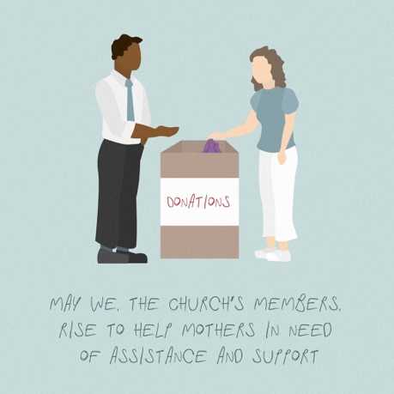**Sunday, June 4th, 2023**

Download Image: [English](https://www.usccb.org/resources/wwmin-graphic-2_0.jpg)

*(Other graphics are available* [*here*](https://www.usccb.org/resources/walking-moms-need-graphics)*.)*

**Sunday, June 11th, 2023**

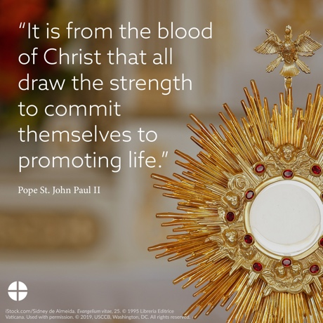

Download Image: [English](https://www.usccb.org/resources/ev-eucharist.png) | [Spanish](https://www.usccb.org/resources/ev-eucharist-spa.png)

**Sunday, June 18th, 2023**

Download Image *(Other graphics are available on the same webpages.)*: [English](https://www.usccb.org/resources/respect-life-action-guide-fathers-day-activity-graphics) | [Spanish](https://www.usccb.org/es/resources/respect-life-action-guide-fathers-day-activity-graphics-spanish)