**Word of Life: July 2023**

*Recommended dates are provided, but you are welcome to use these materials at any time!*

**Featured this Month**

[**National NFP Awareness Week**](https://www.usccb.org/topics/natural-family-planning/national-nfp-awareness-week)**: July 23-29, 2023**

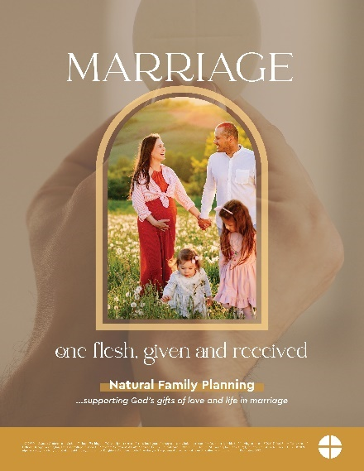The dates of National Natural Family Planning Awareness Week highlight the anniversary of the papal encyclical *Humanae vitae* (July 25), which articulates Catholic beliefs about human sexuality, married love, and responsible parenthood. The dates also mark the feast of Saints Joachim and Anne (July 26), the parents of the Blessed Mother.

Couples’ stories, sample intercessions, [homily notes](https://www.usccb.org/resources/2023%20Homily%20Notes%20Doctrine%20reviewed%20final%20for%20web.pdf), graphics, and more can be found [online](http://www.usccb.org/issues-and-action/marriage-and-family/natural-family-planning/awareness-week/index.cfm).

**Poster**

PDF: [English](https://www.usccb.org/resources/2023%20Poster%20Digital%20English_0.pdf) | [Spanish](https://www.usccb.org/resources/2023%20Poster%20NFP%20Week%20Final%20Digital%20Spanish_2.pdf)

JPG: [English](https://www.usccb.org/resources/2023%20Poster%20Digital%20English.jpg) | [Spanish](https://www.usccb.org/resources/2023%20Poster%20%20Digital%20Spanish.jpg)

*Ordering information is* [*available here*](https://www.usccb.org/issues-and-action/marriage-and-family/natural-family-planning/awareness-week/posters)*.*

**Feast of Saints Joachim and Anne: July 26, 2023**

The Feast of Saints Anne and Joachim, parents of the Blessed Virgin Mary, is celebrated on July 26. They are powerful intercessors for all married couples, expectant mothers, and married couples who are having difficulty conceiving, as well as those who are aging. Copies of the “Faith and Perseverance” novena to Saints Anne and Joachim are available for download or purchase. You can pray the novena from July 17-25 in preparation for their feast day.

**Download:** [English](http://www.usccb.org/issues-and-action/marriage-and-family/natural-family-planning/upload/nfp-sts-anne-joachim-novena.pdf) | [Spanish](http://www.usccb.org/issues-and-action/marriage-and-family/natural-family-planning/resources/upload/Sts-Anne-and-Joachim-Novena-Spanish.pdf)

*Ordering information is* [*available here*](https://www.usccb.org/issues-and-action/marriage-and-family/natural-family-planning/new-nfp-resources)*.*

**USCCB Respect Life Store**

****You can now order your favorite Respect Life print materials from our new online store. Browse resources by topic or product type in the easy-to-use format. Visit the Respect Life Store at <https://store.respectlife.org/>.

**Word of Life – July 2023**

**Intercessions for Life**

|  |  |
| --- | --- |
| **July 2nd**  For our nation:  May our laws protect  every person’s right to life,  from conception to natural death;  *We pray to the Lord*: | **Thirteenth Sunday in Ordinary Time** |
| **July 9th**  For families considering adoption:  May the Lord guide and bless their journeys  and grant them peace along the way;  *We pray to the Lord:* | **Fourteenth Sunday in Ordinary Time** |
| **July 16th**  For all those nearing death:  That their faith will grow ever stronger,  as they prepare in hope  to share eternal life with Christ;  *We pray to the Lord:* | **Fifteenth Sunday in Ordinary Time** |
| **July 23rd**  May married couples embrace their call  to total, faithful, and fruitful love  with openness to new life;  *We pray to the Lord:* | **Sixteenth Sunday in Ordinary Time** |
| **July 30th**  For women who are unexpectedly pregnant:  May they be filled with trust in God’s providence  and supported by those around them  to lovingly welcome the gift of their child;  *We pray to the Lord:* | **Seventeenth Sunday in Ordinary Time** |

**Word of Life – July 2023**

**Bulletin Quotes**

|  |  |
| --- | --- |
| **July 2nd**  “O God our Creator… through the power and working of your Holy Spirit, you call us to live out our faith in the midst of the world, bringing the light and the saving truth of the Gospel to every corner of society.”  United States Conference of Catholic Bishops  “Prayer for Religious Liberty” | [Download](http://www.usccb.org/issues-and-action/religious-liberty/upload/Immaculate-Conception-English.pdf) |
| **July 9th**  “Adopting Andrew has made us more aware of God's power and of his love for us. We realize that he always has a perfect plan for our lives.”  Read more at [www.bit.ly/AdoptionLoveStory](http://www.bit.ly/AdoptionLoveStory).   USCCB Secretariat of Pro-Life Activities “An Adoption Love Story” | [Order](https://store.respectlife.org/collections/adoption/products/an-adoption-love-story) [| Download](http://www.usccb.org/about/pro-life-activities/respect-life-program/2014/upload/An-Adoption-Love-Story-RLP2014-Bulletin.pdf) |
| **July 16th**  “Because of our belief and hope in the Resurrection, we can face death not with fear, but with preparation…. We prepare for eternal life by choosing to love and follow God now, in our daily lives and decisions.” Read more at [www.respectlife.org/end-of-life-considerations](https://www.respectlife.org/end-of-life-considerations).  USCCB Secretariat of Pro-Life Activities  “Catholic Considerations for Our Earthly Passing” | [Order](https://store.respectlife.org/products/catholic-considerations-for-our-earthly-passing) | [Download](https://www.usccb.org/about/pro-life-activities/respect-life-program/2017/upload/rlp-17-end-of-life-flyer-color-secure.pdf) |
| **July 23rd**  “Married love differs from any other love in the world. By its nature, the love of husband and wife is so complete, so ordered to a lifetime of communion with God and each other, that it is open to creating a new human being they will love and care for together. … That power to create a new life with God is at the heart of what spouses share with each other.”  United States Conference of Catholic Bishops  “Married Love and the Gift of Life” | [Read Online](https://www.usccb.org/beliefs-and-teachings/what-we-believe/love-and-sexuality/married-love-and-the-gift-of-life)  [| Download](http://www.usccb.org/issues-and-action/marriage-and-family/natural-family-planning/catholic-teaching/upload/Married-Love-and-the-Gift-of-Life-New-USCCB-Website.pdf) |
| **July 30th**  “A woman with an unexpected pregnancy may have any number of fears and challenges: facing judgment from her friends and family, losing her job or housing, or being abandoned by the father of her child. Following Mary’s example, we can ask ourselves how to better know these mothers, listen to them, seek understanding, and help them obtain the necessities of life for themselves and their children.”  USCCB Secretariat of Pro-Life Activities  “Called to Serve Moms in Need” | [Read Online](https://www.respectlife.org/called-to-serve-reflection) [| Download](https://www.usccb.org/resources/respect-life-reflection-called-serve-moms-need) |

**Word of Life - July 2023**

**Bulletin Art**

*You are welcome to use these, provided they are not altered in any way, other than the size. Thank you!*

**Sunday, July 9th, 2023**

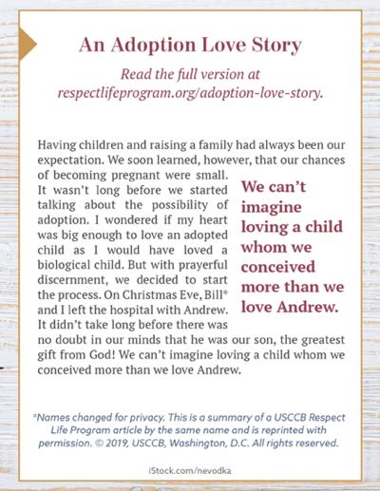Download: [English](https://static.wixstatic.com/media/c138fd_501830b028e94988a3194a0cf2f25c6b~mv2_d_1275_1650_s_2.png/v1/fill/w_1275,h_1650/rlp-19-bulletinboxes-adoption-love-story.png) | [Spanish](https://static.wixstatic.com/media/c138fd_450c9454c6c14392a21ec93eea9caee2~mv2_d_1275_1650_s_2.png/v1/fill/w_1275,h_1650/rlp-19-bulletinboxes-adoption-spn.png)

**Sunday, July 16th, 2023**

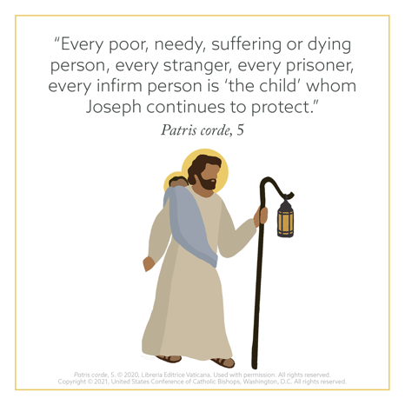

Download: [English](https://www.usccb.org/sites/default/files/2021-11/rlp-21-joseph-4.png) | [Spanish](https://www.usccb.org/resources/rlp-21-joseph-4-spa.png)

**Sunday, July 23rd, 2023**

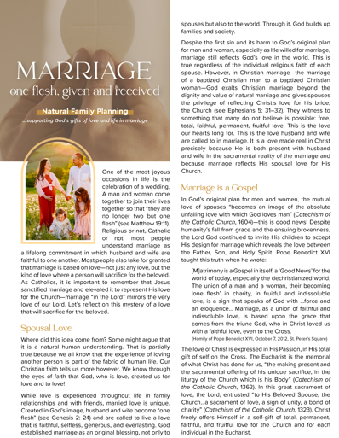

Download: [English](https://www.usccb.org/resources/2023%20NFP%20Week%20Bulletin%20Insert%20English%20final.pdf) | [Spanish](https://www.usccb.org/resources/2023%20NFP%20Week%20Bulletin%20Insert%20Spanish%20final.pdf)